专业化制造的特色产品 Special Motor
游泳池水下智能清洗机专用电机
Motor for Swimming Pool Robotic Cleaner

产品说明 Product Description

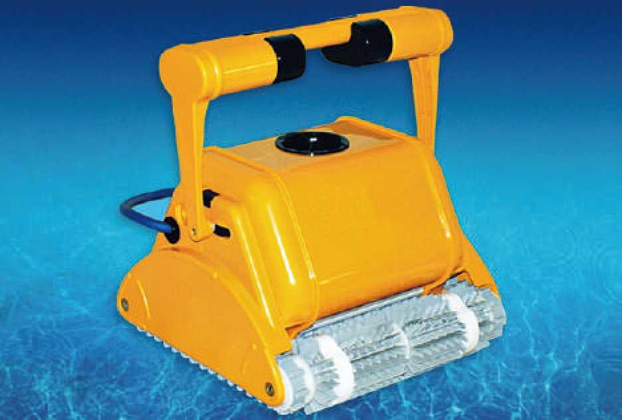
游泳池水下自动化智能清洗机是高科技机电一体化产品, 为其配套的专用电机和减速电机，分为“清洗电机"和“行 走电机”两种，属于高科技核心技术。它们能够潜入水下运 行， 除了能够承受水的压力以外，在耐磨、耐腐蚀两项特性 方面也有创新。

Swimming Pool Robotic Cleaner Are High-tech Mechatronics Products. Motors Specially Made For This Machine Are Including Cleaning Motors And Walking Motors, Belonging To Advanced Core Technology. The Motors Can Be Used Under The Water And Bear Water Pressure. What's More, The Motor's Wear Resistance And Corrosion Resistance Have Been Greatly Improved.

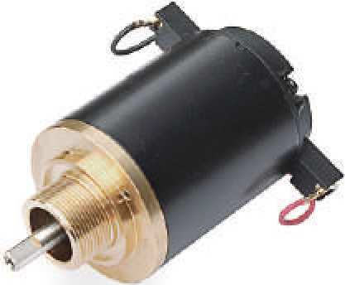
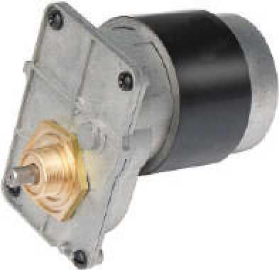
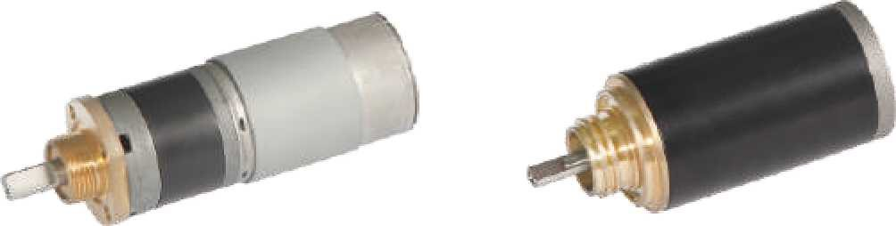

齿轮减速电机主要技术参数 Gearmotor Technical Data

电机型号  Type | 额定电压Rated Voltage  VDC | 空载转速No-load Speed r/min | 空载电流No-load Current  A | 额定转速Rated Speed r/min | 额定转矩Rated Torque N.m | 输出功率Output Powe  r W | 额定电流Rated Current  A | 堵转转矩Stall Torque N.m | 堵转电流Stall Current  A | 电机型号  Type
DZ63ZY | 17.5 | 3600 | 0.8 | 2850 | 0.18 | 45 | 4.8 | 0.55 | 10 | /
DZ6322PMG | 15.8 | 55 | 0.6 | 49 | 1.27 | 10 | 0.8 | 4.2 | 8.0 | 1:57.81
DZ52ZY | 24 | 3600 | 0.6 | 2850 | 0.17 | 50 | 3.3 | 0.5 | 8 | /
36ZY/36JX | 24 | 120 | 0.2 | 100 | 0.5 | 10 | 0.6 | 3.5 | 6 | 1:27

J-5

