专业化制造的特色产品 Special Motor
太阳能发电设备跟踪电机
Special Motor for Solar Trackers


产品说明 Product Description
太阳能发电设备的跟踪电机，也称为“追日系统控制电机”，特点是 转速特别慢，一般为每分钟 2~3 转，正符合行星减速电机的特点。因为行 星减速器可以把减速比做得非常大，所以获得低转速是轻而易举的事情。
本公司推荐以下直流行星电机、步进行星电机，能够满足大、中型 自动跟踪系统的需要，能够抗御恶劣的天气条件，使用安全可靠。
Solar Tracker Motor Is Also Named Solar Tracking System Controlling Motor. The Motor Has Very Low Speed, Generally 2~3 Rpm Which Accords With The Feature Of Planetary Gear Motor. Because Reduction Ratio Of Planetary Gearbox Can Be Very Large To Achieve Very Low Speed.
The Following DC Planetary Gear Motors, Stepping Planetary Gear Motors Can Resist And Work Well In Bad Weather Conditions With Their Safe And Reliable Use And Meet The Demands Of Small And Medium Automatic Tracking Systems.

各种直流行星“追日系统控制电机"
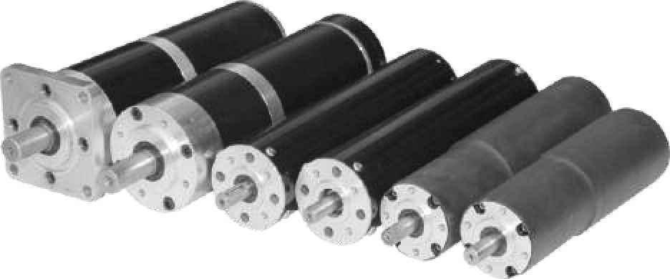
Various Solar Tracker Motors

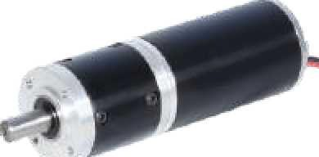

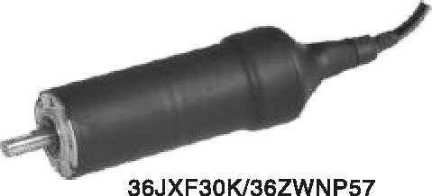
减速器直径 36mm，输出转矩 3N.m Model: 36JXF30K/36ZWNP57
(BLDC Planetary Gear Motor) Gearbox OD: 36mm; Output Torque:3N.m
52JX300K/52ZY95
直流行星减速电机
减速器直径 52mm，输出转矩 30N.m Model: 52JX300K/52ZY95
(DC Planetary Gear Motor) Gearbox OD: 52mm; Output Torque:30N.m

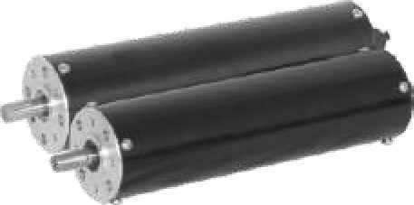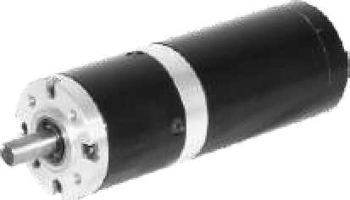

56JX300K/60ZY105BH 直流行星
减速电机
带霍尔传感器.防护等级为 IP65 Model: 56JX300K/60ZY105BH
(DC Planetary Gear Motor) With Hall Sensor; IP65
56JX300K/60ZY105B
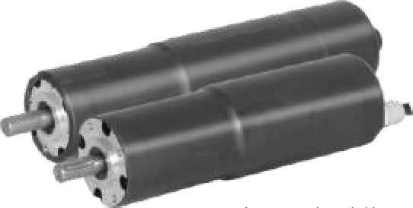
直流行星减速电机
减速器直径 56mm，输出转矩30N.m Model: 56JX300K/60ZY105B
(DC Planetary Gear Motor) Gearbox OD: 56mm; OutputTorque:30N.m
60JX300K/60ZY105
直流行星减速电机
减速器直径 60mm，输出转矩 30N.m Model: 60JX300K/60ZY105
(DC Planetary Gear Motor) Gearbox OD: 60mm; Output Torque:30N.m

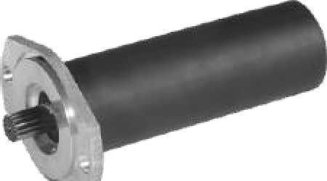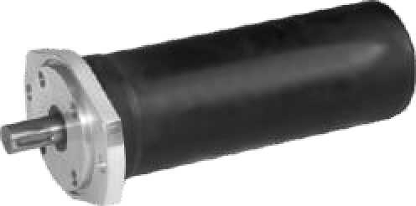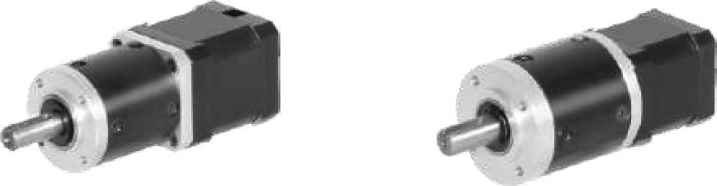

63JX1500K/63ZWN95
直流行星减速电机
减速器直径 63mm，输出转矩 150N.m Model: 63JX1500K/63ZWN95
(DC Planetary Gear Motor)
92JX3000K/80ZY170
直流行星减速电机
减速器直径 92mm，输出转矩 300N.m Model: 92JX3000K/80ZY170
(DC Planetary Gear Motor)
42JXT200K/42STH 混合式
步进行星减速电机
减速器直径 42mm，输出转矩 20N.m Model: 42JXT200K/42STH (
Stepping Planetary Gear Motor)
52JX300K/42STH 混合式
步进行星减速电机
减速器直径 52mm，输出转矩 30N.m Model: 52JX300K/42STH
(Stepping Planetary Gear Motor)

Gearbox OD: 63mm; Output Torque:150N.m
Gearbox OD: 92mm; Output Torque:300N.m
Gearbox OD: 42mm; Output Torque:20N.m Gearbox OD: 52mm; Output Torque:30N.m

J-3

