专业化制造的特色产品 Special Motor
园林电动工具行星电机全自动割草机行星电机
Planetary Gear Motor for Electric Garden Tools and Automatic Mower

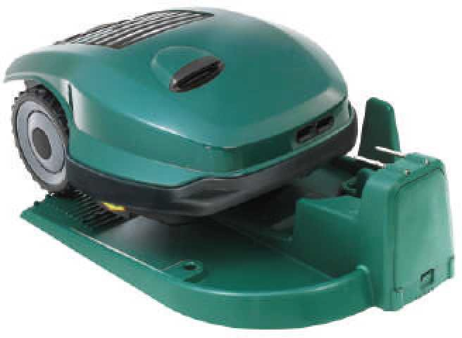
产品说明 Product Description

本公司具有为园林电动工具制造厂家配套的悠久历史和丰富经验，成功的案例包括电动树枝剪 直流行星电机、自行走全自动割草机无刷行星电机等。
自行走全自动割草机也称为机器人割草机。它能够在无人操作的情况下，自行完成充电→出发→割草→返回充电→重新出发的过程。割草的路线是按照园林的实际情况编程的，可以绕开不需要 割草的面积，绕开障碍物，走最经济的路线。本公司提供的行走电机，有无刷行星电机、有刷行星 电机，功能是按照电脑的指令，实现割草机的前进、后退、转弯、行进路程的控制等。
Our Company Is Experienced In Designing And Making Electric Garden Tools for Garden Tool Manufacturers. Successful Cases Are Electric Gardening Scissors(DC Planetary Gear Motor), Self walking Automatic Mowers(BLDC Planetary Gear Motor) and So On.
Self-walking Automatic Mowers, Also Named Robot Mower, Can Complete Power Charge→Start-off→Mowing→Return to Charge->Restart Without Human Operation. Mowing Route Is Programmed According to Different Garden Situations, Bypassing Unnecessary Area And Barriers, Going Economic Way. Selfing-walking Motors We Offer Include BLDC Planetary Gear Motors, Brushed Planetary Gear Motor, Etc.. According to Computerized Instructions, The MotorCan Make The MowerTo Go Forward, Backward, Cornering And Control The Mower's Travel Path.
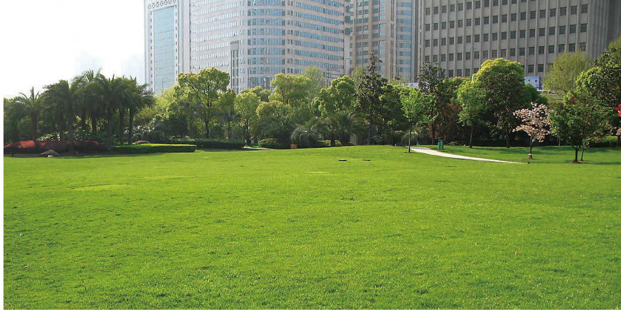

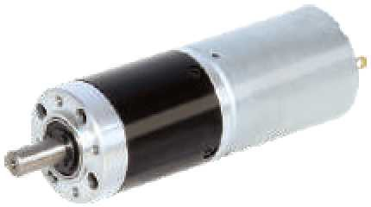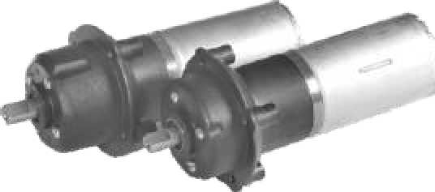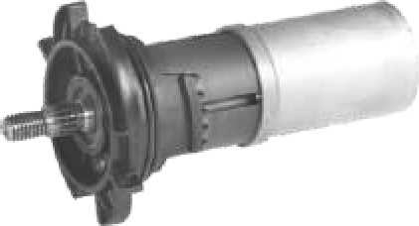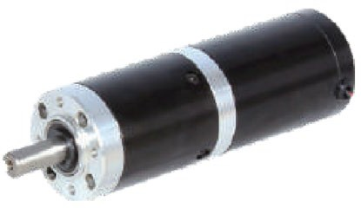

36JX 永磁直流行星减速电机用于电动树枝剪配套
36JX PMDC Planetary Gear Motor Electric Gardening Scissors Motor
36JX 无刷直流行星减速电机用于全自动割草机的行走电机
36JX BLDC Planetary Gear Motor Automatic Mower Motor
42JX 无刷直流行星减速电机用于全自动割草机的行走电机
42JX BLDC Planetary Gear Motor Automatic Mower Motor
45JX 永磁直流行星减速电机用于全自动割草机的行走电机
45JX PMDC Planetary Gear Motor Automatic Mower Motor

J-2

