专业化制造的特色产品 Special Motor
行星开窗电机 行星开门电机
Planetary Gear Motor for Door and Window Opene


产品说明 Product Description
本公司制造的各种行星开窗电机、开门电机，已经形成众多的品种和规格，有许多成功的案例，能够满足 各方面用户的要求。
配套开窗电机的范围包括消防排烟窗、平开窗、垂直窗、伸缩窗等，用于各种民用建筑、工业建筑和公共 建筑。本公司的 60JX 行星电机， 最大转矩达到 30N.m,成功地用于特大型公共建筑，安全可靠，受到建筑单位的信赖。

With Different Kind And Specifications, Door And Window Opener Motors Has Successfully Been Offered To Many Customers And Met Different Needs Of Our Customers.
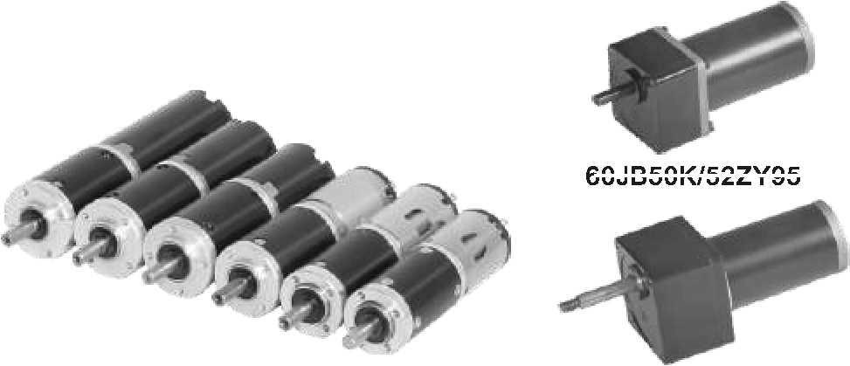
Applications: Fire Smoke Evacuation Window, Casement Window, Vertical Window, Telescopic Window, Widely Used In Civil Building, Industrial Building And Public Buildings; Rated Torque Up lb 30n.m, Successfully Used In Large Public Buildings With Its Safe And Reliable Usage.
60JB50K/52ZY95

第一系列产品：28JX~32JX 直流行星齿轮电机，尺寸小、出力大，用于紧凑型的开窗器。
Series 1: 28JX ~32JX DC Planetary Gear Motor (Small Size, High Torque, Used In Compact Window Openers).
70JB
80K/52ZY95

序号  No. | 产品型  Type | 减速器直径Gearbox Diameter | 允许最大转矩Max. Permissible Torque | 额定电压Rated Voltage
1 | 28JX30K/28ZY47 永磁直流行星减速电机(PM DC Planetary Gear Motor) | ¢28 | 3 N.m | 12VDC/24VDC
2 | 30JX30K/28ZY47P 永磁直流行星减速电机(PM DC Planetary Gear Motor) | ¢30 | 3 N.m | 12VDC/24VDC
3 | 32JX30K/28ZY47P 永磁直流行星减速电机(PM DC Planetary Gear Motor) | ¢32 | 3 N.m | 12VDC/24VDC
4 | 32JX30K/31ZY46 永磁直流行星减速电机(PM DC Planetary Gear Motor) | ¢32 | 3 N.m | 12VDC/24VDC
5 | 32JX30K/31ZY53 永磁直流行星减速电机(PM DC Planetary Gear Motor) | ¢32 | 3 N.m | 12VDC/24VDC
6 | 32JX30K/31ZY70 永磁直流行星减速电机(PM DC Planetary Gear Motor) | ¢32 | 3 N.m | 12VDC/24VDC

第二系列产品:36JX~60JX 直流行星齿轮电机，用于各种开窗器、开门器。
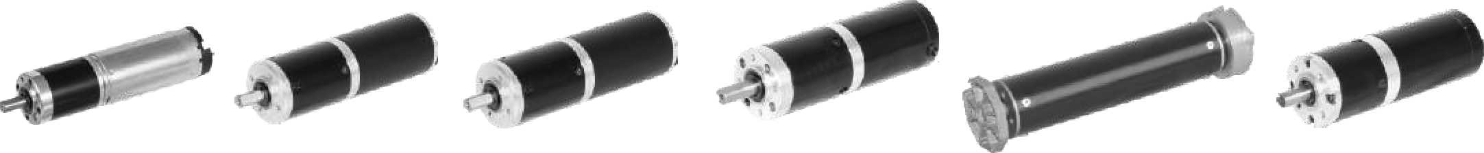
Series 2: 36JX~60JX DC Planetary Gear Motor( Used In Various Kinds of Window and Door Openers),

36JX30K/36ZY85 40JX50K/40ZY68 45JX100K/45ZY68 52JX300K/52ZY80 DZ55X220 60JX300K/60ZY105

序号  No. | 产品型  Type | 减速器直径Gearbox Diameter | 允许最大转矩  Max. Permissible Torque | 额定电压  Rated Voltage
1 | 36JX30K/36ZY85 永磁直流行星减速电机(PM DC Planetary Gear Motor) | ¢36 | 3 N.m | 12VDC/24VDC
2 | 40JX50K/40ZY68 永磁直流行星减速电机(PM DC Planetary Gear Motor) | ¢40 | 5 N.m | 24VDC
3 | 45JX100K/45ZY68 永磁直流行星减速电机｛ PM DC Planetary Gear Motor) | ¢45 | 10 N.m | 24VDC
4 | 52JX300K/52ZY80 永磁直流行星减速电机｛ PM DC Planetary Gear Motor) | ¢52 | 30 N.m | 24VDC
5 | DZ55X220 永磁直流行星减速电机(PM DC Planetary Gear Motor) | ¢55 | 30 N.m | 24VDC
6 | 60JX300K/60ZY105 永磁直流行星减速电机(PM DC Planetary Gear Motor) | ¢60 | 30 N.m | 24VDC

J-1

