- 产品特点和用途 Description of The Product
80ZY100 永磁直流电动机 80ZY100 PMDC Motor
直径 80mm 的永磁直流电动机，密封结构，适合于各种要求低噪音的使用场合。
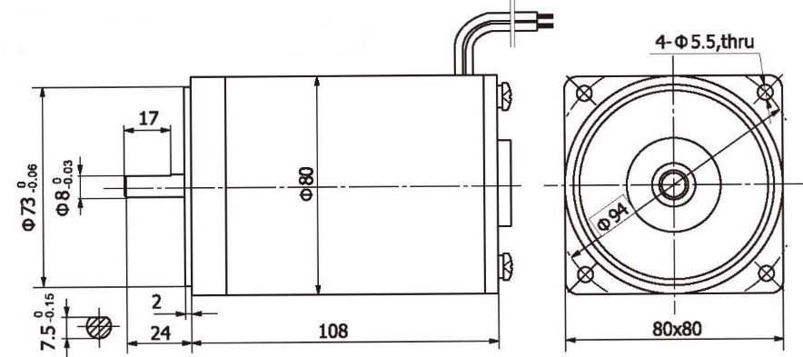
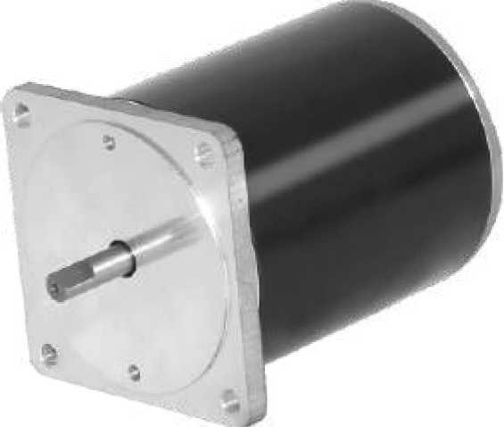
80MM OD PMDC motor, totally enclosed, used in occasions which require motors with low noise.
外形尺寸 Dimensions

●

- 电动机主要技术参数 Motor Technical Data
电机型号  TYPE | 额定电压Rated voltage VDC | 空载转速No-load speed r/min | 空载电流No-load current  A | 额定转速Rated speed r/min | 额定转矩Rated torque mN.m | 输出功率Output Power  W | 额定电流Rated current  A | 堵转转矩Stall torque mN.m | 堵转电流Stall current  A
80ZY100-2420 | 24 | 2000 | 0.4 | 1700 | 0.25 | 45 | 3.0 | 1.5 | 16
80ZY100-2430 | 24 | 3000 | 0.5 | 2600 | 0.30 | 80 | 5.0 | 1.8 | 22

80ZY115 永磁直流电动机 80ZY115 PMDC Motor
- 产品特点和用途 Description of The Product
直径 80mm 的永磁直流电动机，密封结构，适合于各种要求低噪音的使用场合。
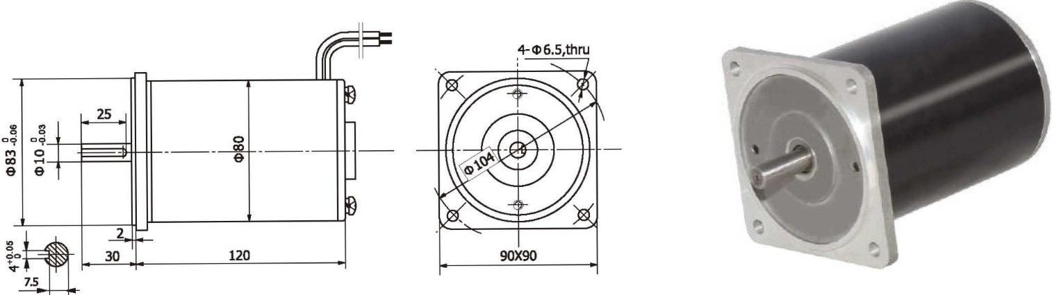
80MM OD PMDC motor, totally enclosed, used in occasions which require motors with low noise.
外形尺寸 Dimensions

●

- 电动机主要技术参数 Motor Technical Data
电机型号  TYPE | 额定电压Rated voltage VDC | 空载转速No-load speed r/min | 空载电流No-load current  A | 额定转速Rated speed r/min | 额定转矩Rated torque mN.m | 输出功率Output Power  W | 额定电流Rated current  A | 堵转转矩Stall torque mN.m | 堵转电流Stall current  A
80ZY115-1234 | 12 | 3400 | 1.5 | 2890 | 0.14 | 42 | 5.0 | 0.65 | 22
80ZY115-2420 | 24 | 2000 | 0.3 | 1700 | 0.32 | 57 | 3.5 | 1.5 | 16
80ZY115-2430 | 24 | 3000 | 0.5 | 2600 | 0.44 | 120 | 7.5 | 2.0 | 33

I-8

