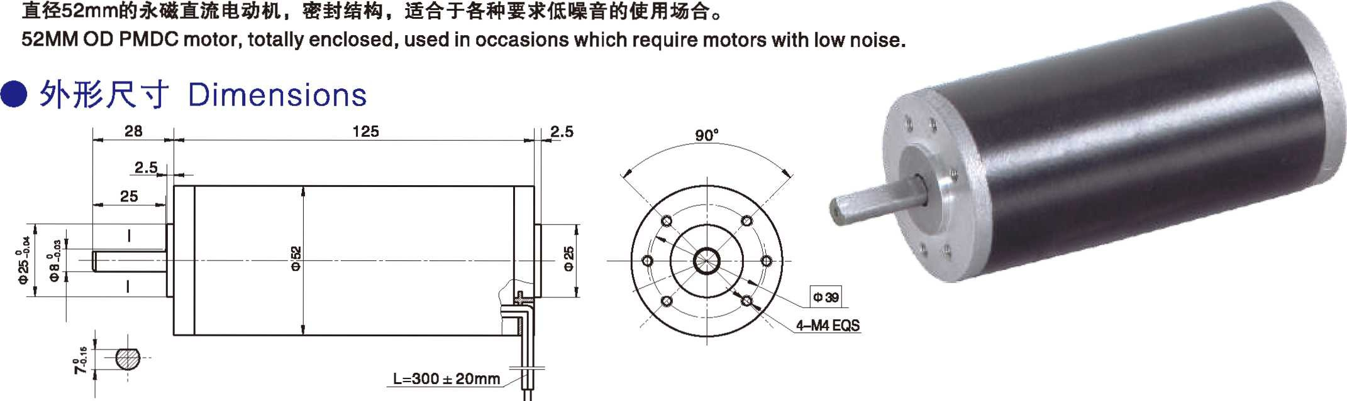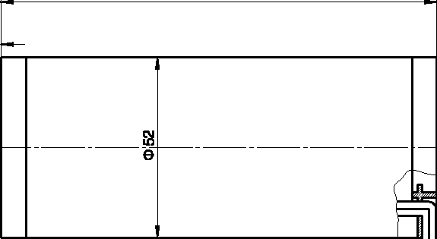产品特点和用途 Description of The Product
直径 52mm 的永磁直流电动机，密封结构，适合于各种要求低噪音的使用场合。
52MM OD PMDC motor, totally enclosed, used in occasions which require motors with low noise

- 外形尺寸 Dimensions
- 电动机主要技术参数 Motor Technical Data
52ZY125 永磁直流电动机 52ZY125 PMDC Motor

电机型号  TYPE | 额定电压Rated voltage VDC | 空载转速  No-load  speed r/min | 空载电流No-load current  A | 额定转速Rated Speed r/min | 额定转矩Rated torque mN.m | 输出功率Output Power  W | 额定电流Rated current  A | 堵转转矩Stall torque mN.m | 堵转电流Stall Current  A
52ZY125-2420 | 24 | 2000 | 0.40 | 1600 | 160 | 30 | 2.0 | 620 | 6.5
52ZY125-2430 | 24 | 3000 | 0.60 | 2400 | 190 | 50 | 3.5 | 700 | 11.5
52ZY125-2440 | 24 | 4000 | 0.80 | 3200 | 220 | 80 | 4.5 | 838 | 16.4

60ZY75 永磁直流电动机 60ZY75 PMDC Motor

- 产品特点和用途 Description of The Product
直径 60mm 的永磁直流电动机，密封结构，适合于各种要求低噪音的使用场合。
60MM OD PMDC motor, totally enclosed, used in occasions which require motors with low noise.
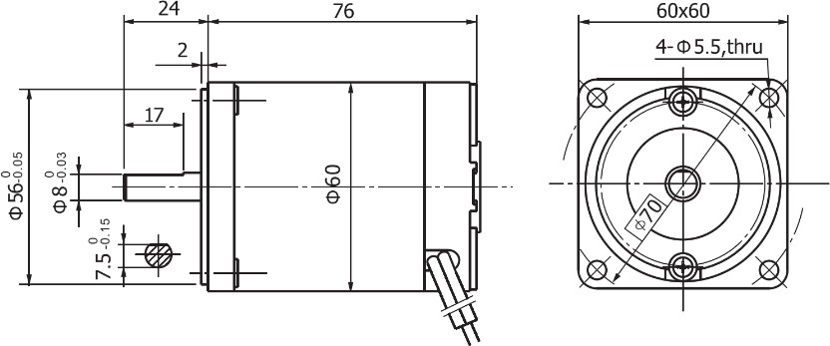
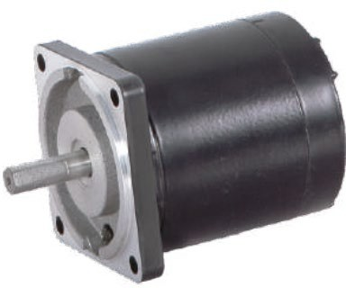

电动机主要技术参数 Motor Technical Data

电机型号  TYPE | 额定电压Rated voltage VDC | 空载转速  No-load  speed r/min | 空载电流No-load current  A | 额定转速Rated Speed r/min | 额定转矩Rated torque mN.m | 输出功率Output Power  W | 额定电流Rated current  A | 堵转转矩Stall torque mN.m | 堵转电流Stall Current  A
60ZY75-2420 | 24 | 2000 | 0.3 | 1600 | 50 | 8 | 0.8 | 215 | 2.1
60ZY75-2430 | 24 | 3000 | 0.4 | 2400 | 70 | 17 | 1.2 | 296 | 5.0
60ZY75-2440 | 24 | 4000 | 0.5 | 3200 | 90 | 30 | 2.2 | 404 | 8.5

I-5

