产品特点和用途 Description of The Product
45ZYN68 稀土永磁直流电动机
45ZYN68 Rare Earth PMDC Motor
直径 45mm 的稀土永磁直流电动机，密封结构，适合于各种要求低噪音的使用场合。
45MM OD rare earth PMDC motor, totally enclosed, used in occasions which require motors with low noise.

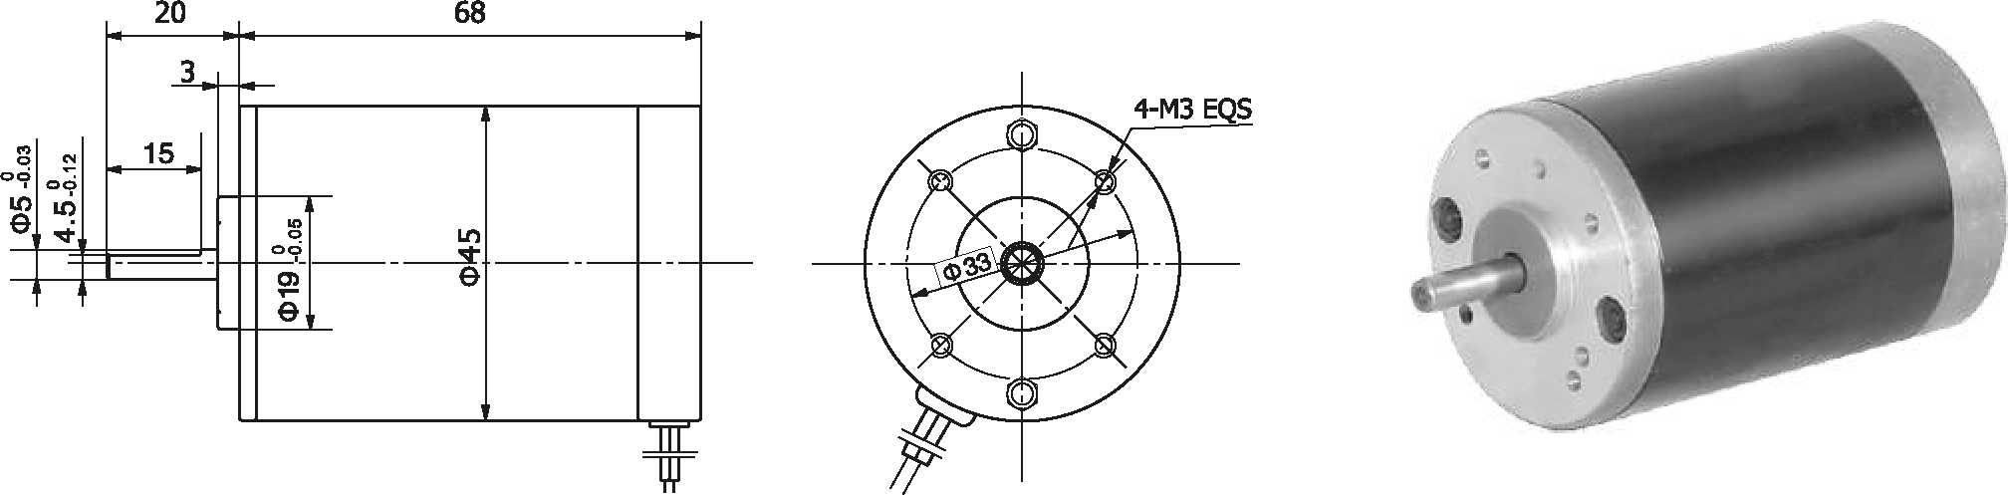
外形尺寸 Dimensions
- 电动机主要技术参数 Motor Technical Data

电机型号  TYPE | 额定电压Rated voltage VDC | 空载转速No-load speed r/min | 空载电流No-load current  A | 额定转速Rated speed r/min | 额定转矩Rated torque mN.m | 输出功率Output Power  W | 额定电流Rated current  A | 堵转转矩Stall torque mN.m | 堵转电流Stall current  A
45ZYN68-2420 | 24 | 2000 | 0.18 | 1600 | 42 | 7 | 0.5 | 220 | 2.0
45ZYN68-2430 | 24 | 3000 | 0.25 | 2400 | 65 | 16 | 1.2 | 300 | 4.4
45ZYN68-2440 | 24 | 4000 | 0.30 | 3200 | 90 | 30 | 2.0 | 375 | 6.8

45ZYN78 稀土永磁直流电动机
45ZYN78 Rare Earth PMDC Motor

- 产品特点和用途 Description of The Product
直径 45mm 的稀土永磁直流电动机，密封结构，适合于各种要求低噪音的使用场合。
45MM OD rare earth PMDC motor, totally enclosed, used in occasions which require motors with low noise.

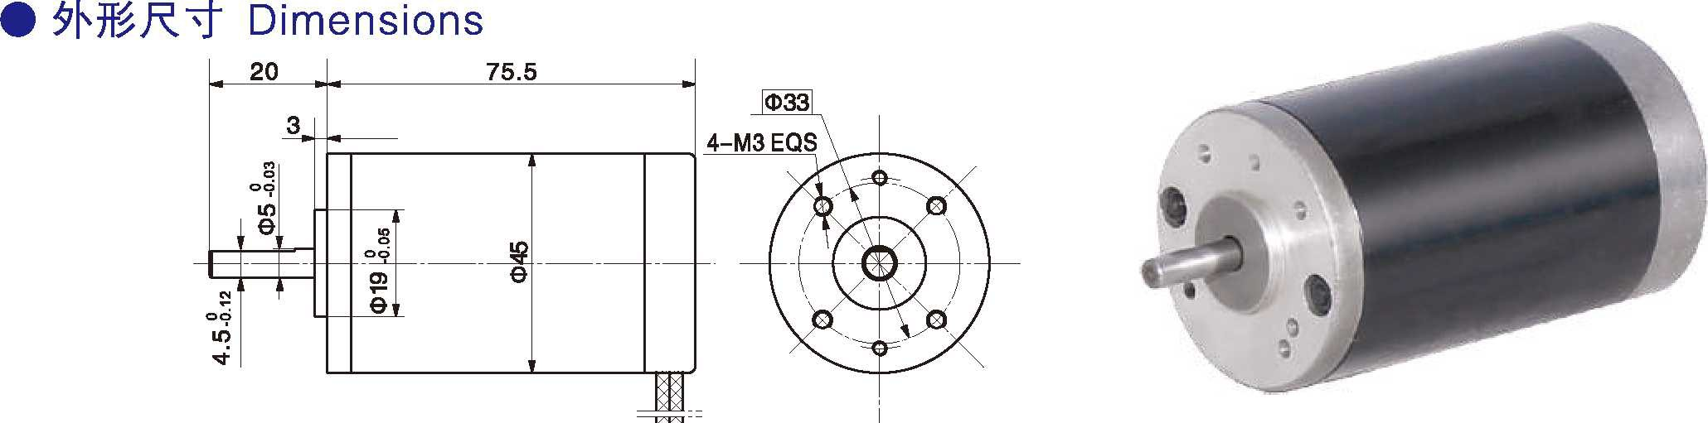

电动机主要技术参数 Motor Technical Data

电机型号  TYPE | 额定电压Rated voltage VDC | 空载转速No-load speed r/min | 空载电流No-load current  A | 额定转速Rated speed r/min | 额定转矩Rated torque mN.m | 输出功率Output Power  W | 额定电流Rated current  A | 堵转转矩Stall torque mN.m | 堵转电流Stall current  A
45ZYN78-2420 | 24 | 2000 | 0.25 | 1600 | 80 | 13 | 0.8 | 310 | 3.0
45ZYN78-2425 | 24 | 2500 | 0.30 | 2000 | 130 | 25 | 1.7 | 570 | 6.6
45ZYN78-2430 | 24 | 3000 | 0.30 | 2400 | 150 | 30 | 2.5 | 720 | 7.5

1-3

