45ZY68 永磁直流电动机 45ZY68 PMDC Motor

- 产品特点和用途 Description of The Product
直径 45mm 的永磁直流电动机，密封结构，适合于各种要求低噪音的使用场合。
45MM OD PMDC motor, totally enclosed, used in occasions which require motors with low noise.
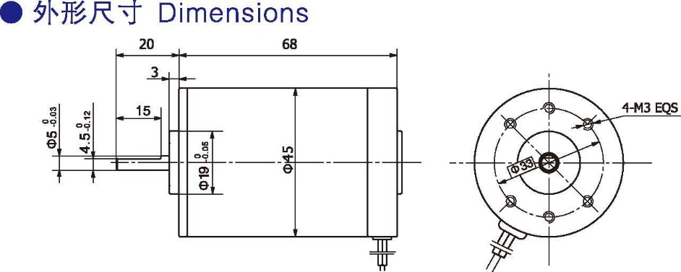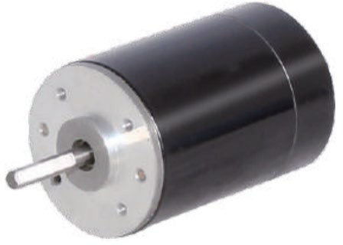
- 外形尺寸 Dimensions
- 电动机主要技术参数 Motor Technical Data
电机型号  Type | 额定电压Rated Voltage DVC | 空载转速  No-load  speed r/min | 空载电流No-load current  A | 额定转速  Rated  speed r/min | 额定转矩  Rated  Torque mN.m | 输出功率Output power  W | 额定电流Rated current  A | 堵转转矩  Stall  Torque mN.m | 堵转电流Stall Current  A
45ZY68-2430 | 24 | 3000 | 0.2 | 2500 | 45 | 12 | 0.8 | 190 | 2.7
45ZY68-2440 | 24 | 4000 | 0.3 | 3200 | 55 | 18 | 1.2 | 195 | 3.0

45ZY78 永磁直流电动机 45ZY78 PMDC Motor
- 产品特点和用途 Description of The Product
直径 45mm 的永磁直流电动机，密封结构，适合于各种要求低噪音的使用场合。
45MM OD PMDC motor, totally enclosed, used in occasions which require motors with low noise.

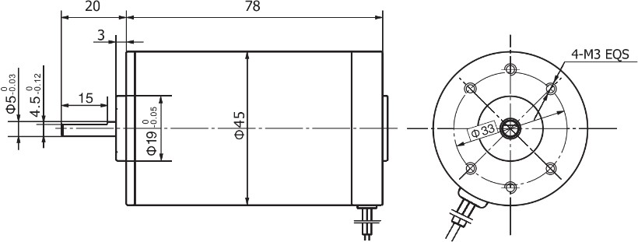
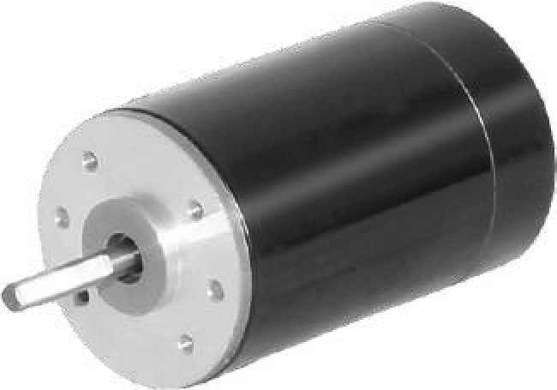
外形尺寸 Dimensions
- 电动机主要技术参数 Motor Technical Data

电机型号  Type | 额定电压Rated Voltage DVC | 空载转速  No-load  speed r/min | 空载电流No-load current  A | 额定转速  Rated  speed r/min | 额定转矩  Rated  Torque mN.m | 输出功率Output power  W | 额定电流Rated current  A | 堵转转矩  Stall  Torque mN.m | 堵转电流Stall Current  A
45ZY78-2430 | 24 | 3000 | 0.22 | 2400 | 55 | 15 | 1.0 | 240 | 3.0
45ZY78-2440 | 24 | 4000 | 0.30 | 3200 | 70 | 23 | 1.5 | 310 | 4.8

I-2

