永磁直流蜗轮减速电机 PM DC Worm Gear Motor
允许转矩范围:20N.m
Permissible Load Range: 20N.m
90JW/60JX/60ZY

产品特点和用途 Description of The Product
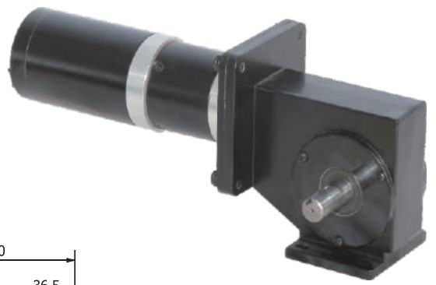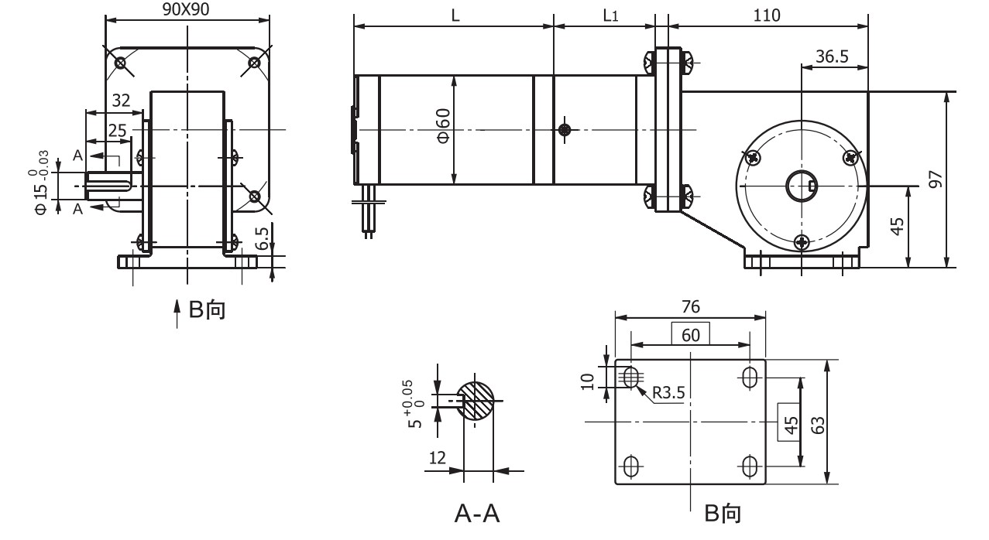
混合配置型，在蜗轮减速器的前面配置了 60JX 型的齿轮减速器、60ZY 的直流电机， 以增加总的传动比，获得更低的转速。总减速比是两种减速器减速比的乘积。
Mixed configuration, 60OD planetary gearbox and 600D PMDC motor are equipped at the front of worm gearbox to increase total drive ratio and achieve lower speed. Total ratio equals to the product of the two gear ratios.
- 外形和安装尺寸 Dimensions

说明：产品出厂时左出轴是常规配置，如要求右出轴需在订货时特别说明。
Remarks:Standard product is left output shaft, right output shaft is available upon request.

齿轮减速电机主要技术参数 Gear Motor Technical Data

额定转速 Rated speed (r/min) | 14 | 11 | 8 | 6 | 4 | 2
额定转矩 Rated torque (N.m) | 9 | 12 | 20 | 20 | 20 | 20
蜗轮减速器减速比  Worm Gearbox Ratio | 1:25 | 1:32 | 1:25 | 1:25 | 1:25 | 1:25
行星齿轮减速比  Planetary Gearbox Ratio | 1:4.25 | 1:4.25 | 1:13 | 1:18 | 1:15 | 1:47
总减速比  Combined Ratio | 1:106 | 1:136 | 1:325 | 1:450 | 1:375 | 1:1175
配置的电动机 DC motor | 60ZY105-2420 | 60ZY105-2420 | 60ZY105-2430 | 60ZY105-2430 | 60ZY105-2420 | 60ZY75-2430
电机长度 L (mm)  Motor Length | 110 | 110 | 110 | 110 | 110 | 80
行星减速器长度 L1 (mm)  Planetary Gearbox Length | 45.5 | 45.5 | 45.5 | 45.5 | 45.5 | 56.5

G-5

