永磁直流蜗轮减速电机 PM DC Worm Gear Motor
允许转矩范围:20N.m
Permissible Load Range: 20N.m
90JW/JB/80ZY115

产品特点和用途 Description of The Product
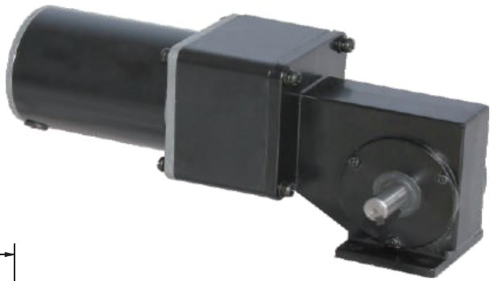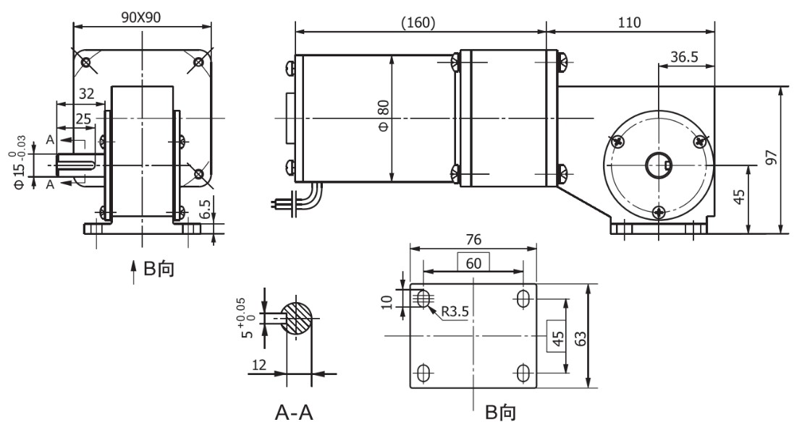混合配置型，在蜗轮减速器的前面配置了 1:10 的JB 型的齿轮减速器，以增加总的传动 比，获得更低的转速。总减速比是两种减速器减速比的乘积。
Mixed configuration, 1:10 eccentric shaft gearbox is equipped at the front of worm gearbox to increase total drive ratio and achieve lower speed. Total ratio equals to the product of the two gear ratios.
- 外形和安装尺
Dimensions

说明：产品出厂时左出轴是常规配置，如要求右出轴需在订货时特别说明。
Remarks:Standard product is left output shaft, right output shaft is available upon request.

电动机主要技术参数 Motor Technical Data

电机型号  Type | 额定电压Rated  voltage  VDC | 空载转速  No-load  speed  r/min | 空载电流No-load current  A | 额定转速Rated  speed  r/min | 额定转矩Rated Torque mN.m | 输出功率Output power  W | 额定电流Rated current  A | 堵转转矩Stall  torque  mN.m | 堵转电流Stall Current  A
80ZY115-1225 | 12 | 2500 | 1.5 | 2000 | 0.4 | 84 | 10 | 1.5 | 30

- 齿轮减速电机主要技术参数 Gear Motor Technical Data

配置 80ZY115-1225 直流电机(80ZY115-1225 DC motor)
减速比
Reduction ratio
125
160
250
蜗杆头数
Number of threads
2
2
1
空载转速
No-load speed
r/min
额定转速 Rated speed r/min
20
16
16
13
10
8
额定转矩 Rated torque N.m 16 20 20
允许转矩
Permissible load
N.m
40
40
40

G-4

