永磁直流蜗轮减速电机 PM DC Worm Gear Motor
允许转矩范围:20N.m
Permissible Load Range: 20N.m
90JW/83ZY125

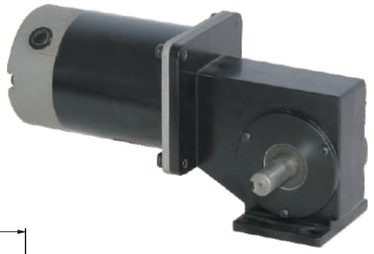
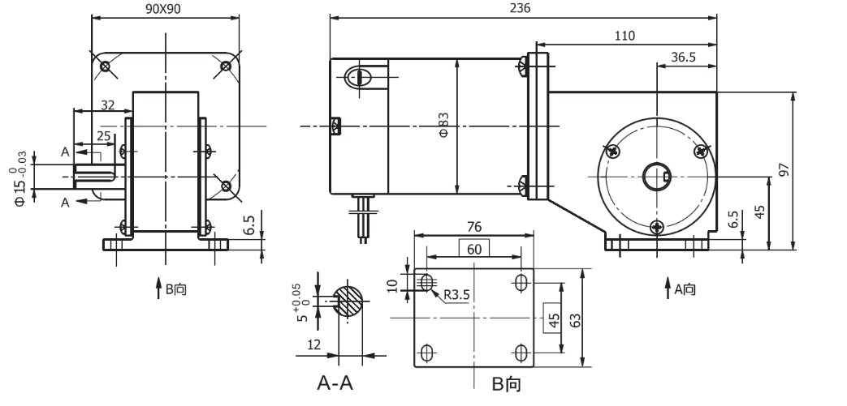
●
产品特点和用途 Description of The Product
1、全部滚动轴承的配置，可以提供左出轴、右出轴、空心出轴。
2、客户可以在空心出轴内自行配置各种长度、形状、方向的输出轴。
1、All equipped with ball bearings, left, right or hollow output shaft are available.
2、Customers can equip output shafts of different length, shape or directions within hollow shaft.

外形和安装尺寸 Dimensions

●

说明：产品出厂时左出轴是常规配置，如要求右出轴需在订货时特别说明。
Remarks:Standard product is left output shaft, right output shaft is available upon request.

电动机主要技术参数 Motor Technical Data
电机型号  Type | 额定电压Rated voltage VDC | 空载转速No-load speed r/min | 空载电流No-load current  A | 额定转速Rated speed r/min | 额定转矩Rated Torque mN.m | 输出功率Output power  W | 额定电流Rated current  A | 堵转转矩Stall torque mN.m | 堵转电流Stall Current  A
83ZY125-2420 | 24 | 2000 | 0.8 | 1700 | 0.24 | 42 | 3.5 | 1.6 | 17
83ZY125-2430 | 24 | 3000 | 0.9 | 2500 | 0.30 | 77 | 4.6 | 1.8 | 20

  - 齿轮减速电机主要技术参数 Gear Motor Technical Data
配置 83ZY125-2420 直流电机(83ZY125-2420 DC Motor)
减 速 比 Reduction ratio | 50 | 40 | 32 | 25 | 16 | 12.5
减速级数 Number of gear trains | 1 | 1 | 1 | 1 | 2 | 2
空载转速 No-load speed r/min | 40 | 50 | 62 | 80 | 125 | 160
额定转速 Rated speed r/min | 30 | 37 | 46 | 60 | 93 | 120
额定转矩 Rated torque N.m | 8.4 | 6.7 | 5.3 | 4.2 | 3.0 | 2.4
最大瞬间允许负载 N.m Max. permissible load in a short time | 20 | 20 | 20 | 20 | 10 | 10
配置 83ZY125-2430 直流电机(83ZY125-2430 DC Motor)

减 速 比 Reduction ratio | 50 | 40 | 32 | 25 | 16 | 12.5
减速级数 Number of gear trains | 1 | 1 | 1 | 1 | 2 | 2
空载转速 No-load speed r/min | 60 | 75 | 93 | 120 | 187 | 240
额定转速 Rated speed r/min | 46 | 57 | 71 | 92 | 143 | 184
额定转矩 Rated torque N.m | 10.5 | 8.4 | 6.7 | 5.2 | 3.8 | 3.0
最大瞬间允许负载 N.m Max. permissible load in a short time | 20 | 20 | 20 | 20 | 10 | 10

G-3

