永磁直流齿轮减速电机 PM DC Spur Gear Motor

Φ37 行星减速器,允许转矩范围:1.0N.m
37JBE10K/36ZY50 37mm OD Planetary Gearbox,
Permissible Load Range: 1.0N.m
- 外形和安装尺寸 Dimensions

电机型号  TYPE | 额定电压Rated voltage VDC | 空载转速  No-load  Speed r/min | 空载电流No-load current mA | 额定转速Rated Speed r/min | 额定转矩Rated torque  mN.m | 输出功率Output power  W | 额定电流Rated current mA | 堵转力矩Stall Torque  mN.m | 堵转电流Stall current  A
36ZY50-2436 | 24 | 3600 | 100 | 3000 | 11 | 3.4 | 0.40 | 58 | 1.7
36ZY50-2442 | 24 | 4200 | 120 | 3450 | 12 | 4.2 | 0.43 | 52 | 1.6

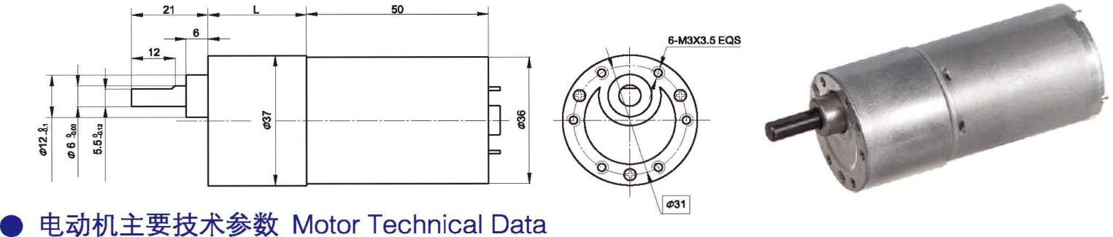
- 齿轮减速电机主要技术参数 Gear Motor Technical Data

- 电动机主要技术参数 Motor Technical Data
配置 36ZY50-2436 直流电机(36ZY50-2436 DC Motor)
减速比 Reduction ratio | 6 | 10 | 18 | 30 | 50 | 75 | 100 | 150 | 200 | 250
减速级数 Number of gear trains | 2 | 2 | 3 | 3 | 4 | 4 | 4 | 5 | 5 | 5
减速器长度(L) Length(L) mm | 21.5 | 21.5 | 26.5 | 26.5 | 29 | 29 | 29 | 31.5 | 31.5 | 31.5
空载转速 No-load speed r/min | 600 | 360 | 200 | 120 | 72 | 48 | 36 | 24 | 18 | 14
额定转速 Rated speed r/min | 500 | 300 | 167 | 100 | 60 | 40 | 30 | 20 | 15 | 12
额定转矩 Rated torque N.m | 0.06 | 0.09 | 0.14 | 0.24 | 0.40 | 0.50 | 0.67 | 1 | 1 | 1
最大瞬间负载 N.m Max. permissible load in a short time | 0.5 | 0.5 | 1 | 1 | 2 | 2 | 2 | 3 | 3 | 3
转向 Direction of rotation | CCW | CCW | CW | CW | CCW | CCW | CCW | CW | CW | CW

配置 36ZY50-2442 直流电机(36ZY50-2442 DC Motor)
Direction of rotation
转向
Max. permissible load in a short time
N.m
最大瞬间负载
额定转矩 Rated torque N.m
额定转速 Rated speed r/min
空载转速 No-load speed r/min
减速器长度(L) Length(L) mm
减速级数 Number of gear trains
减速比 Reduction ratio
CW
CW
CW
CCW
CCW
CCW
CW
CW
CCW
CCW
3
3
3
2
2
2
1
1
0.5
0.5
1
1
1
0.73
0.55
0.42
0.26
0.16
0.10
0.06
14
18
23
35
47
70
117
194
350
583
17
21
28
42
56
84
140
233
420
700
31.5
31.5
31.5
29
29
29
26.5
26.5
21.5
21.5
5
5
5
4
4
4
3
3
2
2
250
200
150
100
75
50
30
18
10
6

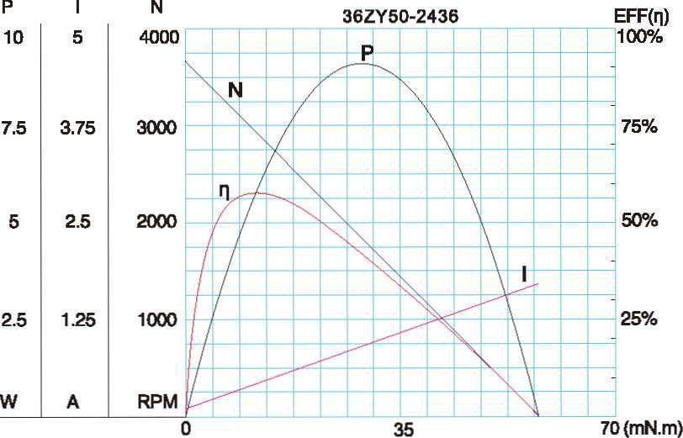
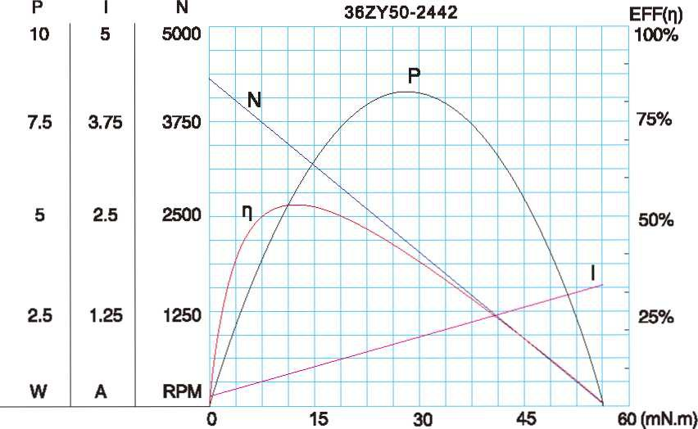
- 电动机特性图 Motor Characteristic Figure
F-4

