永磁直流齿轮减速电机 PM DC Spur Gear Motor
Φ37 行星减速器,允许转矩范围:0.6N.m

37JB6K/35ZY40

- 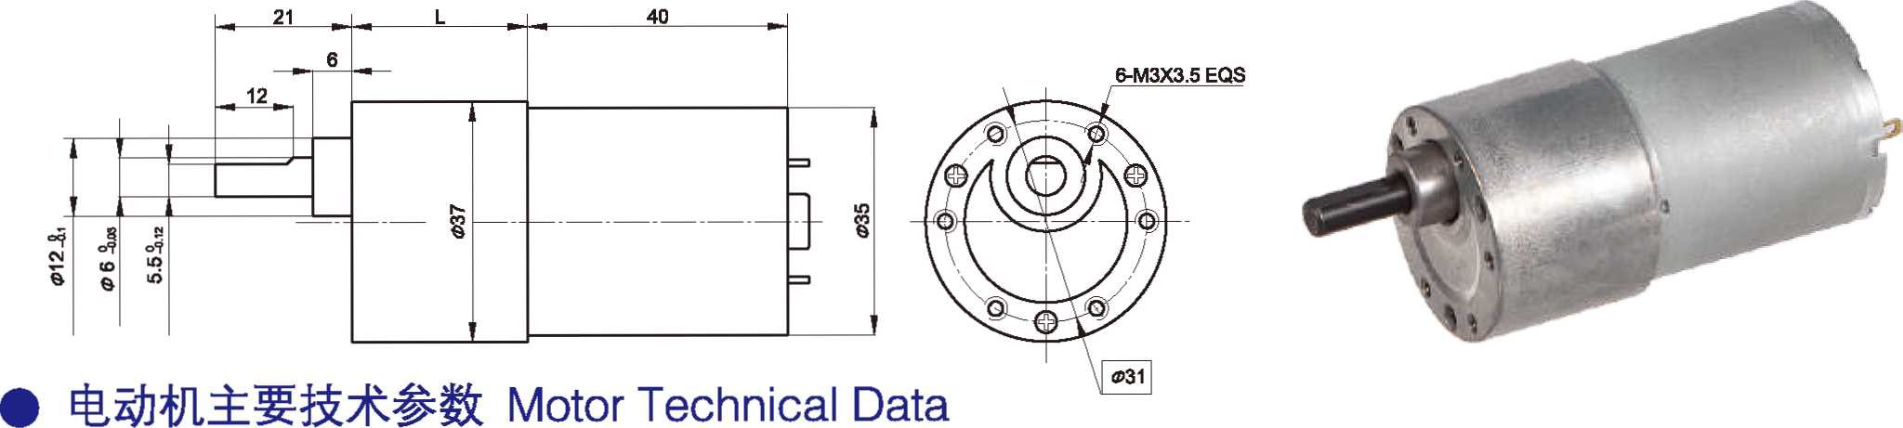外形和安装尺寸 Dimensions

- 电动机主要技术参数 Motor Technical Data
37mm OD Planetary Gearbox, Permissible Load Range: 0.6N.m

电机型号  TYPE | 额定电压Rated voltage  VDC | 空载转速No-load Speed r/min | 空载电流No-load current mA | 额定转速Rated Speed r/min | 额定转矩Rated torque  mN.m | 输出功率Output power  W | 额定电流Rated current mA | 堵转力矩Stall Torque  mN.m | 堵转电流Stall current  A
35ZY40-1230 | 12 | 3000 | 80 | 2300 | 7 | 2.1 | 400 | 22 | 0.8
35ZY40-1250 | 12 | 5000 | 100 | 4100 | 8 | 3.5 | 570 | 34 | 2.2

- 齿轮减速电机主要技术参数 Gear Motor Technical Data
配置 35ZY40-1230 直流电机(35ZY40-1230 DC Motor)
减速比 Reduction ratio | 6 | 10 | 18 | 30 | 50 | 75 | 100 | 150 | 200 | 250 | 300
减速级数 Number of gear trains | 2 | 2 | 3 | 3 | 4 | 4 | 4 | 5 | 5 | 5 | 5
减速器长度(L) Length(L) mm | 19 | 19 | 21.5 | 21.5 | 24 | 24 | 24 | 26.5 | 26.5 | 26.5 | 26.5
空载转速 No-load speed r/min | 500 | 300 | 167 | 100 | 60 | 40 | 30 | 20 | 15 | 12 | 10
额定转速 Rated speed r/min | 383 | 230 | 128 | 77 | 46 | 31 | 23 | 16 | 12 | 10 | 8.5
额定转矩 Rated torque N.m | 0.03 | 0.05 | 0.09 | 0.15 | 0.23 | 0.35 | 0.46 | 0.6 | 0.6 | 0.6 | 0.6
最大瞬间允许负载 N.m Max. permissible load in a short time | 0.3 | 0.3 | 0.6 | 0.6 | 1.2 | 1.2 | 1.2 | 1.8 | 1.8 | 1.8 | 1.8
转向 Direction of rotation | CCW | CCW | CW | CW | CCW | CCW | CCW | CW | CW | CW | CW

配置 35ZY40-1250 直流电机(35ZY40-1250 DC Motor)
减 速 比 Reduction ratio
减速级数 Number of gear train
减速器长度(L) Length(L) 空载转速 No-load speed 额定转速 Rated speed
额定转矩 Rated torque
最大瞬间允许负载
mm r/mi r/min N.m
N.m
6
2
19
833
683
0.04
10
2
19
500
410
0.06
18
3
21.5
278
228
0.11
30
3
21.5
167
137
0.18
50
4
24
100
82
0.26
75
4
24
67
55
0.39
100
4
24
50
41
0.52
150
5
26.5
33
28
0.6
200
5
26.5
25
23
0.6
250
5
26.5
20
18
0.6
300
5
26.5
17
16
0.6
Max. permissible load in a short time
0.3
0.3
0.6
0.6
1.2
1.2
1.2
1.8
1.8
1.8
1.8
转向
Direction of rotation
CCW CCW
CW
CW
CCW CCW CCW
CW
CW
CW
CW

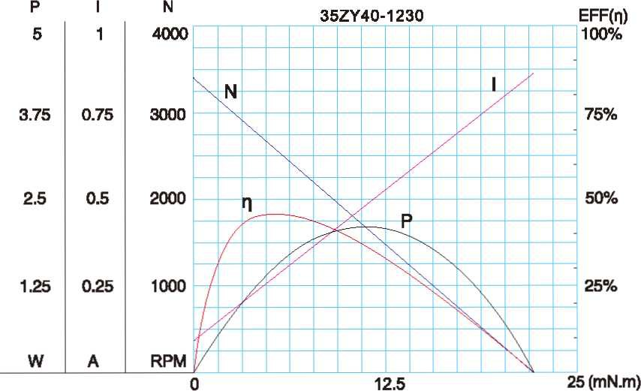
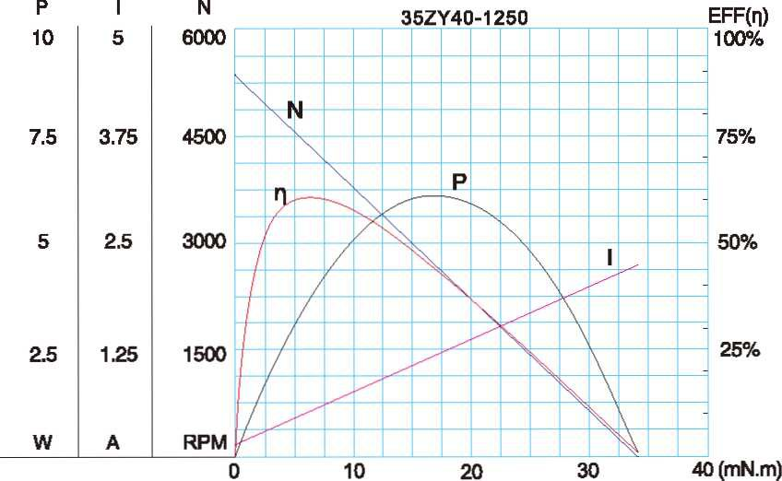
- 电动机特性图 Motor Characteristic Figure

F-3

