永磁直流齿轮减速电机 PM DC Spur Gear Motor
允许转矩范围:30N.m
Permissible Load Range: 30N.m
104JB300K/80ZY125

产品特点和用途 Description of The Product
口 104mm 的一体式齿轮减速器，允许负载 30N.m。合金结构钢齿轮，全部滚动轴承的配置。
口 104mm integrated gearbox, with rated torque up to 30.0 N.m, alloy constructional steel gears, all equipped with ball bearings.

外形和安装尺寸 Dimensions
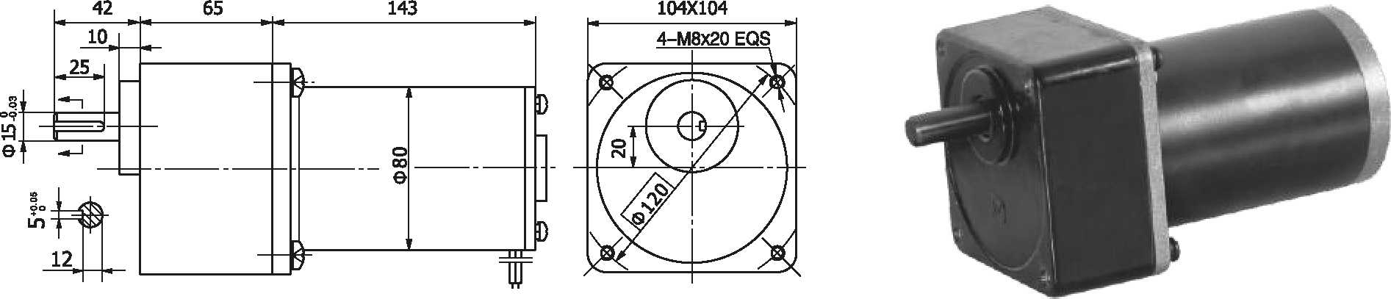
- 电动机主要技术参数 Motor Technical Data
电机型号  Type | 额定电压Rated voltage VDC | 空载转速No-load speed r/min | 空载电流No-load current  A | 额定转速Rated speed r/min | 额定转矩Rated Torque N.m | 输出功率Output power  W | 额定电流Rated current  A | 堵转转矩Stall Torque N.m | 堵转电流Stall current  A
80ZY125-2420 | 24 | 2000 | 0.5 | 1700 | 0.64 | 110 | 6 | 2.9 | 27
80ZY125-2435 | 24 | 3500 | 1.2 | 3000 | 0.70 | 200 | 10 | 3.2 | 45

齿轮减速电机主要技术参数 Gear Motor Technical Data
配置 80ZY125-2420 直流电 (80ZY125-2420 DC Motor)
减速比 Reduction ratio | 3 | 5 | 7.5 | 10 | 12.5 | 20 | 25 | 30 | 50 | 75
减速级数 Number of gear trains | 2 | 2 | 2 | 3 | 3 | 3 | 3 | 3 | 4 | 4
减速器长度(L) Length(L) mm | 65 | 65 | 65 | 65 | 65 | 65 | 65 | 65 | 65 | 65
空载转速 No-load speed r/min | 667 | 400 | 267 | 160 | 160 | 100 | 80 | 67 | 40 | 27
额定转速 Rated speed r/min | 567 | 340 | 227 | 136 | 136 | 85 | 68 | 57 | 34 | 23
额定转矩 Rated torque N.m | 1.6 | 2.6 | 3.9 | 4.8 | 5.8 | 9.3 | 12 | 14 | 23 | 25
最大瞬间允许负载 N.m  Max. permissible load in a short time | 10 | 10 | 10 | 30 | 30 | 30 | 30 | 30 | 60 | 60
转向 Direction of rotation | CW | CW | CW | CCW | CCW | CCW | CCW | CCW | CW | CW
配置 80ZY125-2435 直流电机 (80ZY125-2435 DC Motor)
减速比 Reduction ratio | 3 | 5 | 7.5 | 10 | 12.5 | 20 | 25 | 30 | 50 | 75
减速级数 Number of gear trains | 2 | 2 | 2 | 3 | 3 | 3 | 3 | 3 | 4 | 4
减速器长度(L) Length(L) mm | 65 | 65 | 65 | 65 | 65 | 65 | 65 | 65 | 65 | 65
空载转速 No-load speed r/min | 1167 | 700 | 467 | 350 | 280 | 175 | 140 | 117 | 70 | 47
额定转速 Rated speed r/min | 1000 | 600 | 400 | 300 | 240 | 150 | 120 | 100 | 60 | 40
额定转矩 Rated torque N.m | 1.9 | 3.2 | 4.3 | 5.1 | 6.4 | 10 | 13 | 15 | 26 | 30
最大瞬间允许负载 N.m Max. permissible load in a short time | 10 | 10 | 10 | 30 | 30 | 30 | 30 | 30 | 60 | 60
转向 Direction of rotation | CW | CW | CW | CCW | CCW | CCW | CCW | CCW | CW | CW
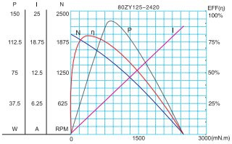
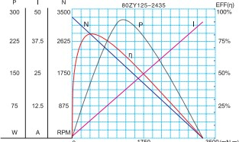
- 电动机特性图 Motor Characteristic Figure
F-15

