永磁直流齿轮减速电机 PM DC Spur Gear Motor
允许转矩范围:10N.m
Permissible Load Flange: 10N.m
80JB100K/80ZY115

产品特点和用途 Description of The Product
□80mm 的一体式齿轮减速器，允许负载 10.0N.m。合金结构钢齿轮，全部滚动轴承的配置。
□80mm integrated gearbox, with rated torque up to 10.0 N.m, alloy constructional steel gears, all equipped with ball bearings.

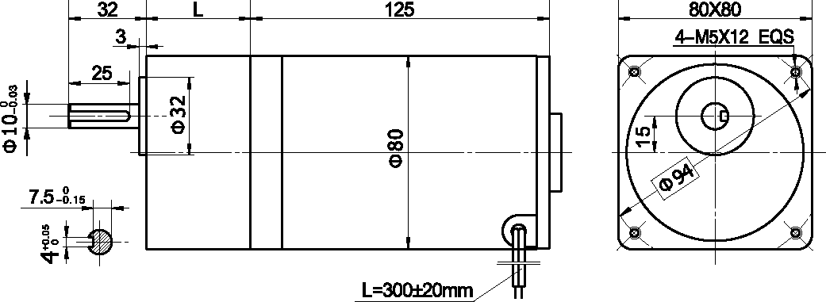
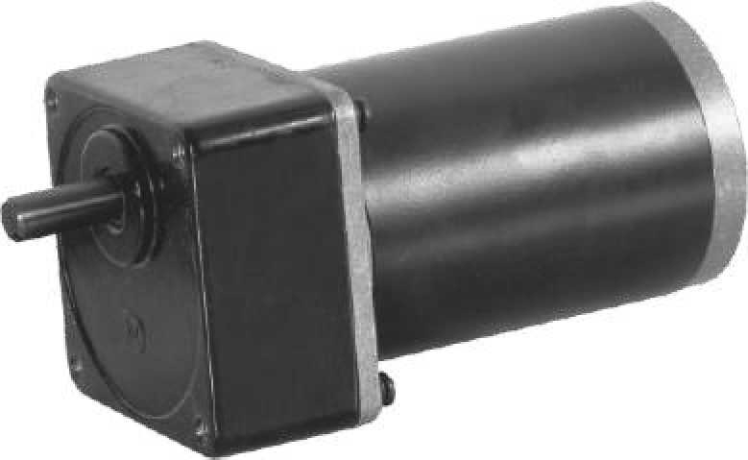
外形和安装尺寸 Dimensions
- 电动机主要技术参数 Motor Technical Data

电机型号  Type | 额定电压Rated voltage VDC | 空载转速No-load speed r/min | 空载电流No-load current  A | 额定转速Rated speed r/min | 额定转矩Rated Torque N.m | 输出功率Output power  W | 额定电流Rated current  A | 堵转转矩Stall Torque N.m | 堵转电流Stall current  A
80ZY115-2420 | 24 | 2000 | 0.3 | 1700 | 0.40 | 57 | 3.5 | 1.5 | 16
80ZY115-2430 | 24 | 3000 | 0.5 | 2600 | 0.44 | 120 | 7.5 | 2.0 | 33

- 齿轮减速电机主要技术参数 Gear Motor Technical Data
配置 80ZY115-2420 直流电机(80ZY115-2420 DC Motor)
减速比 | Reduction ratio |  | 3 | 5 | 7.5 | 10 | 12.5 | 15 | 25 | 30 | 50
减速级数 | Number of gear trains |  | 2 | 2 | 2 | 2 | 2 | 2 | 3 | 3 | 3
减速器长度(L) | Length(L) | mm | 32 | 32 | 32 | 32 | 32 | 32 | 43 | 43 | 43
空载转速 | No-load speed | r/min | 667 | 400 | 267 | 200 | 160 | 133 | 80 | 67 | 40
额定转速 | Rated speed | r/min | 567 | 340 | 227 | 170 | 136 | 113 | 68 | 57 | 34
额定转矩 | Rated torque | N.m | 0.97 | 1.6 | 2.4 | 3.2 | 4.0 | 4.8 | 7.3 | 8.7 | 10
最大瞬间允许负载  Max. permissible load in a short time |  | N.m | 15 | 15 | 15 | 15 | 15 | 15 | 30 | 30 | 30
转向 | Direction of rotation |  | CW | CW | CW | CW | CW | CW | CCW | CCW | CCW
配置 80ZY115-2430 直流电机(80ZY115-2430 DC Motor)
减 速 比 | Reduction ratio |  | 3 | 5 | 7.5 | 10 | 12.5 | 15 | 25 | 30 | 50
减速级数 | Number of gear trains |  | 2 | 2 | 2 | 2 | 2 | 2 | 3 | 3 | 3
减速器长度(L) | Length(L) | mm | 32 | 32 | 32 | 32 | 32 | 32 | 43 | 43 | 43
空载转速 | No-load speed | r/min | 1000 | 600 | 400 | 300 | 240 | 200 | 120 | 100 | 60
额定转速 | Rated speed | r/min | 800 | 520 | 347 | 260 | 208 | 173 | 104 | 87 | 52
额定转矩 | Rated torque | N.m | 1.0 | 1.8 | 2.7 | 3.6 | 4.5 | 5.4 | 8.2 | 9.8 | 10
最大瞬间允许负载  Max. permissible load in a short time |  | N.m | 15 | 15 | 15 | 15 | 15 | 15 | 30 | 30 | 30
转向 | Direction of rotation |  | CW | CW | CW | CW | CW | CW | CCW | CCW | CCW

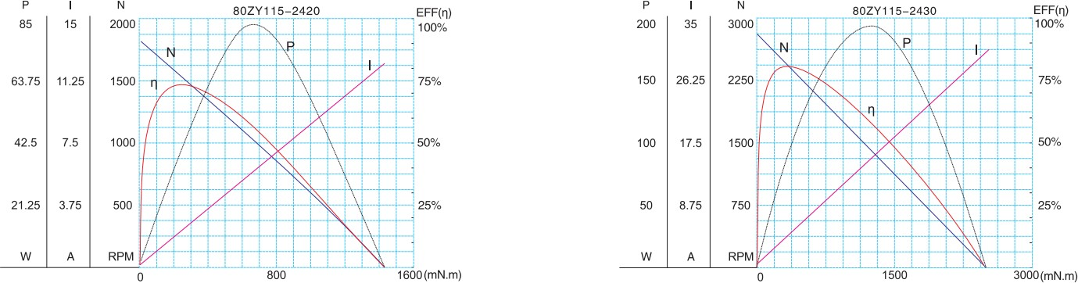
  - 电动机特性图 Motor Characteristic Figure
F-13

