永磁直流齿轮减速电机 PM DC Spur Gear Motor
允许转矩范围:8.0N.m
Permissible Load Range: 8.0N.m
70JB80K/60ZY105

产品特点和用途 Description of The Product
□70mm 的一体式齿轮减速器，允许负载 8.0N.m。合金结构钢齿轮，全部滚动轴承的配置。
□70mm integrated gearbox, with rated torque up to 8.0 N.m, alloy constructional steel gears, all equipped with ball bearings.

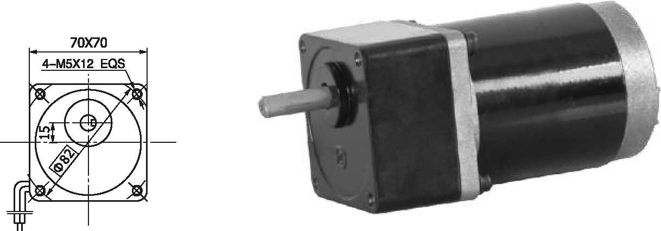
外形和安装尺寸 Dimensions
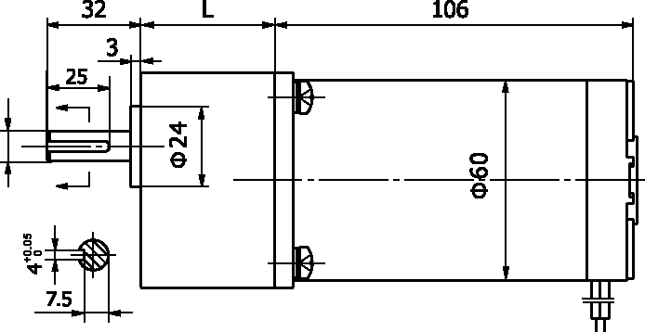
- 电动机主要技术参数 Motor Technical Data

电机型号  Type | 额定电压Rated voltage VDC | 空载转速No-load speed r/min | 空载电流No-load current  A | 额定转速Rated speed r/min | 额定转矩Rated Torque mN.m | 输出功率Output power  W | 额定电流Rated current  A | 堵转转矩Stall torque mN.m | 堵转电流Stall Current  A
60ZY105-2420 | 24 | 2000 | 0.25 | 1600 | 165 | 30 | 1.8 | 760 | 7.3
60ZY105-2430 | 24 | 3000 | 0.35 | 2400 | 180 | 45 | 2.2 | 790 | 11.2

- 齿轮减速电机主要技术参数 Gear Motor Technical Data

配置 60ZY105-2420 直流电机(60ZY105-2420 DC Motor)
减 速 比
减速级数空载转速额定转速
额定转矩
Reduction ratio Number of gear trains No-load speed
Rated speed
Rated torque
最大瞬间允许负载
Max. permissible load in a short time
r/min
r/min N.m
N.m
转向 Direction of rotation
50
3
40
32
6.0
8.0
CCW
60
4
33
26
6.5
16
CW
75
4
27
21
8.0
16
CW
90
4
22
18
8.0
16
CW
100
4
20
16
8.0
16
CW

配置 60ZY105-2430 直流电机(60ZY105-2430 DC Motor)
减 速 比
减速级数空载转速额定转速
额定转矩
Reduction ratio Number of gear trains No-load speed
Rated speed
Rated torque
最大瞬间允许负载
Max. permissible load in a short time
r/min
r/min N.m
N.m
50
3
60
48
6.5

8.0
60
4
50
40
7.8

16
75
4
40
32
8.0

16
90
4
33
26
8.0

16
100
4
30
24
8.0

16
转向 Direction of rotation CCW CW CW CW CW

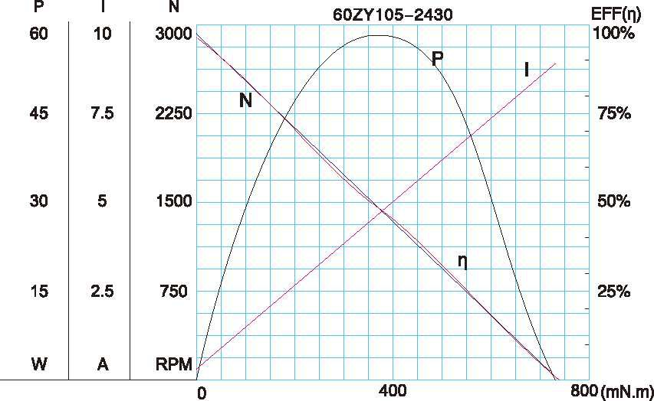
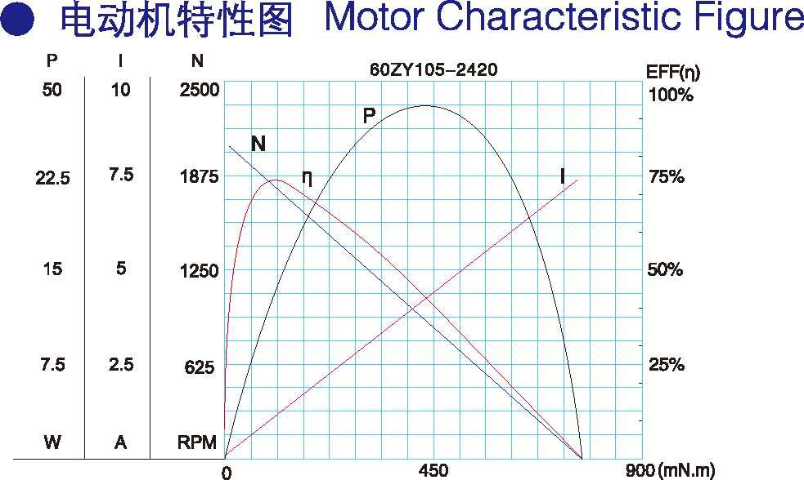F-11
- 电动机特性图 Motor Characteristic Figure

