永磁直流齿轮减速电机 PM DC Spur Gear Motor
Φ37 行星减速器,允许转矩范围:0.6N. m
37mm OD Planetary Gearbox,
Permissible Load Range: 0.6N.m

37JB6K/33ZY24
- 外形和安装尺寸 Dimensions

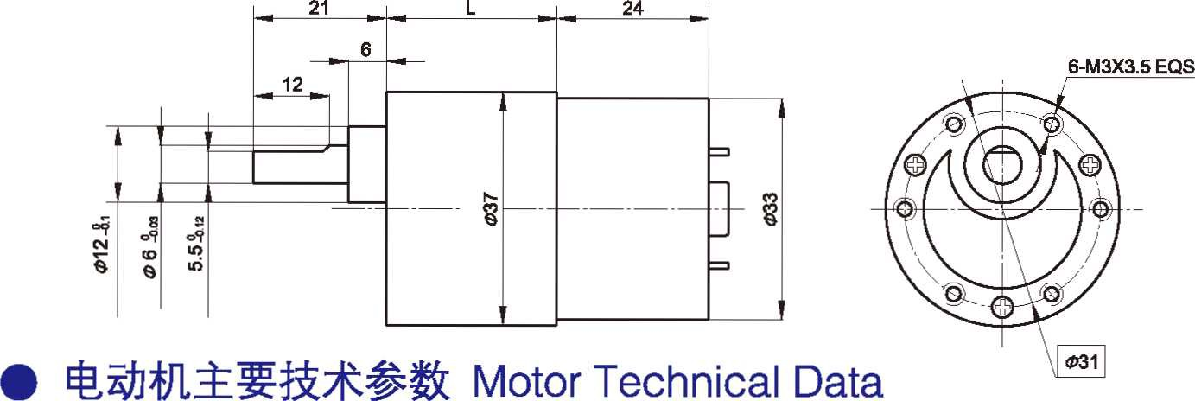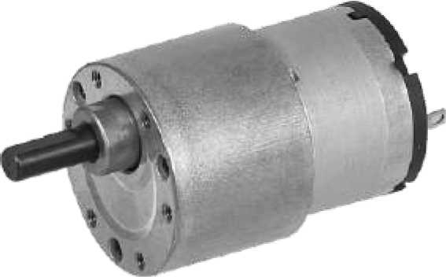

- 电动机主要技术参数 Motor Technical Data

电机型号  TYPE | 额定电压Rated voltage VDC | 空载转速No-load Speed r/min | 空载电流  No-load  current mA | 额定转速  Rated  Speed r/min | 额定转矩Rated torque mN.m | 输出功率Output power  W | 额定电流  Rated  current mA | 堵转力矩Stall Torque mN.m | 堵转电流Stall current  A
33ZY24-1230 | 12 | 3000 | 40 | 2300 | 2.5 | 0.59 | 100 | 10 | 0.26
33ZY24-2430 | 24 | 3000 | 20 | 2300 | 2.5 | 0.59 | 80 | 10 | 0.14

- 齿轮减速电机主要技术参数 Gear Motor Technical Data
配置 33ZY24-1230 直流电机(33ZY24-1230 DC Motor)
减速比 Reduction ratio | 18 | 30 | 50 | 75 | 100 | 150 | 200 | 250 | 300 | 400 | 500 | 750 | 1000 | 1500 | 3000
减速级数 Number of gear trains | 3 | 3 | 4 | 4 | 4 | 5 | 5 | 5 | 5 | 6 | 6 | 6 | 6 | 7 | 7
减速器长度(L) Length(L) mm | 21.5 | 21.5 | 24 | 24 | 24 | 26.5 | 26.5 | 26.5 | 26.5 | 29 | 29 | 29 | 29 | 31.5 | 31.5
空载转速 No-load speed r/min | 161 | 97 | 58 | 39 | 29 | 19 | 15 | 12 | 10 | 7.3 | 5.8 | 3.9 | 2.9 | 1.9 | 1.0
额定转速 Rated speed r/min | 122 | 73 | 44 | 29 | 22 | 15 | 11 | 8.8 | 7 | 5.5 | 4.5 | 3.1 | 2.4 | 1.7 | 0.8
额定转矩 Rated torque N.m | 0.03 | 0.05 | 0.08 | 0.12 | 0.16 | 0.22 | 0.30 | 0.37 | 0.44 | 0.53 | 0.6 | 0.6 | 0.6 | 0.6 | 0.6
最大瞬间允许负载 N.m Max. permissible load in a short time | 0.6 | 0.6 | 1.2 | 1.2 | 1.2 | 1.8 | 1.8 | 1.8 | 1.8 | 1.8 | 1.8 | 1.8 | 1.8 | 1.8 | 1.8
转向 Direction of rotation | CW | CW | CCW | CCW | CCW | CW | CW | CW | CW | CCW | CCW | CCW | CCW | CW | CW

配置 33ZY24-2430 直流电机(33ZY24-2430 DC Motor)
减速比 Reduction ratio | 18 | 30 | 50 | 75 | 100 | 150 | 200 | 250 | 300 | 400 | 500 | 750 | 1000 | 1500 | 3000
减速级数 Number of gear trains | 3 | 3 | 4 | 4 | 4 | 5 | 5 | 5 | 5 | 6 | 6 | 6 | 6 | 7 | 7
减速器长度(L) Length(L) mm | 21.5 | 21.5 | 24 | 24 | 24 | 26.5 | 26.5 | 26.5 | 26.5 | 29 | 29 | 29 | 29 | 31.5 | 31.5
空载转速 No-load speed r/min | 167 | 100 | 60 | 40 | 30 | 20 | 15 | 12 | 10 | 7.5 | 6 | 4 | 3 | 2 | 1
额定转速 Rated speed r/min | 128 | 77 | 46 | 31 | 23 | 15 | 12 | 9.2 | 7.7 | 5.9 | 4.8 | 3.3 | 2.5 | 1.7 | 0.9
额定转矩 Rated torque N.m | 0.04 | 0.06 | 0.10 | 0.14 | 0.18 | 0.27 | 0.37 | 0.41 | 0.49 | 0.6 | 0.6 | 0.6 | 0.6 | 0.6 | 0.6
最大瞬间允许负载 N.m Max. permissible load in a short time | 0.6 | 0.6 | 1.2 | 1.2 | 1.2 | 1.8 | 1.8 | 1.8 | 1.8 | 1.8 | 1.8 | 1.8 | 1.8 | 1.8 | 1.8
转向 Direction of rotation | CW | CW | CCW | CCW | CCW | CW | CW | CW | CW | CCW | CCW | CCW | CCW | CW | CW

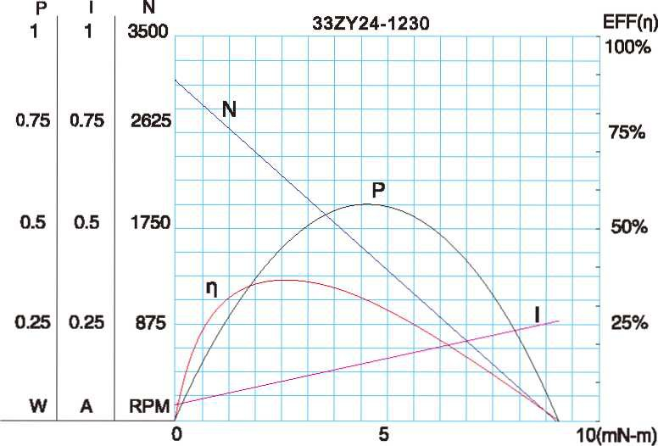
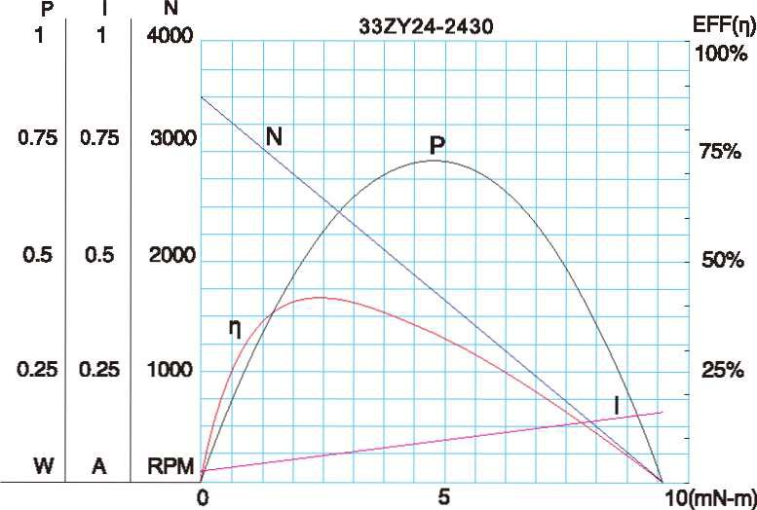
- 电动机特性图 Motor Characteristic Figure

F-1

