混合式步进行星齿轮减速电机（内齿圈材质:金属）
Planetary Gear Stepping Motor (Ring Gear Material: Metal)
Φ56 标准型减速器(带油封),允许转矩范围:9.0N.m~30N.m
56JXS300K/57STH 56mm OD Standard Gearbox(With Oil Seal),
Permissible Load Range: 9.0N.m~30N.m

行星齿轮减速器 Planetary Gearbox
内齿圈材料 | Ring material | 金属Metal
输出轴轴承形式 | Bearing at output | 滚动轴承Ball bearings
最大允许径向负载（离法兰 10mm 处）  Max. Radial load（10mm from flange） |  | ≤250N
最大允许轴向负载Max. shaft axial load |  | ≤100N
径向间隙（测量点尽量接近法兰）  Radial play of shaft （near to flange） |  | ≤ 0.08 mm
轴向间隙 | Axial play of shaft | ≤0.4 mm
背隙（无负载时）Backlash at no-load |  | ≤1.5°
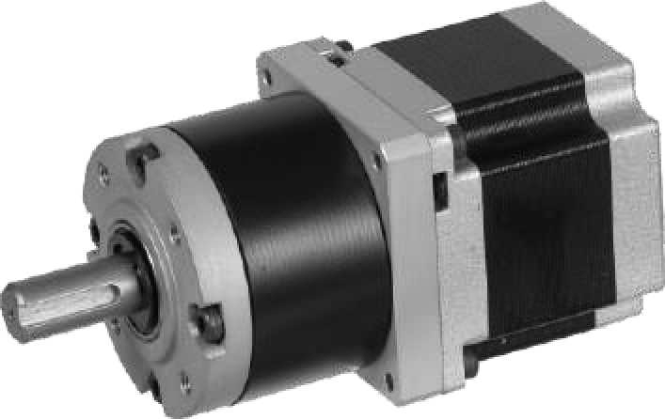
- 57STH 大转矩混合式步进电机性能 57STH High Torque Hybrid Stepping Motor Specifications
Model No. | 额定电压Rated Voltage | 每相电流  Current  /Phase | 每相电阻  Resistance  /Phase | 电感  Inductance  /Phase | 保持转矩Holding Torgue | 引出线数# of Leads | 转动惯量Rotor Inertia | 重 量  Weight | 长度L1 Length L1 | 适配减速比Max. Gear Ratio | Model No.
单轴 Single Shaft | V | A | 0 | mH | Kg.cm |  | g-m² | Kg | mm | Kg-cm
57STH41-1006A | 5.7 | 1 | 5.7 | 5.4 | 3.9 | 6 | 120 | 0.45 | 41 | 0.21 | 1:326
57STH41-2006A | 2.8 | 2 | 1.4 | 1.4 | 3.9 | 6 |  |  |  |  | 1:326
57STH41-3006A | 1.9 | 3 | 0.63 | 0.6 | 3.9 | 6 |  |  |  |  | 1:326
57STH41-2804A | 2 | 2.8 | 0.7 | 1.4 | 5.5 | 4 |  |  |  |  | 1:234
57STH51-1006A | 6.6 | 1 | 6.6 | 8.2 | 7.2 | 6 | 275 | 0.65 | 51 | 0.36 | 1:168
57STH51-2006A | 3.3 | 2 | 1.65 | 2.2 | 7.2 | 6 |  |  |  |  | 1:168
57STH51-3006A | 2.2 | 3 | 0.74 | 0.9 | 7.2 | 6 |  |  |  |  | 1:168
57STH51-2804A | 2.3 | 2.8 | 0.83 | 2.2 | 10.1 | 4 |  |  |  |  | 1:77
57STH56-1006A | 7.4 | 1 | 7.4 | 10 | 9.0 | 6 | 300 | 0.7 | 56 | 0.4 | 1:77
57STH56-2006A | 3.6 | 2 | 1.8 | 2.5 | 9.0 | 6 |  |  |  |  | 1:77
57STH56-3006A | 2.3 | 3 | 0.75 | 1.1 | 9.0 | 6 |  |  |  |  | 1:77
57STH56-2804A | 2.5 | 2.8 | 0.9 | 2.5 | 12.6 | 4 |  |  |  |  | 1:77
- 56JXS300K 行星齿轮减速器性能 56JXS300K Planetary Gearbox Specifications
分加强型、长寿命型两种型号 2 Types:Reinforced or Long Life Gearbox

减速比 Reduction ratio | 3.60 | 4.25 | 7.5 | 13 | 15 | 18 | 27 | 32 | 47 | 55 | 65 | 77 | 168 | 198 | 234 | 276 | 326
减速级数 Number of gear trains | 1 |  |  | 2 |  |  |  |  | 3 |  |  |  | 4
减速器长度(L2) Length(L2) mm | 53 |  |  | 61 |  |  |  |  | 72 |  |  |  | 84
最大额定转矩 kg. cm  Max. rated torque | 90 |  |  | 150 |  |  |  |  | 240 |  |  |  | 300
瞬间允许转矩 kg.cm  Short time permissible torque | 270 |  |  | 450 |  |  |  |  | 720 |  |  |  | 900
效率 Efficiency % | 90% |  |  | 81% |  |  |  |  | 73% |  |  |  | 66%
重量 Weight g | 640 |  |  | 710 |  |  |  |  | 880 |  |  |  | 1220

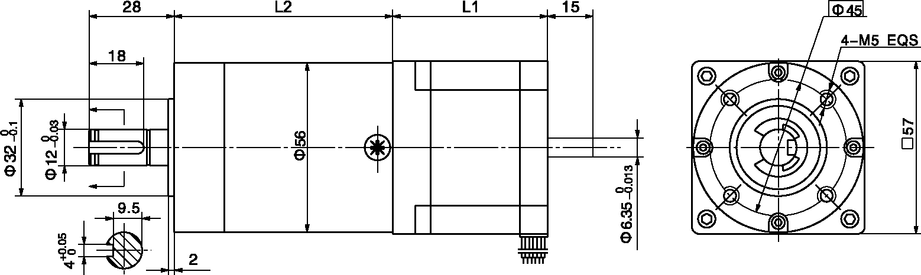
外形和安装尺寸 Dimensions

