混合式步进行星齿轮减速电机（内齿圈材质:金属）
Planetary Gear Stepping Motor (Ring Gear Material: Metal)
42JXGTS200K/42STH

Φ42行星减速器,允许转矩范围:6N.m~20N.m
42mm Planetary Gearbox
Permissible Load Range: 6N.m~20N.m

- 行星齿轮减速器 Planetary Gearbox
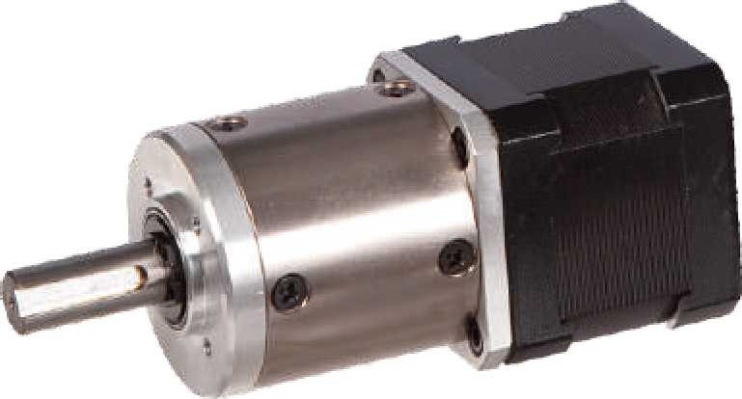
内齿圈材料 | Ring material | 金属Metal
输出轴轴承形式 | Bearing at output | 滚动轴承Ball bearings
最大允许径向负载（离法兰 12mm 处）  Max. Radial load（12mm from flange） |  | ≤80N
最大允许轴向负载Max. shaft axial load |  | ≤30N
径向间隙（测量点尽量接近法兰）  Radial play of shaft （near to flange） |  | ≤0.06 mm
轴向间隙 | Axial play of shaft | ≤0.3 mm
背隙（无负载时）Backlash at no-load |  | ≤1.5°

- 42STH 混合式步进电机性能 42STH Hybrid Stepping Motor Specifications
Model No. | 额定电压Rated Voltage | 每相电流  Current  /Phase | 每相电阻  Resistance  /Phase | 电感  Inductance  /Phase | 保持转矩Holding Torgue | 引出线数# of Leads | 转动惯量Rotor Inertia | 重 量  Weight | 长度L1 Length L1 | 适配减速比Max. Gear Ratio
单轴 Single Shaft | V | A | Ω | mH | g.cm |  | g-m² | g | mm
42STH38-1684A | 2.8 | 1.68 | 1.65 | 3.2 | 3.6 | 4 | 54 | 0.28 | 40 | ≤ 1:247
42STH47-1684A | 2.8 | 1.68 | 1.65 | 2.8 | 4.4 | 4 | 68 | 0.35 | 48 | ≤1:106
常规产品是单出轴，可以订货双出轴，型号的后缀号A 改为B。A Single Shaft, B Double shaft

- 40JXGTS200K 行星减速器性能 40JXGTS200K Planetary Gearbox Specifications
减速比 Reduction ratio | 4.44 | 17 | 22 | 65 | 83 | 106 | 247 | 316 | 403 | 515
减速级数 Number of gear trains | 1 | 2 |  | 3 |  |  | 4
减速器长度(L2) Length(L2) mm | 38.2 | 49.7 |  | 60.0 |  |  | 70.3
最大额定转矩 kg. cm  Max. rated torque | 60 | 100 |  | 160 |  |  | 200
瞬间允许转矩 kg.cm  Short time permissible torque | 180 | 300 |  | 480 |  |  | 600
效率 Efficiency % | 90% | 81% |  | 73% |  |  | 66%
重量 Weight g | 350 | 450 |  | 550 |  |  | 650
- 外形和安装尺寸 Dimensions
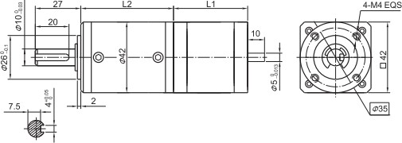
- 矩频曲线 Frequency-torque Characteristics
