混合式步进行星齿轮减速电机（内齿圈材质:金属）
Planetary Gear Stepping Motor （Ring Gear Material: Metal）
42 行星减速器,允许转矩范围：3N.m~10N.m
42JX150K/42STH 42mm OD Reinforced Gearbox,
Permissible Load Range: 3N.m~10N.m
- 行星齿轮减速器 Planetary Gearbox
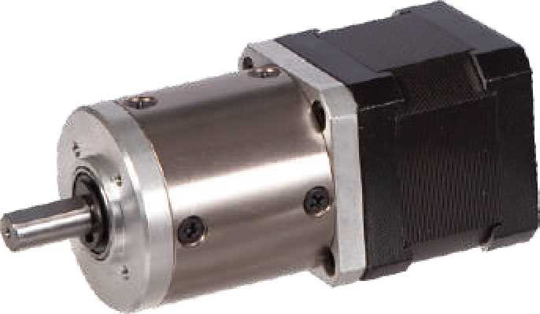
内齿圈材料 Ring material | 金属Metal
输出轴轴承形式 Bearing at output | 滚动轴承Ball bearings
最大允许径向负载 （离法兰 10mm 处）  Max. Radial load （10mm from flange） | ≤80N
最大允许轴向负载Max. shaft axial load | ≤30N
径向间隙 （测量点尽量接近法兰）  Radial play of shaft （near to flange） | ≤0.06nn
轴向间隙 Axial play of shaft | ≤0.3 mm
背隙（无负载时）Backlash at no-load | ≤1.5°

- 42STH 混合式步进电机性能 42STH Hybrid Stepping Motor Specifications
Model No. | 额定电压Rated Voltage | 每相电流  Current  /Phase | 每相电阻  Resistance  /Phase | 电感  Inductance  /Phase | 保持转矩Holding Torgue | 引出线数# of Leads | 转动惯量Rotor Inertia | 重 量  Weight | 长度L1 Length L1 | 适配减速比Max. Gear Ratio
单轴 Single Shaft | V | A | Ω | mH | g.cm |  | g-m² | g | mm
42STH33-0956A | 4 | 0.95 | 4.2 | 2.5 | 1.6 | 6 | 35 | 0.22 | 34 | ≤ 1:264
42STH33-0406A | 9.6 | 0.4 | 24 | 15 | 1.6 | 6 | 35 | 0.22 | 34 | ≤ 1:264
42STH33-0316A | 12 | 0.31 | 38.5 | 21 | 1.6 | 6 | 35 | 0.22 | 34 | ≤1:264
42STH33-1334A | 2.8 | 1.33 | 2.1 | 2.5 | 2.2 | 4 | 35 | 0.22 | 34 | ≤1:189
42STH38-1206A | 4 | 1.2 | 3.3 | 3.2 | 2.6 | 6 | 54 | 0.28 | 40 | ≤1:100
42STH38-0806A | 6 | 0.8 | 7.5 | 6.7 | 2.6 | 6 | 54 | 0.28 | 40 | ≤1:100
42STH38-0406A | 12 | 0.4 | 30 | 30 | 2.6 | 6 | 54 | 0.28 | 40 | ≤1:100
42STH38-1684A | 2.8 | 1.68 | 1.65 | 3.2 | 3.6 | 4 | 54 | 0.28 | 40 | ≤1:71
常规产品是单出轴，可以订货双出轴，型号的后缀号A 改为B。A Single Shaft, B Double shaft

- 42JX150K 行星减速器性能 42JX150K Planetary Gearbox Specifications
减速比 Reduction ratio | 3.5 | 14 | 17 | 21 | 49 | 61 | 84 | 104 | 126 | 172 | 212 | 294
减速级数 Number of gear trains | 1 | 2 |  |  | 3 |  |  |  |  | 4
减速器长度(L2) Length(L2) mm | 32.5 | 39.2 |  |  | 45.9 |  |  |  |  | 52.6
最大额定转矩 kg. cm  Max. rated torque | 30 | 50 |  |  | 90 |  |  |  |  | 150
瞬间允许转矩 kg.cm  Short time permissible torque | 90 | 150 |  |  | 270 |  |  |  |  | 450
效率 Efficiency % | 90% | 81% |  |  | 73% |  |  |  |  | 66%
重量 Weight g | 320 | 420 |  |  | 520 |  |  |  |  | 620

- 外形和安装尺寸 Dimensions
