混合式步进行星齿轮减速电机（内齿圈材质:金属）
Planetary Gear Stepping Motor (Ring Gear Material: Metal)

28JXS40K/28STH
Φ28 行星减速器,允许转矩范围:1.2N.m~4.0N.m 28mm Planetary Gearbox
Permissible Load Range: 1.2N.m~4.0N.m

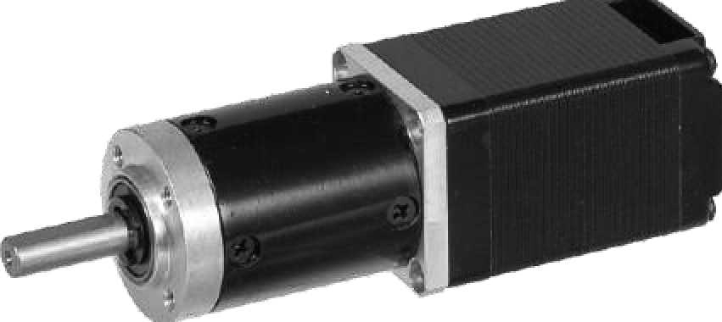
- 行星齿轮减速器 Planetary Gearbox
内齿圈材料 Ring material | 金属Metal
输出轴轴承形式 Bearing at output | 滚动轴承Ball bearings
最大允许径向负载 （离法兰 10mm 处）  Max. Radial load （10mm from flange） | 35N
最大允许轴向负载 Max. shaft axial load | 25N
径向间隙 （测量点尽量接近法兰）  Radial play of shaft （near to flange） | 0.07mm
轴向间隙 Axial play of shaft | ≤0.3 mm
背隙（无负载时） Backlash at no-load | 1.5°

- 28STH 混合式步进电机性能 28STH Hybrid Stepping Motor Specifications
Model No. | 额定电压Rated Voltage | 每相电流  Current  /Phase | 每相电阻  Resistance  /Phase | 电感  Inductance  /Phase | 保持转矩Holding Torgue | 引出线数# of Leads | 转动惯量Rotor Inertia | 重 量  Weight | 长度L1 Length L1 | 适配减速比Max. Gear Ratio
单轴 Single Shaft | V | A | Ω | mH | g.cm |  | g-m² | g | mm
28STH45-0956A | 3.4 | 0.95 | 3.4 | 1.2 | 750 | 6 | 12 | 44.5 | 44.5 | ≤1:189
28STH51-0956A | 4.4 | 0.95 | 4.6 | 1.8 | 900 | 6 | 18 | 50.5 | 50.5 | ≤1:189
常规产品是单出轴，可以订货双出轴，型号的后缀号A 改为B。A Single Shaft, B Double shaft
- 28JXS40K 行星减速器，性能 28JXS40K Planetary Gearbox Specifications
减速比 Reduction ratio | 3.71 | 5.18 | 14 | 19 | 27 | 51 | 71 | 100 | 139 | 189 | 264 | 369
减速级数 Number of gear trains | 1 |  | 2 |  |  | 3 |  |  |  | 4
减速器长度(L2) Length(L2) mm | 31.0 |  | 40.1 |  |  | 49.0 |  |  |  | 57.9
最大额定转矩 kg. cm  Max. rated torque | 12 |  | 20 |  |  | 32 |  |  |  | 40
瞬间允许转矩 kg.cm  Short time permissible torque | 36 |  | 60 |  |  | 96 |  |  |  | 120
效率 Efficiency % | 90% |  | 81% |  |  | 73% |  |  |  | 66%
重量 Weight g | 60 |  | 85 |  |  | 95 |  |  |  | 110

- 外形和安装尺寸 Dimensions

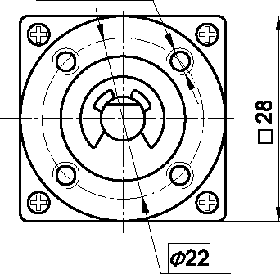
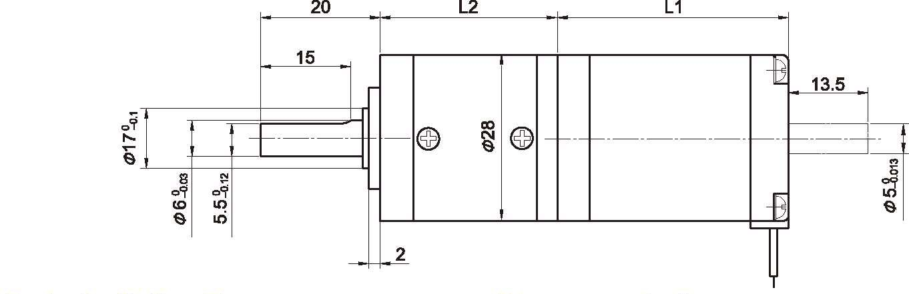4-M3 EQS

矩频曲线 Frequency-torque Characteristics
●

