无刷直流行星齿轮减速电机(内齿圈材质:金属)
LDC Planetary Gear Motor (Ring Gear Material: Metal)
42JX150K/42ZWNP66
Φ42行星减速器,允许转矩范围:2N.m~15N.m
42mm OD Planetary Gearbox,
Permissible Load Range:2N.m~15N.m

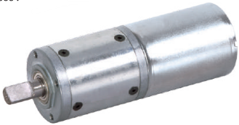
无刷直流电动机，3相 10极，外置驱动器 3 phase 10 poles brushless DC motor, with external driver

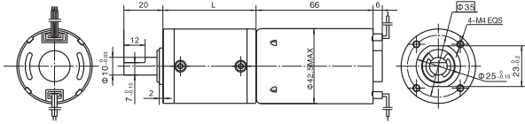
- 外观和安装尺寸 Dimensions

- 无刷电动机主要技术参数Brushless Motor Technical Data
电机型号  TYPE | 极数  Number  of poles | 相数  Number  of phase | 额定电压  Rated  voltage  VDC | 空载转速  No-load  speed  r/min | 额定转速  Rated  speed  r/min | 额定转矩  Rated  torque  mN.m | 额定电流  Rated  current  A | 输出功率  Output  power  W
42ZWNP66-2430 | 10 | 3 | 24 | 3000 | 2550 | 80 | 1.1 | 21

- 无刷行星齿轮减速电机主要技术参数Brushless Gear Motor Technical Data
- 无刷行星齿轮减速电机主要技术参数Brushless Gear Motor Technical Data
配置42ZWNP66-2430无刷直流电机(42ZWNP66-2430 BLDC Motor)
减速比 Reduction ratio | 3.5 | 14 | 21 | 49 | 84 | 104 | 126 | 156 | 172 | 196 | 212 | 294
减速级数 Number of gear trains | 1 | 2 | 2 | 3 | 3 | 3 | 3 | 4 | 4 | 4 | 4 | 4
减速器长度(L) Length(L) mm | 32.5 | 39.2 | 39.2 | 46 | 46 | 46 | 46 | 52.5 | 52.5 | 52.5 | 52.5 | 52.5
空载速度 No-load speed r/min | 857 | 214 | 143 | 61 | 36 | 29 | 24 | 19 | 17 | 15 | 14 | 10
额定转速 Rated speed rAnin | 728 | 182 | 121 | 52 | 30 | 24 | 20 | 16 | 15 | 13 | 12 | 8
额定转矩 Rated torque N.m | 0.25 | 0.9 | 1.3 | 2.8 | 4.9 | 6.0 | 7.3 | 8.2 | 9.0 | 10.3 | 11.2 | 15.6
最大瞬间允许负载 N.m  Max. permissible load in a short time | 3 | 12 | 12 | 25 | 25 | 25 | 25 | 30 | 30 | 30 | 30 | 30

- 接线方式Wire Diagram

U | V | W | Vcc | Ha | Hb | He | GND
灰 | 棕 | 白 | 红 | 黄 | 蓝 | 绿 | 黑
Grey | Brown | White | Red | Yellow | Blue | Green | Black

(Green ) PWM 绿色(Green)
- FG 绿色(Green )

