无刷直流行星齿轮减速电机 (内齿圈材质:金属)
无刷直流行星齿轮减速电机(内齿圈材质:金属和粉末金属)
BLDC Planetary Gear Motor (Ring Gear Material: Metal and Powder Metal)
36JXE30K/36ZWNP57

Φ36行星减速器,允许转矩范围:0.3N.m~3N.m
36mm OD Planetary Gearbox,
Permissible Load Range: 0.3N.m

无刷直流电动机，3相4极，外置驱动器 3 phase 4 poles brushless DC motor, with external driver
可在两种材质的内齿圈中进行选择：粉末金属(型号36JXF30K),金属(型号36JXE30K)
Ring gear can be selected within the two materials: Powder metal (Type: 36JXF30K) , Metal (Type: 36JXE30K)

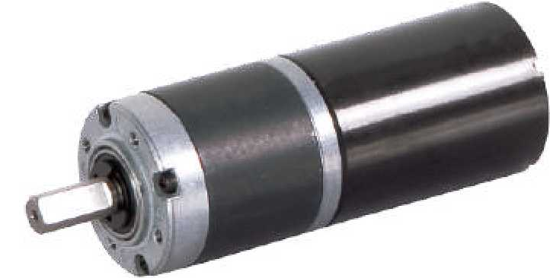
- 外形和安装尺寸Dimensions

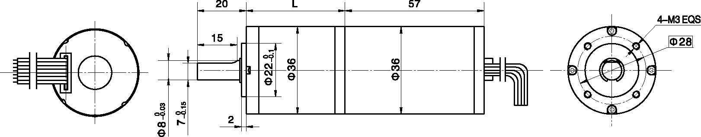

- 无刷电动机主要技术参数Brushless Motor Technical Data
电机型号  TYPE | 极数  Number  of poles | 相数  Number  of phase | 额定电压  Rated  voltage  VDC | 空载转速  No-load  speed  r/min | 额定转速  Rated  speed  r/min | 额定转矩  Rated  torque  mN.m | 额定功率  Rated  Power  W | 额定电流  Rated  current  mA
36ZWNP57-2450 | 4 | 3 | 24 | 5000 | 4200 | 40 | 18 | 257
  - 无刷行星齿轮减速电机主要技术参数Brushless Gear Motor Technical Data
配置36ZWNP57-2450无刷直流电机(36ZWNP57-2450 BLDC Motor)
减速比 Reduction ratio | 3.7 | 5.2 | 14 | 19 | 27 | 51 | 71 | 100 | 139 | 189
减速级数 Number of gear trains | 1 | 1 | 2 | 2 | 2 | 3 | 3 | 3 | 3 | 4
减速器长度(L) Length(L) mm | 26.5 | 26.5 | 33.6 | 33.6 | 33.6 | 40.5 | 40.5 | 40.5 | 40.5 | 47.4
空载速度 No-load speed r/min | 1348 | 965 | 357 | 263 | 185 | 98 | 70 | 50 | 36 | 26
额定转速 Rated speed rAnin | 1132 | 811 | 300 | 221 | 156 | 82 | 59 | 42 | 30 | 22
额定转矩 Rated torque N.m | 0.13 | 0.19 | 0.45 | 0.62 | 0.87 | 1.5 | 2.1 | 2.9 | 3 | 3
最大瞬间允许负载 N.m  Max. permissible load in a short time | 1.0 | 1.0 | 3.5 | 3.5 | 3.5 | 7.5 | 7.5 | 7.5 | 7.5 | 9

- 接线方式Wire Diagram

U | V | W | Vcc | Ha | Hb | He | GND
灰  Grey | 棕  Brown | 白  White | 红  Red | 黄  Yellow | 蓝  Blue | 绿  Green | 黑  Black
26AWG UL 1007

蓝色肩舌脉冲输出，电机每转一周为5个脉冲输出RBK绿色(Green ) PWM 绿色(Green)
- FG 绿色(Green )

