无刷直流行星齿轮减速电机 (内齿圈材质:金属和粉末金属)
BLDC Planetary Gear Motor (Fling Gear Material: Metal and Powder Metal)
36JXE30K/36ZWNP57
Φ36行星减速器,允许转矩范围:0.3N.m~3N.m
36mm OD Planetary Gearbox,
Permissible Load Range: 0.3N.m

无刷直流电动机，3相4极，内置驱动器 3 phase 4 poles brushless DC motor, with built-in driver
可在两种材质的内齿圈中进行选择：粉末金属(型号36JXF30K),金属(型号36JXE30K)
Ring gear can be selected within the two materials: Powder metal (Type: 36JXF30K) , Metal (Type: 36JXE30K)
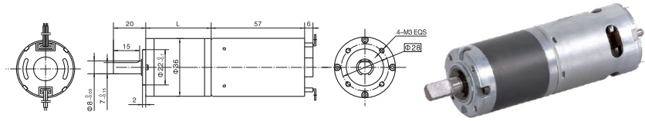
- 外形和安装尺寸Dimensions
- 无刷电动机主要技术参数Brushless Motor Technical Data
电机型号  TYPE | 极数  Number  of poles | 相数  Number  of phase | 额定电压  Rated  voltage  VDC | 空载转速  No-load  speed  r/min | 额定转速  Rated  speed  r/min | 额定转矩  Rated  torque  mN.m | 额定功率  Rated  Power  W | 额定电流  Rated  current  mA
36ZWNP57-2450 | 4 | 3 | 24 | 5000 | 4200 | 40 | 18 | 257
- 无刷行星齿轮减速电机主要技术参数Brushless Gear Motor Technical Data
配置36ZWNP57-2450无刷直流电机(36ZWNP57-2450 BLDC Motor)
减速比 Reduction ratio | 3.7 | 5.2 | 14 | 19 | 27 | 51 | 71 | 100 | 139 | 189
减速级数 Number of gear trains | 1 | 1 | 2 | 2 | 2 | 3 | 3 | 3 | 3 | 4
减速器长度(L) Length(L) mm | 26.5 | 26.5 | 33.6 | 33.6 | 33.6 | 40.5 | 40.5 | 40.5 | 40.5 | 47.4
空载速度 No-load speed r/min | 1348 | 965 | 357 | 263 | 185 | 98 | 70 | 50 | 36 | 26
额定转速 Rated speed rAnin | 1132 | 811 | 300 | 221 | 156 | 82 | 59 | 42 | 30 | 22
额定转矩 Rated torque N.m | 0.13 | 0.19 | 0.45 | 0.62 | 0.87 | 1.5 | 2.1 | 2.9 | 3 | 3
最大瞬间允许负载 N.m  Max. permissible load in a short time | 1.0 | 1.0 | 3.5 | 3.5 | 3.5 | 7.5 | 7.5 | 7.5 | 7.5 | 9
- 接线方式Wire Diagram
正极+  Phase V | 负极-  Phase W | 转向  Reversing | 调速  Speed Control | 制动  Braking | 脉冲输出  Pulse Output
红 | 黑 | 棕 | 橙 | 白 | 蓝
Red | Black | Brown | Orange | White | Blue

棕色与黑色导通为CCW,断开为CW。
白色与黑色导通为停止。
橙色为调速功能。
绿色与棕色导通全速工作。
蓝色线为脉冲输出，电机每转一周为2个脉冲输出。

Brown wire connects with black wire for CCW and disconnects for CW.
White wire connects with black wire for stopping.
Orange wire is for speed control.
Green wire connects with brown wire for full-speed working.
Blue wire is for pulse output, motor outputs 2 pulses per revolution.

