无刷直流行星齿轮减速电机 BLDC Planetary Gear Motor
Φ60 标准型减速器,允许转矩范围:2N.m~5N.m
60JB50K/57ZWN55 60mmJB Standard Gearbox,
Permissible Load Range: 2N.m~5N.m

- 外形和安装尺寸 Dimensions
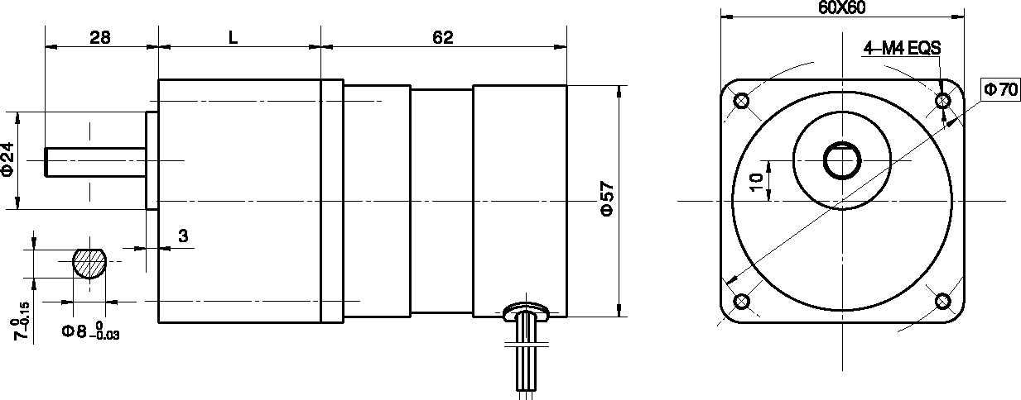
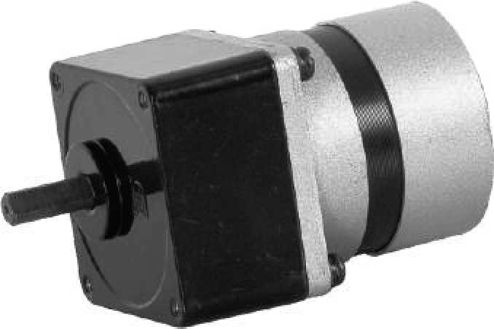
- 无刷电动机主要技术参数 Brushless Motor Technical Data
电机型号  TYPE | 额定电压Rated Voltage  VDC | 空载转速No-load Speed  r/min | 空载电流No-load Current  A | 额定转速Rated Speed  r/min | 额定转矩Rated Torque  mN.m | 输出功率Output power  W | 额定电流Rated Current  A
57ZWN55-2420 | 24 | 2000 | 200 | 1300 | 85 | 10 | 1.2
57ZWN55-2430 | 24 | 3000 | 400 | 2250 | 110 | 25 | 2.0

- 无刷行星齿轮减速电机主要技术参数 Brushless Gear Motor Technical Data

配置 57ZWN55-2420 无刷直流电机(57ZWN55-2420 BLDC Motor)

减速比 Reduction ratio | 3 | 5 | 7.5 | 10 | 12.5 | 15 | 25 | 30 | 50 | 75 | 90
减速级数 Number of gear trains | 2 | 2 | 2 | 2 | 2 | 2 | 3 | 3 | 3 | 4 | 4
减速器长度(L) Lengh(L) mm | 32 | 32 | 32 | 32 | 32 | 32 | 40 | 40 | 40 | 40 | 40
空载转速 No-lod speed r/min | 667 | 400 | 267 | 200 | 160 | 133 | 80 | 67 | 40 | 27 | 22
额定转速 Rated speed r/min | 433 | 260 | 173 | 130 | 104 | 86 | 52 | 43 | 26 | 17 | 14
额定转矩 Rated torque N.m | 0.20 | 0.34 | 0.51 | 0.68 | 0.86 | 1.2 | 1.5 | 1.8 | 3.1 | 4.2 | 5.0
最大瞬间允许负载 N.m Max. permissible load in a short time | 2.5 | 2.5 | 2.5 | 2.5 | 2.5 | 2.5 | 5.0 | 5.0 | 5.0 | 10 | 10

配置 57ZWN55-2430 无刷直流电机(57ZWN55-2430 BLDC Motor)

减速比 Reduction ratio | 3 | 5 | 7.5 | 10 | 12.5 | 15 | 25 | 30 | 50 | 75
减速级数 Number of gear trains | 2 | 2 | 2 | 2 | 2 | 2 | 3 | 3 | 3 | 4
减速器长度(L) Lengh(L) mm | 32 | 32 | 32 | 32 | 32 | 32 | 40 | 40 | 40 | 40
空载转速 No-lod speed r/min | 1000 | 600 | 400 | 300 | 240 | 200 | 120 | 100 | 60 | 40
额定转速 Rated speed r/min | 750 | 450 | 300 | 225 | 180 | 150 | 90 | 75 | 45 | 30
额定转矩 Rated torque N.m | 0.26 | 0.44 | 0.66 | 0.89 | 1.1 | 1.3 | 2.0 | 2.4 | 4.0 | 5.0
最大瞬间允许负载 N.m Max. permissible load in a short time | 2.5 | 2.5 | 2.5 | 2.5 | 2.5 | 2.5 | 5.0 | 5.0 | 5.0 | 10

