无刷直流行星齿轮减速电机（内齿圈材质:金属）
BLDC Planetary Gear Motor（Ring Gear Material: Metal）
Φ56 行星减速器（带油封）,允许转矩范围:2N.m~20N.m
56JX200K/57ZWN95 56mm OD Standard Gearbox,(with Oil seal)
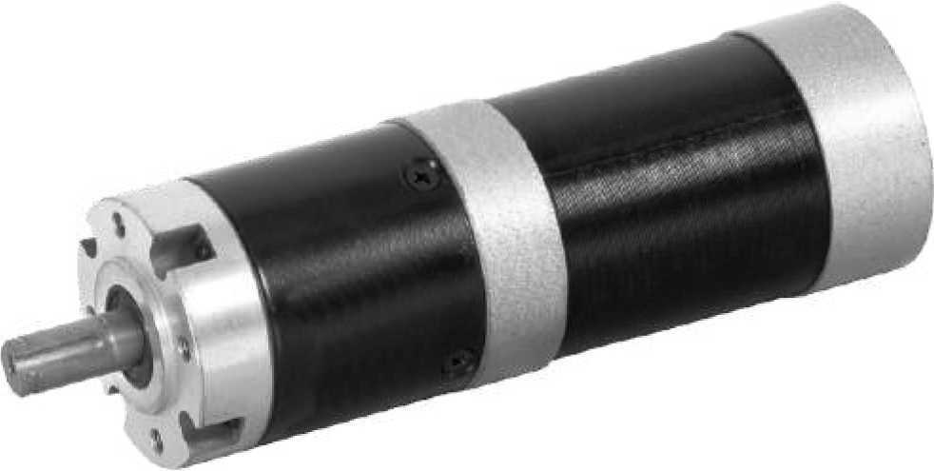
Permissible Load Range: 2N.m~20N.m

  - 外形和安装尺寸 Dimensions

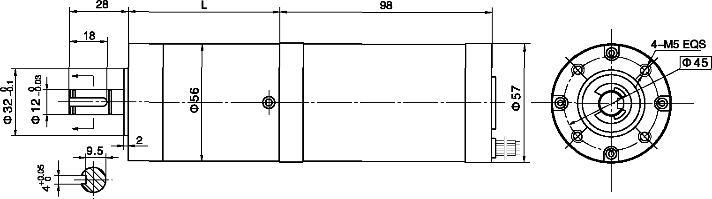
  - 无刷电动机主要技术参数 Brushless Motor Technical Data
电机型号  TYPE | 额定电压Rated Voltage  VDC | 空载转速No-load Speed  r/min | 空载电流No-load Current  A | 额定转速Rated Speed  r/min | 额定转矩Rated Torque  mN.m | 输出功率Output power  W | 额定电流Rated Current  A
57ZWN95-2420 | 24 | 2000 | 200 | 1450 | 400 | 60 | 4.0
57ZWN95-2430 | 24 | 3000 | 300 | 2000 | 400 | 80 | 6.0

- 无刷行星齿轮减速电机主要技术参数 Brushless Gear Motor Technical Data
配置 57ZWN95-2420 无刷J 直流电机(57ZWN95-2420 BLDC Motor)
减速比 Reduction ratio | 3.6 | 4.25 | 13 | 15 | 18 | 32 | 47 | 55 | 65 | 76
减速级数 Number of gear trains | 1 | 1 | 2 | 2 | 2 | 2 | 3 | 3 | 3 | 3
减速器长度(L) Lengh(L) mm | 41 | 41 | 53 | 53 | 53 | 53 | 64 | 64 | 64 | 64
空载转速 No-lod speed r/min | 556 | 471 | 154 | 133 | 111 | 63 | 43 | 36 | 31 | 26
额定转速 Rated speed r/min | 403 | 341 | 112 | 97 | 81 | 45 | 31 | 26 | 22 | 19
额定转矩 Rated torque N.m | 1.3 | 1.5 | 4.2 | 4.9 | 5.8 | 10 | 14 | 16 | 19 | 20
最大瞬间允许负载 N.m Max. permissible load in a short time | 6 | 6 | 25 | 25 | 25 | 25 | 50 | 50 | 50 | 50

配置 57ZWN95-2430 无刷直流电机(57ZWN95-2430 BLDC Motor)
减速比 Reduction ratio | 3.6 | 4.25 | 13 | 15 | 18 | 32 | 47 | 55 | 65 | 76
减速级数 Number of gear trains | 1 | 1 | 2 | 2 | 2 | 2 | 3 | 3 | 3 | 3
减速器长度(L) Lengh(L) mm | 41 | 41 | 53 | 53 | 53 | 53 | 64 | 64 | 64 | 64
空载转速 No-lod speed r/min | 833 | 706 | 231 | 200 | 167 | 94 | 64 | 55 | 46 | 39
额定转速 Rated speed r/min | 556 | 471 | 154 | 133 | 111 | 63 | 43 | 36 | 31 | 26
额定转矩 Rated torque N.m | 1.3 | 1.5 | 4.2 | 4.9 | 5.8 | 10 | 14 | 16 | 19 | 20
最大瞬间允许负载 N.m Max. permissible load in a short time | 6 | 6 | 25 | 25 | 25 | 25 | 50 | 50 | 50 | 50

