无刷直流行星齿轮减速电机(内齿圈材质:金属)
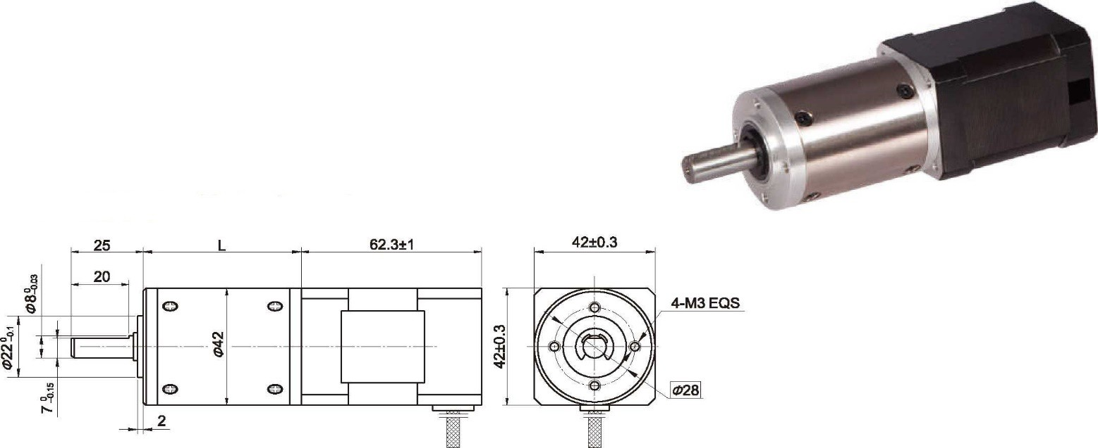BLDC Planetary Gear Motor (Fling Gear Material: Metal)
- 外观和安装尺寸
Φ42 行星减速器,允许转矩范围:2N.m~20N.m
42JXGT200K/42BL60 42mm OD Planetary Gearbox,
Permissible Load Range: 2N.m~20N.m

- 无刷电动机主要技术参数 Brushless Motor Technical Data

电机型号  TYPE | 极数Number of poles | 相数Number of phase | 额定电压Rated Voltage VDC | 空载转速No-load Speed r/min | 额定转速Rated Speed r/min | 额定转矩Rated Torque mN.m | 额定功率Rated Power  W | 峰值转矩Reak Torque  mN.m | 峰值电流Peak Current  A | 电阻Line to line resistance  ohms | 电感Line to line inductance  mH
42BL60-2440 | 10 | 3 | 24 | 4000 | 3000 | 160 | 50 | 650 | 11.8 | 1.1 | 0.96

- 无刷行星齿轮减速电机主要技术参数 Brushless Gear Motor Technical Data
配置 42BL60-2440 无刷直流电机(42BL60-2440 BLDC Motor)
减速比 Reduction ratio
减速级数 Number of gear trains 减速器长度(L) Lengh(L) mm 空载转速 No-lod speed
额定转速 Rated speed
额定转矩 Rated torque
r/min
r/min N.m
17
2
48.0
235
176
2.2
22
2
48.0
182
136
2.9
65
3
58.3
62
46
7.6
83
3
58.3
48
36
9.7
106
3
58.3
38
28
12
247
4
68.6
16
12
20
最大瞬间允许负载 N.m
Max. permissible load in a short time
25
25
50
50
50
60

- 接线方式 Wire Diagram

U | V | W | Vcc | Ha | Hb | He | GND
黄  Yellow | 红  Red | 黑  Black | 红  Red | 蓝  Blue | 绿  Green | 白  White | 黑  Black
20AWG UL1430 |  |  | 26AWG UL1430

