无刷直流行星齿轮减速电机(内齿圈材质:金属)
BLDC Planetary Gear Motor (Ring Gear Material: Metal)
Φ42 行星减速器,允许转矩范围:1N.m~15N.m

42JXG50K/42BL60
42mm OD Planetary Gearbox,
Pe1rmissible Load Range: 1N.m~15N.m

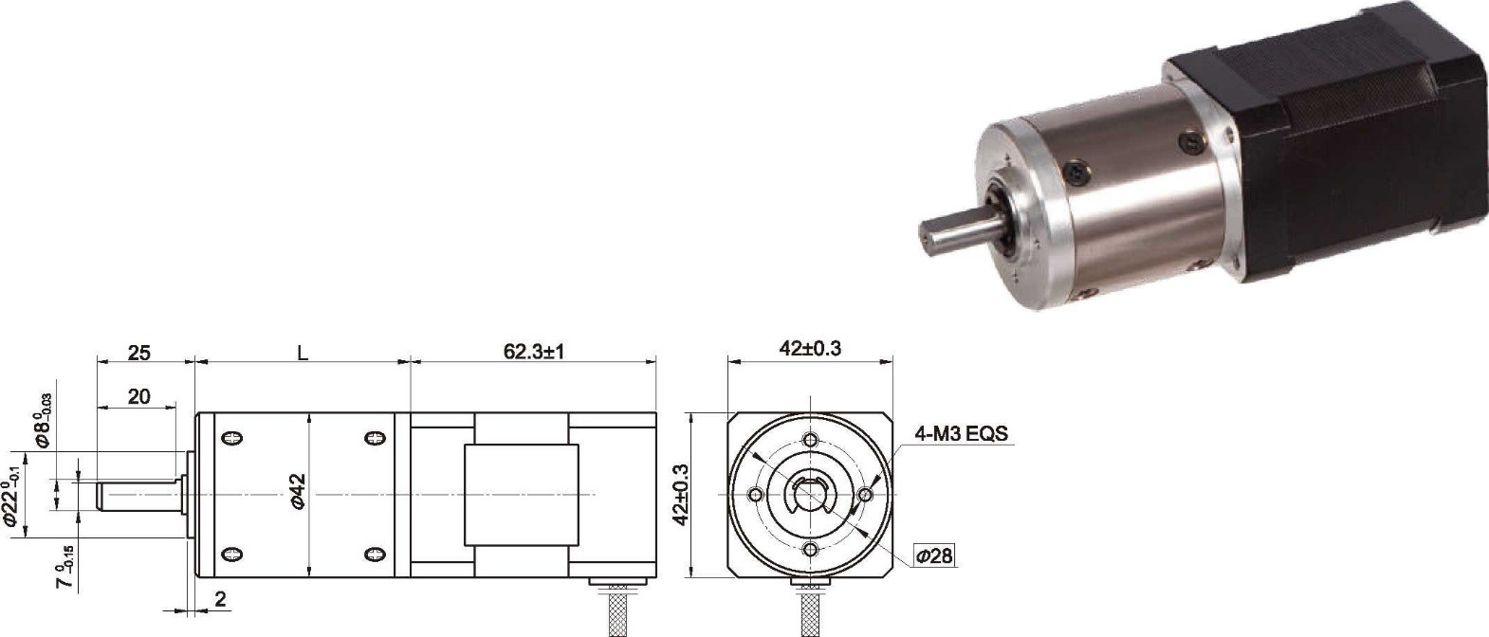
- 外形和安装尺寸 Dimensions
  - 无刷电动机主要技术参数 Brushless Motor Technical Data
电机型号  TYPE | 极数Number of poles | 相数Number of phase | 额定电压Rated Voltage VDC | 空载转速No-load Speed r/min | 额定转速Rated Speed r/min | 额定转矩Rated Torque mN.m | 额定功率Rated Power  W | 峰值转矩Reak Torque  mN.m | 峰值电流Peak Current A | 电阻Line to line resistance  ohms | 电感Line to line inductance  mH
42BL60-2440 | 10 | 3 | 24 | 4000 | 3000 | 160 | 50 | 650 | 11.8 | 1.1 | 0.96

  - 无刷行星齿轮减速电机主要技术参数 Brushless Gear Motor Technical Data
配置 42BL60—2440 无屈U 直流电机(42BL60-2440 BLDC Motor)

减速比 Reduction ratio | 3.8 | 4.9 | 15 | 19 | 24
减速级数 Number of gear trains | 1 | 1 | 2 | 2 | 2
减速器长度(L) Lengh(L) mm | 35.2 | 35.2 | 45.7 | 45.7 | 45.7
空载转速 No-lod speed r/min | 1047 | 820 | 267 | 211 | 167
额定转速 Rated speed r/min | 785 | 615 | 200 | 158 | 125
额定转矩 Rated torque N.m | 0.55 | 0.70 | 1.9 | 2.5 | 3
最大瞬间允许负载 N.m Max. permissible load in a short time | 1.5 | 1.5 | 6 | 6 | 6

  - 接线方式 Wire Diagram

U | V | W | Vcc | Ha | Hb | He | GND
黄  Yellow | 红  Red | 黑  Black | 红  Red | 蓝  Blue | 绿  Green | 白  White | 黑  Black
20AWG UL1430 |  |  | 26AWG UL1430

