无刷直流行星齿轮减速电机(内齿圈材质:金属和粉末金属)
BLDC Planetary Gear Motor (Ring Gear Material: Metal and Powder Metal)
Φ42 行星减速器,允许转矩范围:1N.m~1.5N.m
42JX150K/42BL60 42mm OD Planetary Gearbox,
Permissible Load Range: 1N.m~1.5N.m
可在两种材质的内齿圈中进行选择：粉末金属(型号 42JXF150K),金属(型号 42JXE150K)
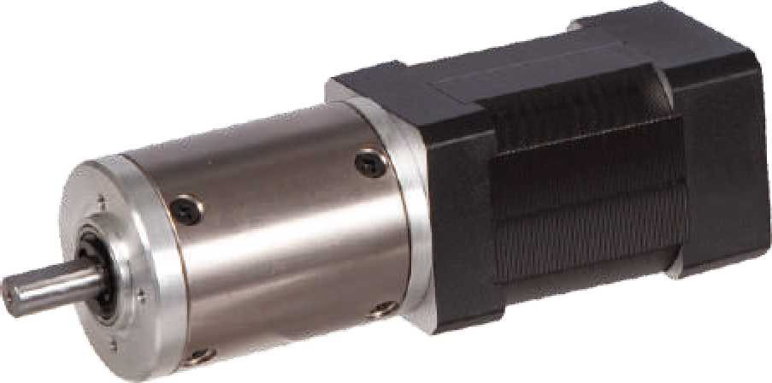
Ring gear can be selected within the two materials : Powder metal (Type: 42JXF150K) , Metal (Type: 42JXE150K)

- 外形和安装尺寸 Dimensions
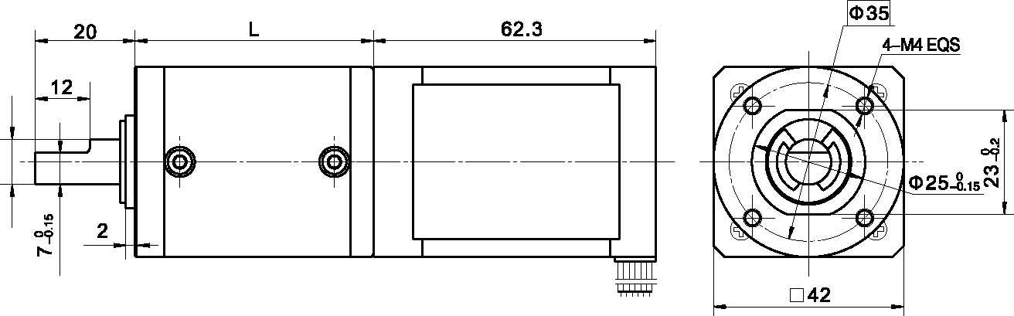
- 无刷电动机主要技术参数 Brushless Motor Technical Data
电机型号  TYPE | 极数Number of poles | 相数Number of phase | 额定电压Rated Voltage VDC | 空载转速No-load Speed r/min | 额定转速Rated Speed r/min | 额定转矩Rated Torque mN.m | 额定功率Rated Power  W | 峰值转矩Reak Torque mN.m | 峰值电流Peak Current A | 电阻Line to line resistance  ohms | 电感Line to line inductance  mH
42BL60-2440 | 10 | 3 | 24 | 4000 | 3000 | 160 | 50 | 650 | 11.8 | 1.1 | 0.96

- 无刷行星齿轮减速电机主要技术参数 Brushless Gear Motor Technical Data
配置 42BL60-2440 无刷直流电机(42BLS60-2440 BLDC Motor)

减速比 Reduction ratio | 3.5 | 14 | 21 | 49 | 84 | 104 | 126
减速级数 Number of gear trains | 1 | 2 | 2 | 3 | 3 | 3 | 3
减速器长度(L) Lengh(L) mm | 32.5 | 39.2 | 39.2 | 46 | 46 | 46 | 46
空载转速 No-lod speed r/min | 1143 | 286 | 190 | 82 | 48 | 38 | 32
额定转速 Rated speed r/min | 857 | 214 | 143 | 61 | 36 | 29 | 24
额定转矩 Rated torque N.m | 0.50 | 1.8 | 2.7 | 5.7 | 9.8 | 12 | 14.7
最大瞬间允许负载 N.m Max. permissible load in a short time | 3 | 12 | 12 | 25 | 25 | 25 | 25

- 接线方式 Wire Diagram

U | V | W | Vcc | Ha | Hb | He | GND
黄  Yellow | 红  Red | 黑  Black | 红  Red | 蓝  Blue | 绿  Green | 白  White | 黑  Black
20AWG UL1430 |  |  | 26AWG UL1430

