无刷直流行星齿轮减速电机（内齿圈材质:金属）
BLDC Planetary Gear Motor (Ring Gear Material: Metal)
Φ42 行星减速器,允许转矩范围:2N.m~20N.m

42JXGT200K/42ZWN60

- 外形和安装尺寸 Dimensions
42mm OD Planetary Gearbox,
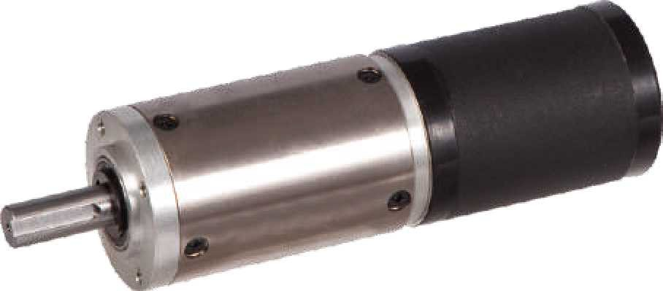
Permissible Load Range: 2N.m~20N.m

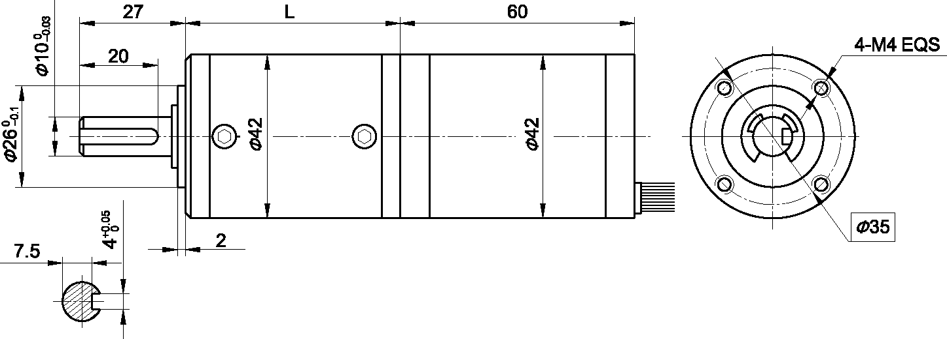
- 无刷电动机主要技术参数 Brushless Motor Technical Data

电机型号  TYPE | 极数Number of poles | 相数Number of phase | 额定电压Rated Voltage VDC | 空载转速No-load Speed r/min | 额定转速Rated Speed r/min | 额定转矩Rated Torque mN.m | 额定功率Rated Power  W | 峰值转矩Reak Torque  mN.m | 峰值电流Peak Current  A | 电阻Line to line resistance  ohms | 电感Line to line inductance  mH
42ZWN60-2430 | 8 | 3 | 24 | 3000 | 2100 | 50 | 11 | 150 | 2.6 | 6.0 | 6.4

- 无刷行星齿轮减速电机主要技术参数 Brushless Gear Motor Technical Data
配置 42ZWN60-2430 无刷直流电机(42ZWN60-2430 BLDC Motor)
减速比 Reduction ratio | 65 | 83 | 83 | 247 | 247 | 403 | 515 | 944
减速级数 Number of gear trains | 3 | 3 | 3 | 4 | 4 | 4 | 4 | 5
减速器长度(L) Lengh(L) mm | 58.3 | 58.3 | 58.3 | 68.6 | 68.6 | 68.6 | 68.6 | 78.9
空载转速 No-lod speed r/min | 46 | 36 | 36 | 12 | 12 | 7.4 | 5.8 | 3.2
额定转速 Rated speed r/min | 32 | 25 | 25 | 9 | 9 | 5.2 | 4.1 | 2.2
额定转矩 Rated torque N.m | 2.4 | 3.0 | 3.0 | 8.0 | 8.0 | 13 | 17 | 20
最大瞬间允许负载 N.m Max. permissible load in a short time | 50 | 50 | 50 | 60 | 60 | 60 | 60 | 60

- 接线方式 Wire Diagram

U | V | W | Vcc | Ha | Hb | He | GND
红  Red | 棕  Brown | 黑  Black | 蓝  Blue | 黄  Yellow | 棕  Brown | 红  Red | 绿  Green
22AWG UL1007 |  |  | 26AWG UL1007

