无刷直流行星齿轮减速电机(内齿圈材质:金属)
BLDC Planetary Gear Motor (Ring Gear Material: Metal)
Φ42 行星减速器,允许转矩范围:2N.m~15N.m
42JX150K/42ZWNP66T 42mm OD Planetary Gearbox,
Permissible Load Range: 2N.m~15N.m

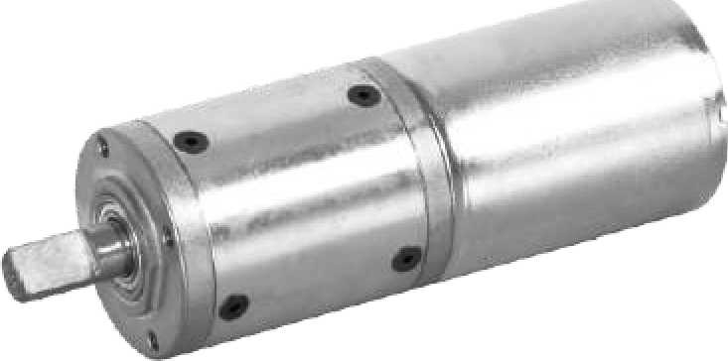
● 外形和安装尺寸 Dimensions
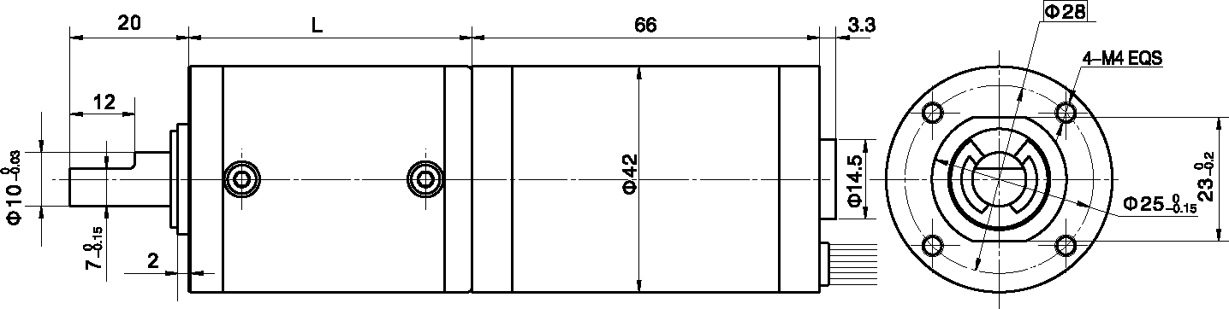
- 无刷电动机主要技术参数 Brushless Motor Technical Data

电机型号  TYPE | 极数Number of poles | 相数Number of phase | 额定电压Rated Voltage  VDC | 空载转速No-load Speed  r/min | 额定转速Rated Speed  r/min | 额定转矩Rated Torque  mN.m | 额定电流Rated Current  A | 输出功率Output power  W
42ZWNP66T-2430 | 8 | 3 | 24 | 3000 | 2600 | 150 | 3.7 | TBD

- 无刷行星齿轮减速电机主要技术参数 Brushless Gear Motor Technical Data
配置 42ZWNP66T-2430 无刷直流电机(42ZWNP66T-2430 BLDC Motor)

减速比 Reduction ratio | 3.5 | 14 | 21 | 49 | 84 | 104 | 126 | 156 | 172 | 196 | 212
减速级数 Number of gear trains | 1 | 2 | 2 | 3 | 3 | 3 | 3 | 4 | 4 | 4 | 4
减速器长度(L) Lengh(L) mm | 32.5 | 39.2 | 39.2 | 46 | 46 | 46 | 46 | 52.5 | 52.5 | 52.5 | 52.5
空载转速 No-lod speed r/min | 857 | 214 | 143 | 61 | 36 | 29 | 24 | 19 | 17 | 15 | 14
额定转速 Rated speed r/min | 728 | 182 | 121 | 52 | 30 | 24 | 20 | 16 | 15 | 13 | 12
额定转矩 Rated torque N.m | 0.47 | 1.7 | 2.5 | 5.3 | 9.2 | 11.4 | 13.8 | 15.4 | 16.8 | 19 | 20
最大瞬间允许负载 N.m Max. permissible load in a short time | 3 | 12 | 12 | 25 | 25 | 25 | 25 | 30 | 30 | 30 | 30

- 接线方式 Wire

Vcc | GND | F/R | PWM | PG
红  Red | 黑  Black | 绿  Green | 白  White | 黄  Yellow
22AWG UL3266 |  | 26AWG UL1430

