无刷直流行星齿轮减速电机（内齿圈材质:金属）
BLDC Planetary Gear Motor (Ring Gear Material: Metal)
Φ32 行星减速器,允许转矩范围:0.3N.m~3.0N.m
32JXE30K/33ZWN80 32mm OD Planetary Gearbox,
Permissible Load Range: 0.3N.m~3.0N.m
可在两种材质的内齿圈中进行选择：粉末金属(型号 36JXF30K ),金属(型号 36JXE30K )
Ring gear can be selected within the two materials : Powder metal (Type: 36JXF30K) , Metal (Type: 36JXE30K)

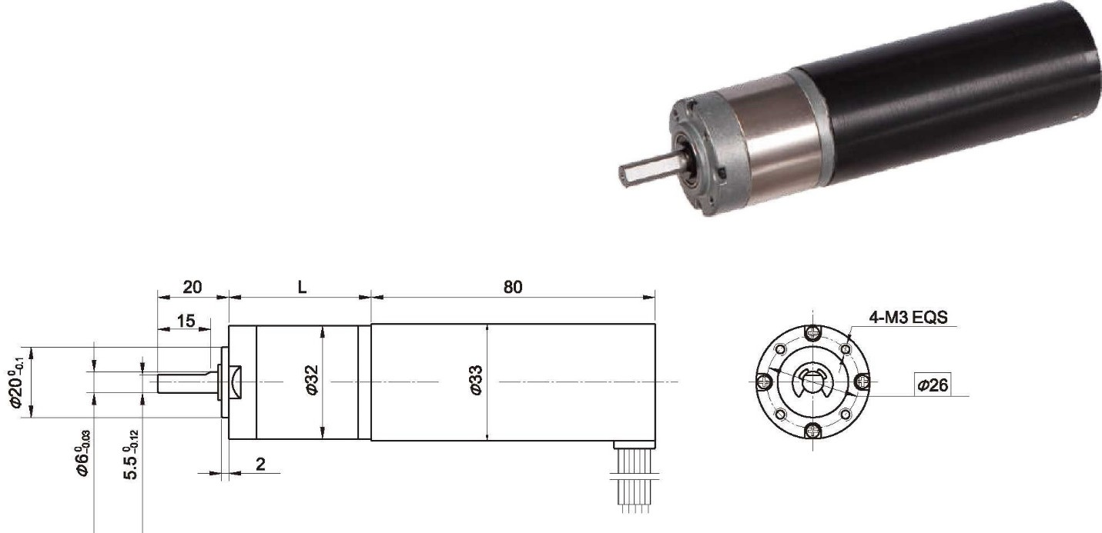
- 外形和安装尺寸 Dimensions
- 无刷电动机主要技术参数 Brushless Motor Technical Data
电机型号  TYPE | 极数Number of poles | 相数Number of phase | 额定电压Rated Voltage VDC | 空载转速No-load Speed r/min | 额定转速Rated Speed r/min | 额定转矩Rated Torque mN.m | 额定功率Rated Power  W | 峰值转矩Reak Torque mN.m | 峰值电流Peak Current  A | 电阻Line to line resistance  ohms | 电感Line to line inductance  mH
33ZWN80-2490 | 4 | 3 | 24 | 9000 | 7800 | 50 | 40 | 350 | 11 | 0.86 | 0.55

- 无刷行星齿轮减速电机主要技术参数 Brushless Gear Motor Technical Data
配置 33ZWN80-2490 无刷直流电机(33ZWN80-2490 BLDC Motor)

减速比 Reduction ratio | 3.7 | 5.2 | 14 | 19 | 27 | 51 | 71 | 100 | 139
减速级数 Number of gear trains | 1 | 1 | 2 | 2 | 2 | 3 | 3 | 3 | 3
减速器长度(L) Lengh(L) mm | 25.7 | 25.7 | 32.8 | 32.8 | 32.8 | 39.7 | 39.7 | 39.7 | 39.7
空载转速 No-lod speed r/min | 2624 | 1737 | 643 | 474 | 333 | 176 | 127 | 90 | 65
额定转速 Rated speed r/min | 2101 | 1506 | 557 | 411 | 289 | 153 | 110 | 78 | 56
额定转矩 Rated torque N.m | 0.17 | 0.23 | 0.57 | 0.77 | 1.1 | 1.9 | 2.5 | 2.5 | 2.5
最大瞬间允许负载 N.m Max. permissible load in a short time | 1.0 | 1.0 | 3.5 | 3.5 | 3.5 | 7.5 | 7.5 | 7.5 | 7.5

  - 接线方式 Wire Diagram

U | V | W | Vcc | Ha | Hb | He | GND
绿  Green | 红  Red | 黑  Black | 黄  Yellow | 蓝  Blue | 橙  Orange | 棕  Brown | 白  White
26AWG UL1007

