无刷直流行星齿轮减速电机（内齿圈材质:金属）
BLDC Planetary Gear Motor (Ring Gear Material:Metal)
Φ28 行星减速器,允许转矩范围:0.3N.m~3.0N.m
28JXB30K/28ZWN38 28mm OD Planetary Gearbox,
Permissible Load Range:0.3N.m~3.0N.m

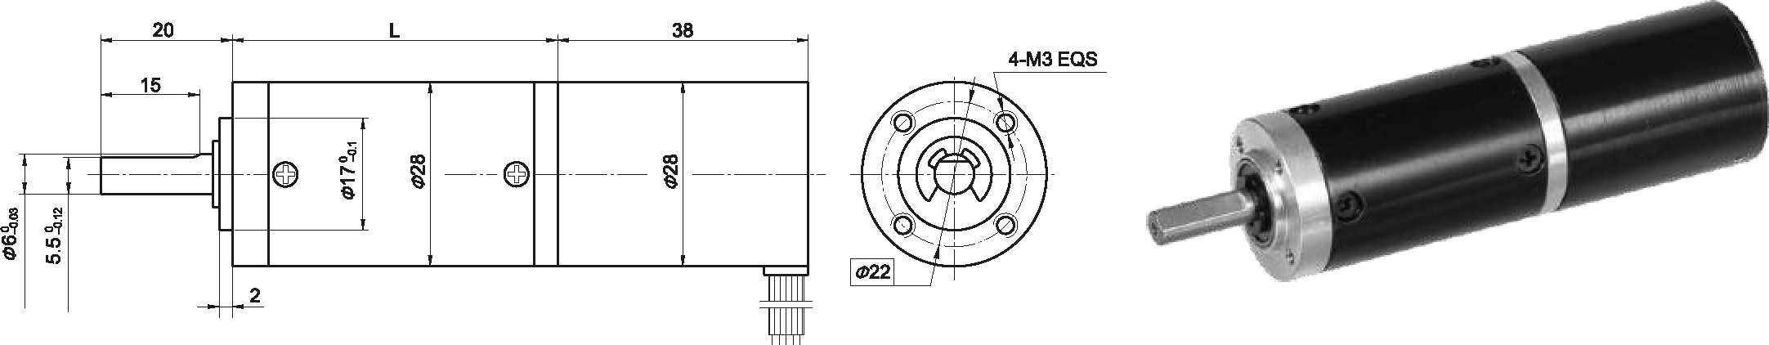
- 外形和安装尺寸 Dimensions
- 无刷电动机主要技术参数 Brushless Motor Technical Data

电机型号  TYPE | 极数Number of poles | 相数Number of phase | 额定电压Rated Voltage VDC | 空载转速No-load Speed r/min | 额定转速Rated Speed r/min | 额定转矩Rated Torque mN.m | 额定功率Rated Power  W | 峰值转矩Reak Torque mN.m | 峰值电流Peak Current  A | 电阻Line to line resistance  ohms | 电感Line to line inductance  mH
28ZWN38-2430 | 4 | 3 | 24 | 3000 | 2000 | 5 | 1.0 | 15 | 0.45 | 93.3 | 28
28ZWN38-2440 | 4 | 3 | 24 | 4000 | 2700 | 7 | 1.9 | 21 | 0.60 | 55 | 18.3
- 无刷行星齿轮减速电机主要技术参数 Brushless Gear Motor Technical Data
配置 28ZWN38-2430 无刷直流电机(28ZWN38-2430 BLDC Motor)

减速比 Reduction ratio | 3.7 | 5.2 | 14 | 19 | 27 | 51 | 71 | 100 | 139 | 189 | 264 | 369 | 516 | 720
减速级数 Number of gear trains | 1 | 1 | 2 | 2 | 2 | 3 | 3 | 3 | 3 | 4 | 4 | 4 | 4 | 4
减速器长度(L) Lengh(L) mm | 31.0 | 31.0 | 40.1 | 40.1 | 40.1 | 49.0 | 49.0 | 49.0 | 49.0 | 57.9 | 57.9 | 57.9 | 57.9 | 57.9
空载转速 No-load speed r/min | 809 | 576 | 214 | 158 | 111 | 59 | 42 | 30 | 22 | 16 | 11 | 8.1 | 5.8 | 4.2
额定转速 Rated speed r/min | 539 | 386 | 143 | 105 | 74 | 39 | 28 | 20 | 14 | 11 | 7.6 | 5.4 | 3.9 | 2.8
额定转矩 Rated torque N.m | 0.017 | 0.023 | 0.057 | 0.077 | 0.11 | 0.19 | 0.26 | 0.37 | 0.51 | 0.61 | 0.86 | 1.2 | 1.7 | 2
最大瞬间允许负载 N.m Max. permissible load in a short time | 1.0 | 1.0 | 3.5 | 3.5 | 3.5 | 7.5 | 7.5 | 7.5 | 7.5 | 9.0 | 9.0 | 9.0 | 9.0 | 9.0

配置 28ZWN38-2440 无刷直流电机(28ZWN38-2440 BLDC Motor)

减速比 Reduction ratio | 3.7 | 5.2 | 14 | 19 | 27 | 51 | 71 | 100 | 139 | 189 | 264 | 369 | 516 | 720
减速级数 Number of gear trains | 1 | 1 | 2 | 2 | 2 | 3 | 3 | 3 | 3 | 4 | 4 | 4 | 4 | 4
减速器长度(L) Lengh(L) mm | 31.0 | 31.0 | 40.1 | 40.1 | 40.1 | 49.0 | 49.0 | 49.0 | 49.0 | 57.9 | 57.9 | 57.9 | 57.9 | 57.9
空载转速 No-load speed r/min | 1078 | 772 | 286 | 211 | 148 | 78 | 56 | 40 | 29 | 21 | 15 | 11 | 7.8 | 5.6
额定转速 Rated speed r/min | 728 | 521 | 193 | 142 | 100 | 53 | 38 | 27 | 19 | 14 | 10 | 7.3 | 5.2 | 3.8
额定转矩 Rated torque N.m | 0.023 | 0.033 | 0.079 | 0.11 | 0.15 | 0.26 | 0.36 | 0.51 | 0.71 | 0.86 | 1.2 | 1.7 | 2.3 | 3
最大瞬间允许负载 N.m Max. permissible load in a short time | 1.0 | 1.0 | 3.5 | 3.5 | 3.5 | 7.5 | 7.5 | 7.5 | 7.5 | 9.0 | 9.0 | 9.0 | 9.0 | 9.0

- 接线方式 Wire Diagram
U | V | W | Vcc | Ha | Hb | He | GND
绿  Green | 红  Red | 黑  Black | 黄  Yellow | 蓝  Blue | 橙  Orange | 棕  Brown | 白  White
26AWG UL1007

B-14

