无刷直流行星齿轮减速电机(内齿圈材质:金属)
BLDC Planetary Gear Motor (Ring Gear Material: Metal)
22JX10K/22ZWN45
Φ22行星减速器,允许转矩范围:0.05N.m~0.5N.m
22mm OD Planetary Gearbox,
Permissible Load Range: 0.05N.m~0.5N.m

无刷直流电动机，3相 10极，外置驱动器 3 phase 10 poles brushless DC motor, with external driver
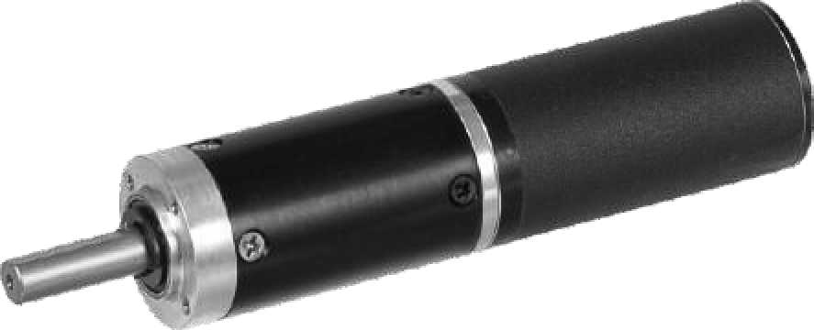

- 外观和安装尺寸 Dimensions

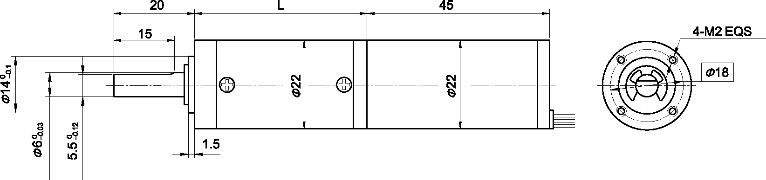

- 无刷电动机主要技术参数Brushless Motor Technical Data
电机型号  TYPE | 极数  Number  of poles | 相数  Number of phase | 额定电压 Rated  Voltage  VDC | 空载转速  No-load  Speed  r/min | 额定转速 Rated  Speed  r/min | 额定转矩 Rated  Torque  mN.m | 额定功率 Rated  Power  W | 峰值转矩 Reak  Torque  mN.m | 峰值电流 Peak  Current  A | 电阻  Line to line resistance ohms | 电感  Line to line inductance mH
22ZWN45-2470 | 8 | 3 | 24 | 7000 | 4600 | 8.0 | 3.8 | 21 | 1.1 | 23 | 6.2

- 无刷行星齿轮减速电机主要技术参数Brushless Gear Motor Technical Data
- 无刷行星齿轮减速电机主要技术参数Brushless Gear Motor Technical Data
配置22ZWN45—2470无刷直流电机(22ZWN45-2470 BLDC Motor)
减速比 Reduction ratio | 3.7 | 5.2 | 14 | 19 | 27 | 51 | 71 | 100 | 139 | 189 | 264 | 369
减速级数 Number of gear trains | 1 | 1 | 2 | 2 | 2 | 3 | 3 | 3 | 3 | 4 | 4 | 4
减速器长度(L) Length(L) mm | 24.4 | 24.4 | 33 | 33 | 31 | 41.5 | 41.5 | 41.5 | 41.5 | 49.8 | 49.8 | 49.8
空载速度 No-load speed r/min | 1887 | 1351 | 500 | 368 | 259 | 137 | 99 | 70 | 50 | 37 | 27 | 19
额定转速 Rated speed rAnin | 1240 | 888 | 329 | 242 | 170 | 90 | 65 | 46 | 33 | 24 | 17 | 12
额定转矩 Rated torque N.m | 0.027 | 0.037 | 0.091 | 0.12 | 0.17 | 0.30 | 0.41 | 0.58 | 0.80 | 1 | 1 | 1
最大瞬间允许负载 N.m  Max. permissible load in a short time | 0.3 | 0.3 | 1.2 | 1.2 | 1.2 | 2.5 | 2.5 | 2.5 | 2.5 | 3 | 3 | 3

- 接线方式Wire Diagram

U | V | W | Vcc | Ha | Hb | He | GND
灰 | 棕 | 白 | 红 | 黄 | 蓝 | 绿 | 黑
Grey | Brown | White | Red | Yellow | Blue | Green | Black
(Green ) PWM 绿色(Green)
- FG 绿色(Green )

