无刷直流行星齿轮减速电机 BLDC Planetary Gear Motor
Φ37标准型减速器,允许转矩范围:0.6N.m
37mm OD Planetary Gearbox,
Permissible Load Range: 0.6N.m

37JB10K/36ZWNP40
无刷直流电动机，3相10极，内置驱动器 3 phase 10 poles brushless DC motor, with built-in driver

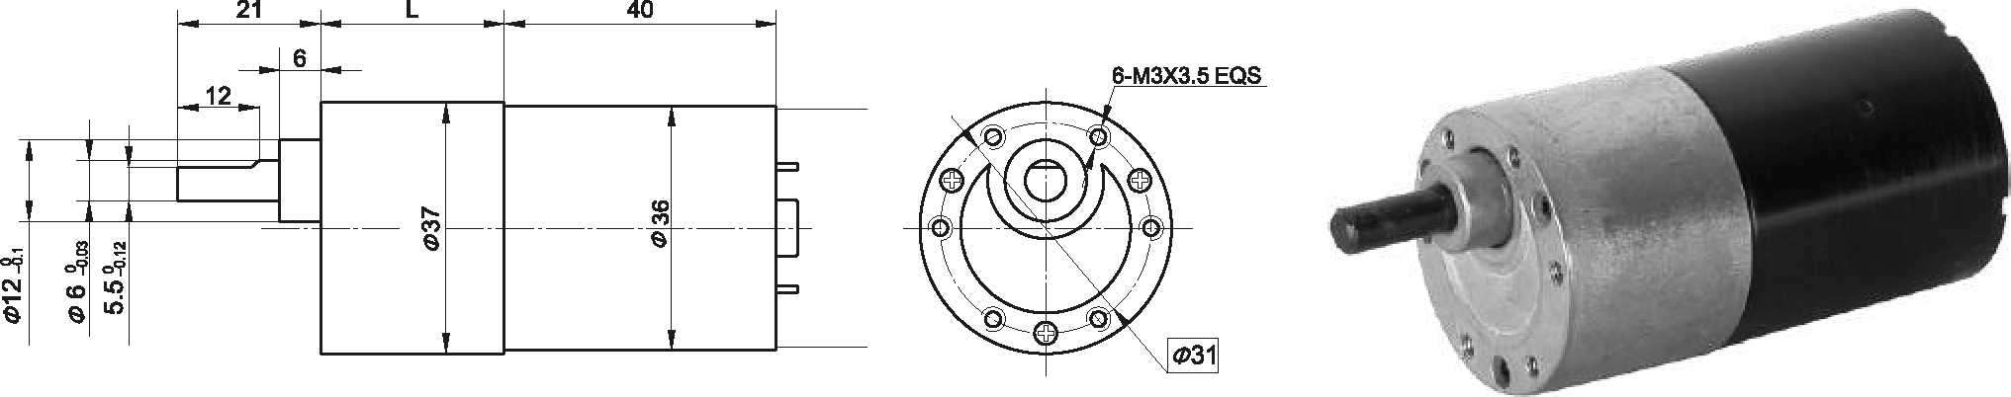
- 外观和安装尺寸 Dimensions
  - 无刷电动机主要技术参数Brushless Motor Technical Data
电机型号  TYPE | 极数  Number  of poles | 相数  Number of phase | 额定电压 Rated  voltage  VDC | 空载转速  No-load  speed  r/min | 空载电流  No-load  current  mA | 额定转矩  Rated  torque  mN.m | 额定转速  Rated  speed  r/min | 额定电流 Rated  current  mA | 额定功率  Rated  power  W
36ZWNP40-1240 | 4 | 3 | 12 | 4000 | 400 | 15 | 3000 | 850 | 4.7
36ZWNP40-2440 | 4 | 3 | 24 | 4000 | 200 | 20 | 3000 | 550 | 6.3
  - 无刷行星齿轮减速电机主要技术参数Brushless Gear Motor Technical Data
减速比 Reduction ratio | 4.44 | 17 | 22 | 65 | 83 | 106 | 247 | 316 | 403 | 515
减速级数 Number of gear trains | 1 | 2 | 2 | 3 | 3 | 3 | 4 | 4 | 4 | 4
减速器长度(L) Length(L) mm | 37.5 | 48.0 | 48.0 | 58.3 | 58.3 | 58.3 | 68.6 | 68.6 | 68.6 | 68.6
空载速度 No-load speed r/min | 901 | 235 | 182 | 62 | 48 | 38 | 16 | 13 | 10 | 7.8
额定转速 Rated speed rAnin | 676 | 176 | 136 | 46 | 36 | 28 | 12 | 9 | 7 | 5.8
额定转矩 Rated torque N.m | 0.27 | 0.94 | 1.2 | 3.2 | 4.1 | 5.3 | 11 | 14 | 18 | 20
最大瞬间允许负载 N.m  Max. permissible load in a short time | 6 | 25 | 25 | 50 | 50 | 50 | 60 | 60 | 60 | 60
配置36ZWNP40-1240无刷直流电机(36ZWNP40-1240 BLDC Motor)
配置36ZWNP40-2440无刷直流电机(36ZWNP40-2440 BLDC Motor)
减速比 Reduction ratio | 6 | 10 | 18 | 30 | 50 | 75 | 100 | 150 | 200 | 250
减速级数 Number of gear trains | 2 | 2 | 3 | 3 | 4 | 4 | 4 | 5 | 5 | 5
减速器长度(L) Length(L) mm | 21.5 | 21.5 | 26.5 | 26.5 | 29 | 29 | 29 | 31.5 | 31.5 | 31.5
空载速度 No-load speed r/min | 667 | 400 | 222 | 133 | 80 | 53 | 40 | 27 | 20 | 15
额定转速 Rated speed rAnin | 500 | 300 | 167 | 100 | 60 | 40 | 30 | 20 | 15 | 12
额定转矩 Rated torque N.m | 0.10 | 0.16 | 0.26 | 0.44 | 0.65 | 0.98 | 1 | 1 | 1 | 1
最大瞬间允许负载 N.m  Max. permissible load in a short time | 0.5 | 0.5 | 1.5 | 1.5 | 3 | 3 | 3 | 3 | 3 | 3
转向 Direction of rotation | CCW | CCW | CW | CW | CCW | CCW | CCW | CW | CW | CW

- 接线方式Wire Diagram
VCC接电源正极、GMD接电源负极，不能接反。
无刷电机的接线端子排序
BLDC Motor Wiring Diagram

FR正反转信号线，悬空或接5V时电机转向CCW,接GMD转向CW。
FG转速信号线，电机每转一周输出2个方波信号。
PWM调速信号输入，接+5V时电机全速，接GND停止。
BRK制动信号输入，接GND时制动。
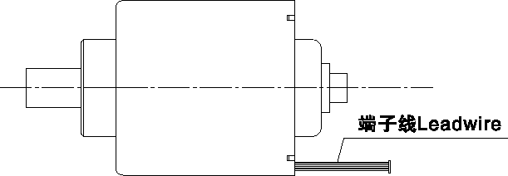
Vcc connects positive wire, GND connects negative wire.
RBK绿色(Green ) PWM 绿色(Green) FG 绿色(Green ) FR 绿色(Green ) GMD 白色(White) VCC红色(Red)

FR is signal wire for differentiating CCW and CW. Motor rotation is CCW when FR is Disconnected or connected with 5V. Motor rotation is CW when FR is connected with GND.
FG is wire for speed signal, motor outputs 2 quare signals per revolution.
PWM input speed control signal, connect +5V for motor full-speed working, while connect GND for stopping.
BRK is braking signal input, connect GND for braking.

(Green ) PWM 绿色(Green)
- FG 绿色(Green )

