无刷直流行星齿轮减速电机 (内齿圈材质:金属)
BLDC Planetary Gear Motor (Ring Gear Material: Metal)
Φ28行星减速器,允许转矩范围:0.3N·m~3N·m
28mm OD Planetary Gearbox,
Permissible Load Range:0.3N·m~3N·m

28JXB30K/28ZWNP38

无刷直流电动机，3相4极，内置驱动器 3 phase 4 poles brushless DC motor, with built-in driver可在
- 外形和安装尺寸Dimensions

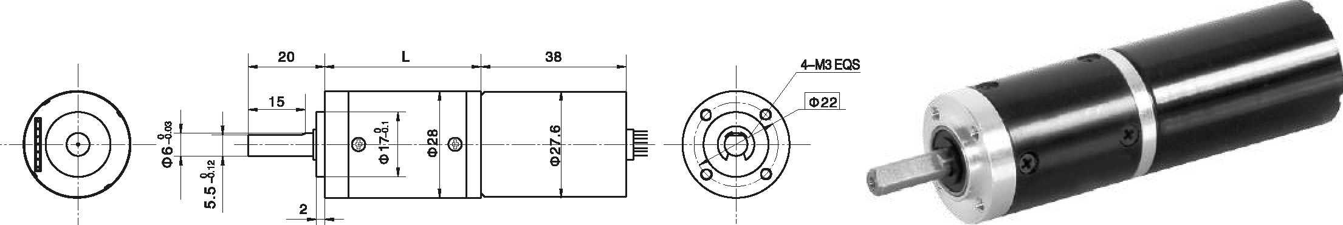

- 电动机主要技术参数Motor Technical Data
电机型号  TYPE | 极数  Number  of poles | 相数  Number  of phase | 额定电压  Rated  voltage  VDC | 空载转速  No-load  speed  r/min | 空载电流  No-load  current  mA | 额定转矩  Rated  torque  mN.m | 额定转速  Rated  speed  r/min | 额定电流  Rated  current  mA | 额定功率  Rated  Power  W
28ZWNP38-2431 | 4 | 3 | 24 | 3100 | 180 | 6.9 | 2600 | 250 | 1.87
使用电压范围(Voltage Range ) ： 10-24.5VDC

- 无刷行星齿轮减速电机主要技术参数Brushless Gear Motor Technical Data
配置28ZY38P-1265直流电机(28ZY38P-1265 DC Motor)
减速比 Reduction ratio | 3.7 | 5.2 | 14 | 19 | 27 | 51 | 71 | 100 | 139 | 189 | 264 | 369 | 516 | 720
减速级数 Number of gear trains | 1 | 1 | 2 | 2 | 2 | 3 | 3 | 3 | 3 | 4 | 4 | 4 | 4 | 4
减速器长度(L) Length(L) mm | 31.0 | 31.0 | 40.1 | 40.1 | 40.1 | 49.0 | 49.0 | 49.0 | 49.0 | 57.9 | 57.9 | 57.9 | 57.9 | 57.9
空载速度 No-load speed r/min | 836 | 598 | 221 | 163 | 115 | 61 | 44 | 31 | 22 | 16 | 12 | 8.4 | 6.0 | 4.3
额定转速 Rated speed rAnin | 701 | 502 | 186 | 137 | 96 | 51 | 37 | 26 | 19 | 14 | 9.8 | 7.0 | 5.0 | 3.6
额定转矩 Rated torque N.m | 0.023 | 0.032 | 0.078 | 0.11 | 0.15 | 0.26 | 0.36 | 0.50 | 0.70 | 0.85 | 1.2 | 1.7 | 2.3 | 3
最大瞬间允许负载 N.m  Max. permissible load in a short time | 1.0 | 1.0 | 3.5 | 3.5 | 3.5 | 7.5 | 7.5 | 7.5 | 7.5 | 9 | 9 | 9 | 9 | 9

- 接线方式Wire Diagram

VCC接电源正极，GND接负极，正负极不能接反。
控制线路接线图 Driver Circuit Wiring Diagram
FR正反转信号线，悬空或接5V时电机转向CCW,接GND转向CW。
FG转速信号线。PWM调速信号输入，接+5V时电机全速，接GND停止。
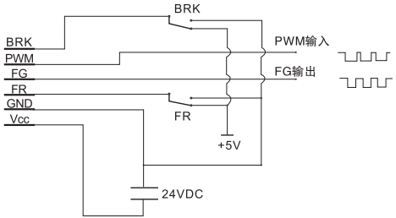
BRK制动信号输入，接GND时制动。
Vcc connects positive wire, GND connects negative wire.
FR is signal wire for differentiating CCW and CW. Motor rotation is CCW when FR is Disconnected or connected with 5V. Motor rotation is CW when FR is connected with GND.
FG is wire for speed signal.PWM input speed control signal,connect +5V for motor full-speed working, while connect GND for stopping. BRK is braking signal input, connect GND for braking.

