永磁直流行星齿轮电机（内齿圈材质:金属）
PM DC Planetary Gear Motor (Ring Gear Material: Metal)

32JXE20K/28ZY38P
Φ32行星减速器，允许转矩范围：0.2N.m~2.0N.m
32mm OD Planetary Gearbox,
Permissible Load Range:0.2N.m~2.0N.m
常规产品出轴直径Φ6,也可以配置直径Φ8的出轴。Standard output shaft OD 6mm, OD 8mm optional.
- 外形和安装尺寸Dimensions
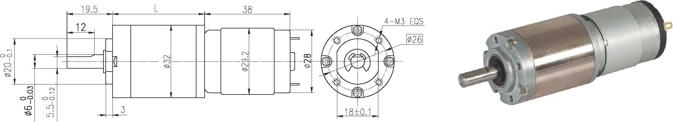

- 电动机主要技术参数Motor Technical Data
电机型号  Type | 额定电压  Rated  Voltage  VDC | 空载转速  No-load  Speed  r/min | 空载电流  No-load current  mA | 额定转速  Rated  Speed  r/min | 额定转矩  Rated  torque  mN.m | 输出功率  Output  power  W | 额定电流  Rated  current  mA | 堵转力矩  Stall  torque  mN.m | 堵转电流  Stall  current  A
28ZY38P-1265 | 12 | 6500 | 150 | 5250 | 7.6 | 4.2 | 530 | 38 | 2.65
28ZY38P-2465 | 24 | 6500 | 85 | 5250 | 7.6 | 4.2 | 250 | 38 | 1.25

- 齿轮减速电机主要技术参数Gear Motor Technical Data
配置28ZY38P-1265直流电机(28ZY38P-1265 DC Motor)
减速比 Reduction ratio | 3.7 | 5.2 | 14 | 19 | 27 | 35 | 51 | 71 | 100 | 139 | 189 | 264 | 369 | 516 | 721 | 939
减速级数 Number of gear trains | 1 | 1 | 2 | 2 | 2 | 2 | 3 | 3 | 3 | 3 | 4 | 4 | 4 | 4 | 4 | 4
减速器长度(L) Length(L) mm | 20.7 | 20.7 | 27.3 | 27.3 | 27.3 | 27.3 | 33.6 | 33.6 | 33.6 | 33.6 | 39.9 | 39.9 | 39.9 | 39.9 | 39.9 | 39.9
空载转速 No-load speed r/min | 1752 | 1255 | 464 | 342 | 241 | 186 | 127 | 92 | 65 | 47 | 34 | 25 | 18 | 13 | 9.0 | 6.9
额定转速 Rated speed r/min | 1415 | 1014 | 375 | 276 | 194 | 150 | 103 | 74 | 53 | 38 | 28 | 20 | 14 | 10 | 7.3 | 5.6
额定转矩 Rated torque N.m | 0.025 | 0.035 | 0.086 | 0.12 | 0.17 | 0.22 | 0.28 | 0.39 | 0.55 | 0.77 | 0.93 | 1.3 | 1.8 | 2.0 | 2.0 | 2.0
最大瞬间允许负载 N.m  Max. permissible load in a short time | 0.6 | 0.6 | 2.4 | 2.4 | 2.4 | 2.4 | 4.8 | 4.8 | 4.8 | 4.8 | 4.8 | 4.8 | 4.8 | 4.8 | 4.8 | 4.8

配置28ZY38P-2465直流电机(28ZY38P-2465 DC Motor)
减速比 Reduction ratio | 3.7 | 5.2 | 14 | 19 | 27 | 35 | 51 | 71 | 100 | 139 | 189 | 264 | 369 | 516 | 721 | 939
减速级数 Number of gear trains | 1 | 1 | 2 | 2 | 2 | 2 | 3 | 3 | 3 | 3 | 4 | 4 | 4 | 4 | 4 | 4
减速器长度(L) Length(L) mm | 20.7 | 20.7 | 27.3 | 27.3 | 27.3 | 27.3 | 33.6 | 33.6 | 33.6 | 33.6 | 39.9 | 39.9 | 39.9 | 39.9 | 39.9 | 39.9
空载转速 No-load speed r/min | 1752 | 1255 | 464 | 342 | 241 | 186 | 127 | 92 | 65 | 47 | 34 | 25 | 18 | 13 | 9.0 | 6.9
额定转速 Rated speed r/min | 1415 | 1014 | 375 | 276 | 194 | 150 | 103 | 74 | 53 | 38 | 28 | 20 | 14 | 10 | 7.3 | 5.6
额定转矩 Rated torque N.m | 0.025 | 0.035 | 0.086 | 0.12 | 0.17 | 0.22 | 0.28 | 0.39 | 0.55 | 0.77 | 0.93 | 1.3 | 1.8 | 2.0 | 2.0 | 2.0
最大瞬间允许负载 N.m  Max. permissible load in a short time | 0.6 | 0.6 | 2.4 | 2.4 | 2.4 | 2.4 | 4.8 | 4.8 | 4.8 | 4.8 | 4.8 | 4.8 | 4.8 | 4.8 | 4.8 | 4.8

- 电动机特性图 Motor Characteristic Figure
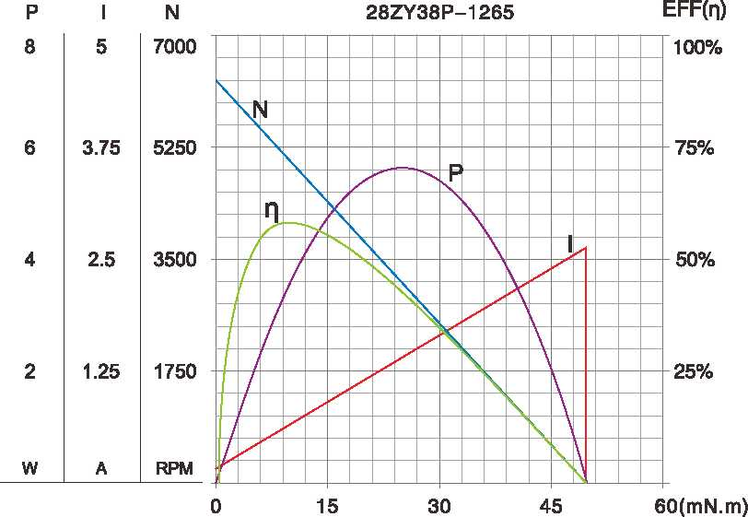
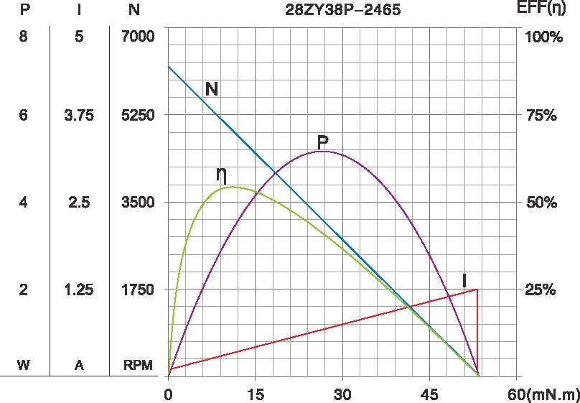

A-9
技术参数如有变动，恕不另行通知

