永磁直流行星齿轮电机（内齿圈材质:金属）
PM DC Planetary Gear Motor (Ring Gear Material: Metal)
120JX3000K/96ZY140

Φ120行星齿轮减速器，允许转矩范围：300N.m
120mm OD Planetary Gearhead,
Permissible Load Range:300N.m

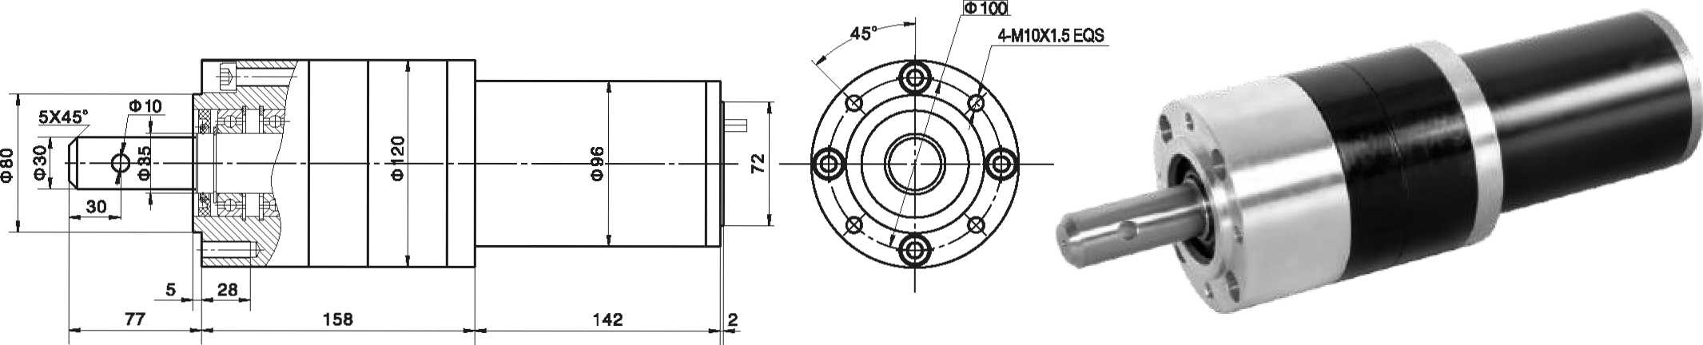
- 外形和安装尺寸Dimensions

- 电动机主要技术参数Motor Technical Data
电机型号  TYPE | 额定电压  Rated  voltage  VDC | 空载转速  No-load  Speed  r/min | 空载电流  No-load  current  A | 额定转速  Rated  Speed  r/min | 额定转矩  Rated  torque  mN.m | 输出功率  Output  Power  W | 额定电流  Rated  current  A | 堵转力矩  Stall  torque  N.m | 堵转电流  Stall  Current  A
96ZY140-2420 | 24 | 2000 | 1.0 | 1600 | 800 | 150 | 9 | 2.9 | 27
96ZY140-2435 | 24 | 3500 | 1.8 | 2800 | 950 | 200 | 13 | 3.2 | 45

- 齿轮减速电机主要技术参数Gear Motor Technical Data
配置96ZY140-2420直流电机(96ZY140-2420DC Motor)
减速比 Reduction ratio | 4.8 | 6 | 10 | 23 | 38 | 42 | 69 | 84 | 142 | 234 | 258 | 387 | 427
减速级数 Number of gear trains | 1 | 1 | 1 | 2 | 2 | 2 | 2 | 3 | 3 | 3 | 3 | 3 | 3
减速器长度(L) Length(L) mm | 119 | 119 | 119 | 153 | 153 | 153 | 153 | 182 | 182 | 182 | 182 | 182 | 182
空载转速 No-load speed r/min | 416 | 233 | 200 | 87 | 52 | 47 | 29 | 24 | 14 | 8.5 | 7.7 | 5.2 | 4.6
额定转速 Rated speed r/min | 333 | 266 | 160 | 70 | 42 | 38 | 23 | 19 | 11 | 6.8 | 6.2 | 4.1 | 3.7
额定转矩 Rated torque N.m | 3.4 | 4.3 | 7.2 | 15 | 24 | 27 | 44 | 49 | 83 | 136 | 150 | 200 | 249
最大瞬间允许负载 N.m  Max. permissible load in a short time | 150 | 150 | 150 | 450 | 450 | 450 | 450 | 900 | 900 | 900 | 900 | 900 | 900
配置96ZY140-2435直流电机(96ZY140-2435 DC Motor)
减速比 Reduction ratio | 4.8 | 6 | 10 | 23 | 38 | 42 | 69 | 84 | 142 | 234 | 258 | 387 | 427
减速级数 Number of gear trains | 1 | 1 | 1 | 2 | 2 | 2 | 2 | 3 | 3 | 3 | 3 | 3 | 3
减速器长度(L) Length(L) mm | 119 | 119 | 119 | 153 | 153 | 153 | 153 | 182 | 182 | 182 | 182 | 182 | 182
空载转速 No-load speed r/min | 729 | 583 | 350 | 152 | 92 | 83 | 51 | 42 | 25 | 15 | 13.5 | 9 | 8
额定转速 Rated speed r/min | 583 | 466 | 280 | 121 | 73 | 66 | 40 | 33 | 19 | 12 | 10.8 | 7.2 | 6.5
额定转矩 Rated torque N.m | 4.1 | 5.1 | 8.5 | 17 | 29 | 32 | 53 | 58 | 98 | 162 | 178 | 268 | 296
最大瞬间允许负载 N.m  Max. permissible load in a short time | 150 | 150 | 150 | 450 | 450 | 450 | 450 | 900 | 900 | 900 | 900 | 900 | 900

- 电动机特性图 Motor Characteristic Figure
技术参数如有变动，恕不另行通知
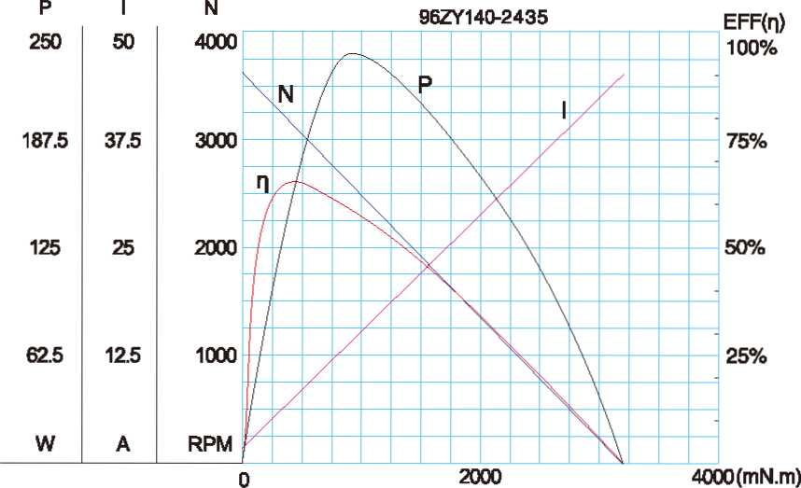
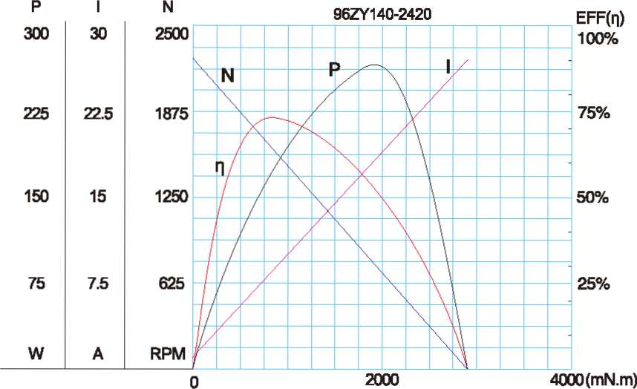

A-37

