永磁直流行星齿轮电机（内齿圈材质:金属）
PM DC Planetary Gear Motor (Ring Gear Material: Metal)
92JX4500K/80ZY170

Φ92 行星齿轮减速器，允许转矩范围：450N.m
92mm OD Planetary Gearhead,
Permissible Load Range:450N.m

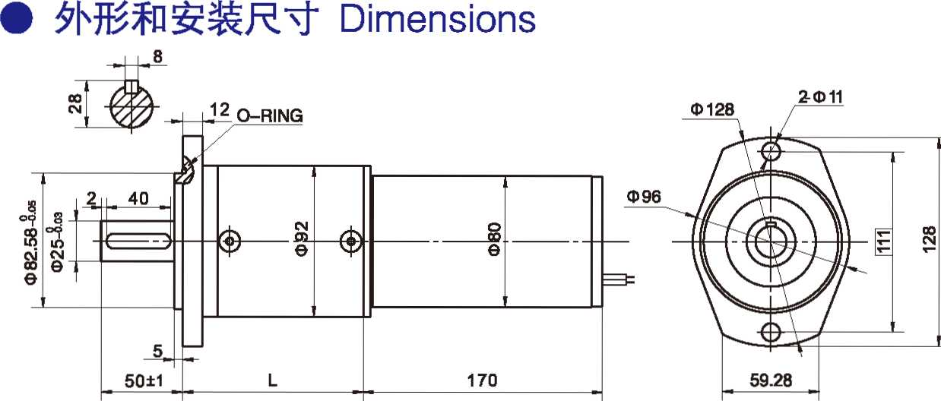
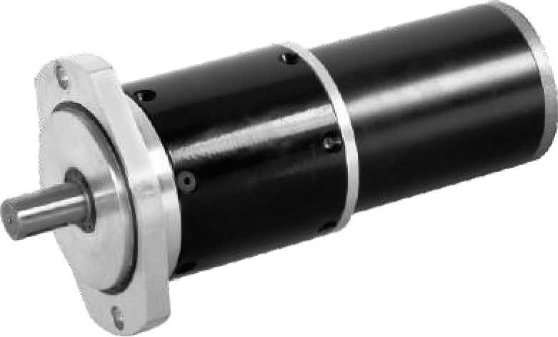
- 外形和安装尺寸Dimensions

- 电动机主要技术参数Motor Technical Data
电机型号  TYPE | 额定电压  Rated  voltage  VDC | 空载转速  No-load  speed  r/min | 空载电流  No-load  current  A | 额定转速  Rated  speed  r/min | 额定转矩  Rated  torque  N.m | 输出功率 Output  Power  W | 额定电流  Rated  current  A | 堵转力矩  Stall  torque  N.m | 堵转电流  Stall  current  A
80ZY170-2415 | 24 | 1500 | 0.5 | 1250 | 0.8 | 105 | 7 | 3.5 | 24
80ZY170-2420 | 24 | 2000 | 0.6 | 1600 | 0.9 | 150 | 9 | 4.0 | 30

- 齿轮减速电机主要技术参数Gear Motor Technical Data
配置80ZY170-2415直流电机(80ZY170-2415 DC Motor)
减速比 Reduction ratio | 95 | 135 | 239 | 387 | 422 | 506 | 576 | 717 | 772
减速级数 Number of gear trains | 3 | 3 | 3 | 3 | 3 | 4 | 4 | 4 | 4
减速器长度(L) Length(L) mm | 124 | 124 | 124 | 124 | 124 | 143 | 143 | 143 | 143
空载转速 No-load speed r/min | 15.8 | 11 | 6.3 | 3.9 | 3.6 | 3.0 | 2.6 | 2.1 | 1.9
额定转速 Rated speed r/min | 13 | 9.2 | 5.2 | 3.2 | 3.0 | 2.5 | 2.2 | 1.7 | 1.6
额定转矩 Rated torque N.m | 55 | 79 | 139 | 226 | 246 | 267 | 304 | 378 | 408
最大瞬间允许负载 N.m  Max. permissible load in a short time | 300 | 300 | 300 | 300 | 300 | 600 | 600 | 600 | 600
配置80ZY170-2420直流电机(80ZY170-2420 DC Motor)
减速比 Reduction ratio | 95 | 135 | 239 | 387 | 422 | 506 | 576 | 717 | 772
减速级数 Number of gear trains | 3 | 3 | 3 | 3 | 3 | 4 | 4 | 4 | 4
减速器长度(L) Length(L) mm | 124 | 124 | 124 | 124 | 124 | 143 | 143 | 143 | 143
空载转速 No-load speed r/min | 21 | 15 | 8.4 | 5.2 | 4.7 | 4.0 | 3.5 | 2.8 | 2.6
额定转速 Rated speed r/min | 17 | 12 | 6.7 | 4.1 | 3.8 | 3.2 | 2.8 | 2.2 | 2.1
额定转矩 Rated torque N.m | 62 | 88 | 157 | 254 | 277 | 300 | 342 | 425 | 458
最大瞬间允许负载 N.m  Max. permissible load in a short time | 300 | 300 | 300 | 300 | 300 | 600 | 600 | 600 | 600

- 电动机特性图 Motor Characteristic Figure
技术参数如有变动，恕不另行通知
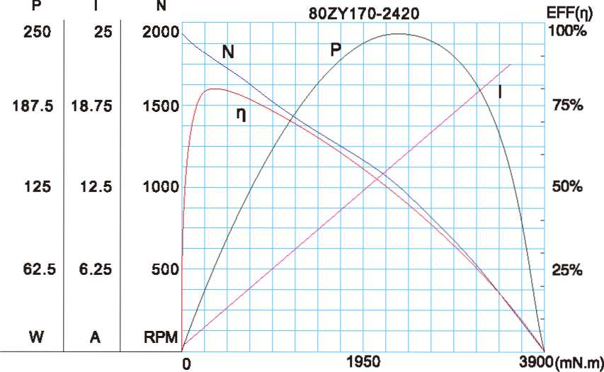
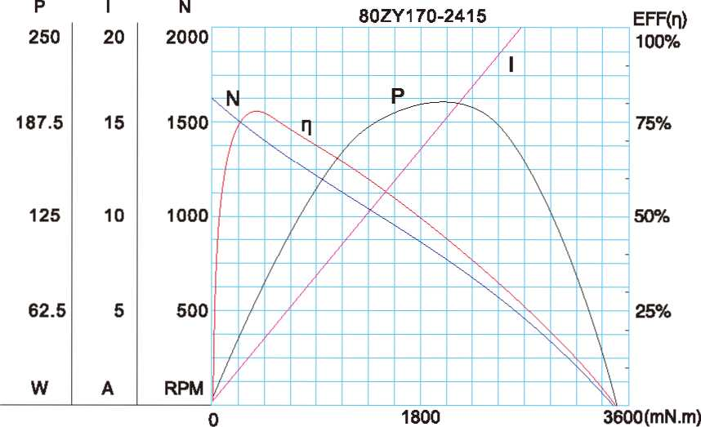

A-36

