永磁直流行星齿轮电机（内齿圈材质:金属）
PM DC Planetary Gear Motor (Ring Gear Material: Metal)
Φ82 行星齿轮减速器，允许转矩范围：120N.m
82mm OD Planetary Gearhead,
Permissible Load Range:120N.m
82JX1200K/80ZY115

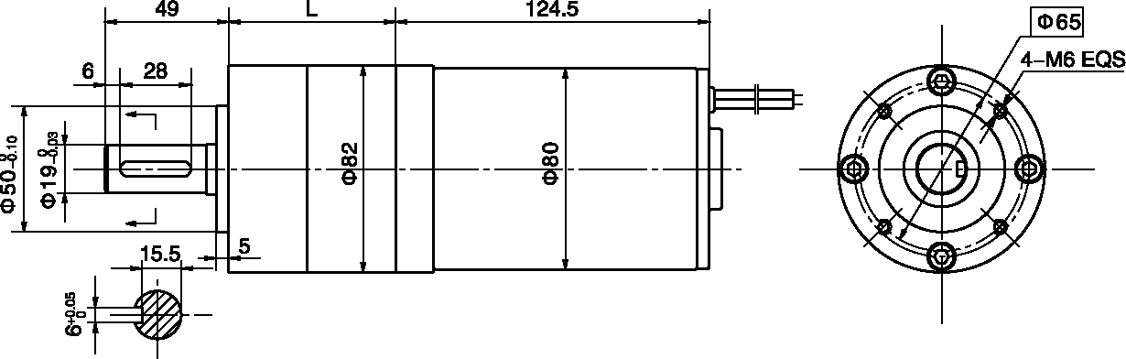
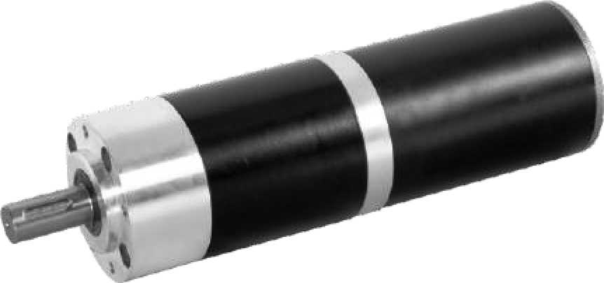
- 外形和安装尺寸Dimensions

- 电动机主要技术参数Motor Technical Data
电机型号  TYPE | 额定电压  Rated  voltage  VDC | 空载转速  No-load  Speed  r/min | 空载电流  No-load  current  A | 额定转速  Rated  speed  r/min | 额定转矩  Rated  torque  mN.m | 输出功率  Output  power  W | 额定电流  Rated  current  A | 堵转力矩  Stall  torque  N.m | 堵转电流  Stall  current  A
80ZY115-2420 | 24 | 2000 | 0.3 | 1500 | 440 | 72 | 4.2 | 1.7 | 15.4
80ZY115-2430 | 24 | 3000 | 0.5 | 2700 | 320 | 90 | 5.2 | 2.5 | 30

- 齿轮减速电机主要技术参数Gear Motor Technical Data
配置80ZY115-2420直流电机(80ZY115-2420 DC Motor)
减速比 Reduction ratio | 4 | 7 | 14 | 19 | 25 | 32 | 50 | 64 | 71 | 90 | 116 | 152 | 195 | 329
减速级数 Number of gear trains | 1 | 1 | 2 | 2 | 2 | 2 | 3 | 3 | 3 | 3 | 3 | 3 | 3 | 3
减速器长度(L)Length(L) mm | 66 | 66 | 90 | 90 | 90 | 90 | 115 | 115 | 115 | 115 | 115 | 115 | 115 | 115
空载转速 No-load speed r/min | 500 | 286 | 143 | 105 | 80 | 63 | 40 | 31 | 28 | 22 | 17 | 13 | 10 | 6
额定转速 Rated speed r/min | 375 | 214 | 107 | 79 | 60 | 47 | 30 | 23 | 21 | 17 | 13 | 10 | 8 | 4.5
额定转矩 Rated torque N.m | 1.6 | 2.8 | 5.0 | 6.8 | 8.9 | 11 | 16 | 21 | 23 | 29 | 37 | 49 | 63 | 105
最大瞬间允许负载 N.m  Max. permissible load in a short time | 60 | 60 | 180 | 180 | 180 | 180 | 360 | 360 | 360 | 360 | 360 | 360 | 360 | 360
配置80ZY115-2430直流电机(80ZY115-2430 DC Motor)
减速比 Reduction ratio | 4 | 7 | 14 | 19 | 25 | 32 | 50 | 64 | 71 | 90 | 116 | 152 | 195 | 329
减速级数 Number of gear trains | 1 | 1 | 2 | 2 | 2 | 2 | 3 | 3 | 3 | 3 | 3 | 3 | 3 | 3
减速器长度(L)Length(L) mm | 66 | 66 | 90 | 90 | 90 | 90 | 115 | 115 | 115 | 115 | 115 | 115 | 115 | 115
空载转速 No-load speed r/min | 750 | 429 | 214 | 158 | 120 | 94 | 60 | 47 | 42 | 33 | 26 | 20 | 15 | 9
额定转速 Rated speed r/min | 675 | 386 | 193 | 142 | 108 | 84 | 54 | 42 | 38 | 30 | 23 | 17.5 | 13.8 | 8
额定转矩 Rated torque N.m | 1.2 | 2.0 | 3.6 | 4.9 | 6.5 | 8.3 | 12 | 15 | 16.5 | 21 | 27 | 36 | 46 | 77
最大瞬间允许负载 N.m  Max. permissible load in a short time | 60 | 60 | 180 | 180 | 180 | 180 | 360 | 360 | 360 | 360 | 360 | 360 | 360 | 360

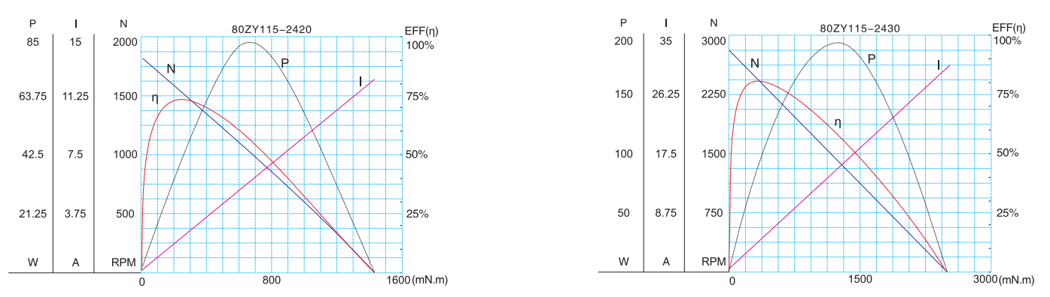
- 电动机特性图 Motor Characteristic Figure
技术参数如有变动，恕不另行通知

A-33

