永磁直流行星齿轮电机（内齿圈材质:金属）
PM DC Planetary Gear Motor (Ring Gear Material: Metal)
56JX300K/80ZY115

Φ56 行星减速器，允许转矩范围：30N.m
56mm OD Planetary Gearbox,
Permissible Load Range:30N.m

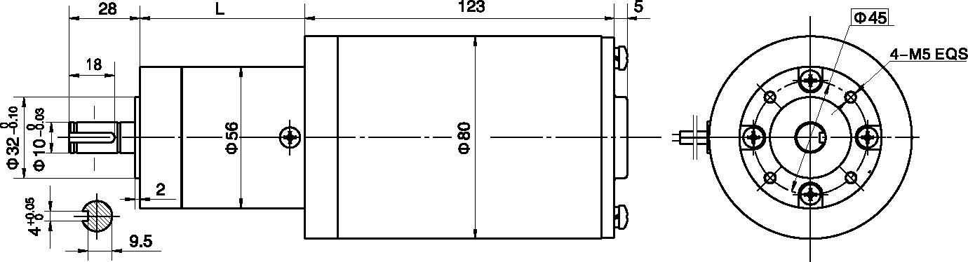
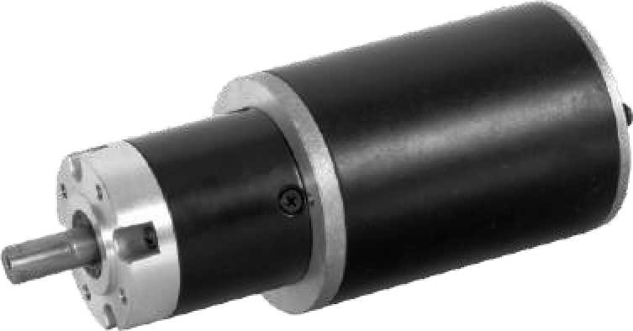
- 外形和安装尺寸Dimensions

- 电动机主要技术参数Motor Technical Data
电机型号  TYPE | 额定电压  Rated  voltage  VDC | 空载转速  No-load  Speed  r/min | 空载电流  No-load  current  A | 额定转速  Rated  Speed  r/min | 额定转矩  Rated  torque  mN.m | 输出功率  Output  Power  W | 额定电流  Rated  current  A | 堵转力矩  Stall  torque  N.m | 堵转电流  Stall  current  A
80ZY115-2430 | 24 | 3000 | 0.80 | 2400 | 450 | 120 | 7.5 | 2.5 | 30
80ZY115-2435 | 24 | 3500 | 1.10 | 2900 | 500 | 150 | 9.5 | 3.0 | 35

- 齿轮减速电机主要技术参数Gear Motor Technical Data
配置80ZY115-2430直流电机(80ZY115-2430 DC Motor)
减速比 Reduction ratio | 3.6 | 4.25 | 7.5 | 13 | 15 | 18 | 27 | 32 | 47 | 55 | 65 | 76
减速级数 Number of gear trains | 1 | 1 | 1 | 2 | 2 | 2 | 2 | 2 | 3 | 3 | 3 | 3
减速器长度(L) Length(L) mm | 41 | 41 | 41 | 61 | 61 | 61 | 61 | 61 | 72 | 72 | 72 | 72
空载转速 No-load speed r/min | 833 | 706 | 400 | 230 | 200 | 167 | 111 | 94 | 64 | 54 | 46 | 39
额定转速 Rated speed r/min | 667 | 565 | 320 | 185 | 160 | 133 | 88 | 75 | 51 | 44 | 37 | 32
额定转矩 Rated torque N.m | 1.46 | 1.72 | 2.7 | 4.7 | 5.4 | 6.5 | 8.7 | 10.3 | 15.4 | 18 | 21.3 | 25
最大瞬间允许负载 N.m  Max. permissible load in a short time | 6 | 6 | 6 | 25 | 25 | 25 | 25 | 25 | 50 | 50 | 50 | 50
配置80ZY115-2435直流电机(80ZY115-2435 DC Motor)
减速比 Reduction ratio | 3.6 | 4.25 | 7.5 | 13 | 15 | 18 | 27 | 32 | 47 | 55 | 65 | 76
减速级数 Number of gear trains | 1 | 1 | 1 | 2 | 2 | 2 | 2 | 2 | 3 | 3 | 3 | 3
减速器长度(L)Length(L) mm | 41 | 41 | 41 | 61 | 61 | 61 | 61 | 61 | 72 | 72 | 72 | 72
空载转速 No-load speed r/min | 972 | 824 | 467 | 269 | 233 | 194 | 130 | 109 | 74 | 64 | 54 | 46
额定转速 Rated speed r/min | 805 | 682 | 320 | 223 | 193 | 161 | 107 | 90 | 62 | 53 | 44 | 38
额定转矩 Rated torque N.m | 1.6 | 1.9 | 3.0 | 5.2 | 6.0 | 7.2 | 9.8 | 11.6 | 17 | 20 | 23.7 | 27.7
最大瞬间允许负载 N.m  Max. permissible load in a short time | 6 | 6 | 6 | 6 | 25 | 25 | 25 | 25 | 50 | 50 | 50 | 50

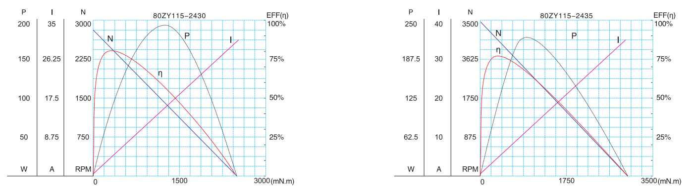
- 电动机特性图 Motor Characteristic Figure
技术参数如有变动，恕不另行通知

A-32

