永磁直流行星齿轮电机（内齿圈材质:金属）
PM DC Planetary Gear Motor (Ring Gear Material: Metal)
56JX300K/60ZY105

Φ56 加强型减速器，允许转矩范围：2N.m~30N.m
56mm OD Reinforced Gearbox,
Permissible Load Range:2 N.m~30N.m

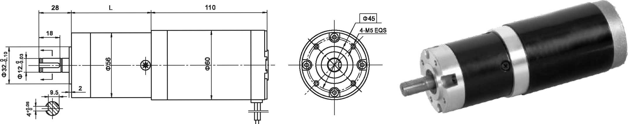
- 外形和安装尺寸Dimensions

- 电动机主要技术参数Motor Technical Data
电机型号  TYPE | 额定电压  Rated  voltage  VDC | 空载转速  No-load  speed  r/min | 空载电流  No-load  current  A | 额定转速  Rated  speed  r/min | 额定转矩  Rated  torque  mN.m | 输出功率 Output  Power  W | 额定电流  Rated  current  A | 堵转力矩  Stall  torque  mN.m | 堵转电流  Stall  current  A
60ZY105-2420 | 24 | 2000 | 0.25 | 1600 | 165 | 30 | 1.8 | 760 | 7.3
60ZY105-2430 | 24 | 3000 | 0.35 | 2400 | 180 | 45 | 2.2 | 790 | 11.2
60ZY105-2450 | 24 | 5000 | 0.50 | 4000 | 230 | 90 | 6.0 | 920 | 15.5

- 齿轮减速电机主要技术参数Gear Motor Technical Data
配置60ZY105-2430直流电机(60ZY105-2430 DC Motor)
减速比 Reduction ratio | 3.6 | 4.25 | 7.5 | 13 | 15 | 18 | 27 | 32 | 47 | 55 | 65 | 76 | 115 | 168 | 198 | 234
减速级数 Number of gear trains | 1 | 1 | 1 | 2 | 2 | 2 | 2 | 2 | 3 | 3 | 3 | 3 | 3 | 4 | 4 | 4
减速器长度(L) Length(L) mm | 41 | 41 | 41 | 53 | 53 | 53 | 53 | 53 | 64 | 64 | 64 | 64 | 64 | 84 | 84 | 84
空载转速 No-load speed r/min | 833 | 706 | 400 | 230 | 200 | 167 | 111 | 94 | 64 | 54 | 46 | 39 | 26 | 18 | 15 | 13
额定转速 Rated speed r/min | 667 | 565 | 320 | 185 | 160 | 133 | 89 | 75 | 51 | 44 | 37 | 32 | 20 | 14 | 12 | 10
额定转矩 Rated torque N.m | 0.58 | 0.68 | 1.2 | 1.8 | 2.1 | 2.6 | 3.9 | 4.6 | 6.1 | 7.2 | 8.5 | 10 | 15 | 20 | 23.5 | 28
最大瞬间允许负载 N.m  Max. permissible load in a short time | 6 | 6 | 6 | 25 | 25 | 25 | 25 | 25 | 50 | 50 | 50 | 50 | 50 | 90 | 90 | 90
配置60ZY105-2450直流电机(60ZY105-2450DC Motor)
减速比 Reduction ratio | 3.6 | 4.25 | 7.5 | 13 | 15 | 18 | 27 | 32 | 47 | 55 | 65 | 76 | 168 | 198
减速级数 Number of gear trains | 1 | 1 | 1 | 2 | 2 | 2 | 2 | 2 | 3 | 3 | 3 | 3 | 4 | 4
减速器长度(L) Length(L) mm | 41 | 41 | 41 | 53 | 53 | 53 | 53 | 53 | 64 | 64 | 64 | 64 | 84 | 84
空载转速 No-load speed r/min | 1389 | 1176 | 666 | 385 | 333 | 278 | 185 | 156 | 106 | 91 | 77 | 66 | 30 | 25
额定转速 Rated speed r/min | 1111 | 941 | 533 | 307 | 266 | 222 | 148 | 125 | 85 | 72 | 61 | 52 | 24 | 20
额定转矩 Rated torque N.m | 0.74 | 0.87 | 1.5 | 2.4 | 2.7 | 3.3 | 5.0 | 5.9 | 7.8 | 9.2 | 10.9 | 12.7 | 25.5 | 30
最大瞬间允许负载 N.m  Max. permissible load in a short time | 6 | 6 | 25 | 25 | 25 | 25 | 25 | 25 | 50 | 50 | 50 | 50 | 60 | 60

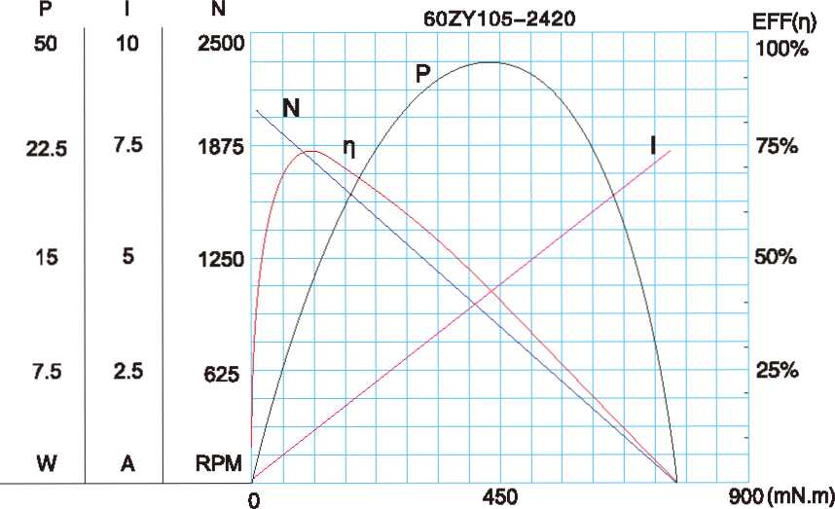
- 电动机特性图 Motor Characteristic Figure
技术参数如有变动，恕不另行通知
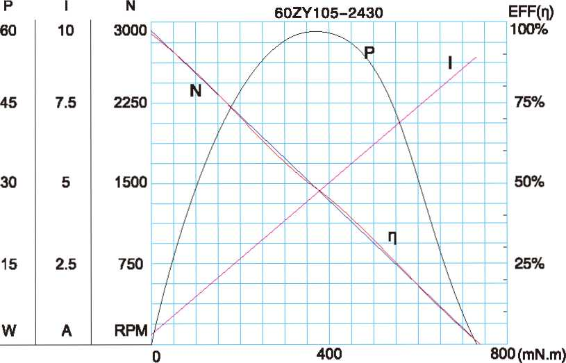

A-30

