永磁直流行星齿轮电机（内齿圈材质:金属）
PM DC Planetary Gear Motor (Ring Gear Material: Metal)
24JN10K/24ZY30₍₁₎
Φ24 行星减速器，允许转矩范围：0.1N.m~1.0N.m
24mm OD Planetary Gearbox,
Permissible Load Range:0.1N.m~1.0N.m
减速器输出轴直径可以做成Φ6,轴伸长度20
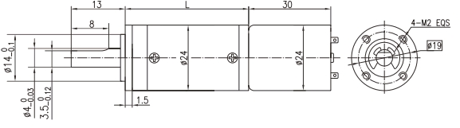
The diameter of the gearbox output shaft can be madeΦ6, the shaft length can be made 20
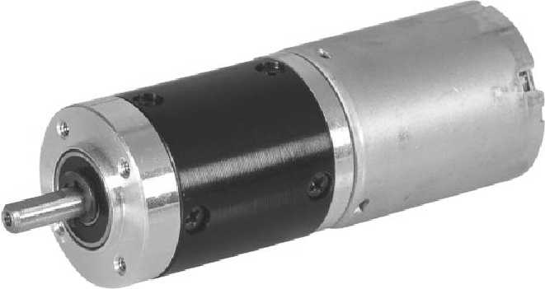
- 外形和安装尺寸Dimensions
- 电动机主要技术参数Motor Technical Data
电机型号  Type | 额定电压  Rated  voltage  VDC | 空载转速  No-load  speed  r/min | 空载电流  No-load  current  mA | 额定转速  Rated  Speed  r/min | 额定转矩  Rated  Torque  mN.m | 输出功率  Output  Power  W | 额定电流  Rated  current  mA | 堵转力矩  Stall  Torque  mN.m | 堵转电流  Stall  Current  A
24ZY30-1230 | 12 | 3000 | 40 | 2400 | 2 | 0.5 | 90 | 10 | 0.3
24ZY30-1245 | 12 | 4500 | 60 | 3600 | 2.5 | 0.9 | 170 | 12.5 | 0.5
24ZY30-1260 | 12 | 6000 | 70 | 4800 | 3 | 1.5 | 240 | 15 | 1.0

- 齿轮减速电机主要技术参数Gear Motor Technical Data
配置24ZY30-1230直流电机(24ZY30-1230 DC Motor)
减速比 Reduction ratio | 14 | 19 | 27 | 51 | 71 | 100 | 139 | 189 | 264 | 369 | 516 | 720 | 981 | 1370
减速级数 Number of gear trains | 2 | 2 | 2 | 3 | 3 | 3 | 3 | 4 | 4 | 4 | 4 | 4 | 5 | 5
减速器长度(L) Length(L) mm | 31.6 | 31.6 | 31.6 | 38.0 | 38.0 | 38.0 | 38.0 | 44.4 | 44.4 | 44.4 | 44.4 | 44.4 | 50.8 | 50.8
空载转速 No-load speed r/min | 214 | 158 | 111 | 59 | 42 | 30 | 22 | 16 | 11 | 8.1 | 5.8 | 4.2 | 3.1 | 2.2
额定转速 Rated speed r/min | 171 | 126 | 89 | 47 | 34 | 24 | 17 | 13 | 9.1 | 6.5 | 4.7 | 3.3 | 2.4 | 1.8
额定转矩 Rated torque N.m | 0.023 | 0.031 | 0.044 | 0.074 | 0.10 | 0.15 | 0.20 | 0.25 | 0.34 | 0.48 | 0.67 | 0.94 | 1.0 | 1.0
最大瞬间允许负载 N.m  Max. permissible load in a short time | 1.2 | 1.2 | 1.2 | 2.5 | 2.5 | 2.5 | 2.5 | 3.0 | 3.0 | 3.0 | 3.0 | 3.0 | 3.0 | 3.0

配置24ZY30-1245直流电机(24ZY30-1245 DC Motor)
减速比 Reduction ratio | 3.7 | 5.2 | 14 | 19 | 27 | 51 | 71 | 100 | 139 | 189 | 264 | 369 | 516 | 720
减速级数 Number of gear trains | 1 | 1 | 2 | 2 | 2 | 3 | 3 | 3 | 3 | 4 | 4 | 4 | 4 | 4
减速器长度(L) Length(L) mm | 25.0 | 25.0 | 31.6 | 31.6 | 31.6 | 38.0 | 38.0 | 38.0 | 38.0 | 44.4 | 44.4 | 44.4 | 44.4 | 44.4
空载转速 No-load speed r/min | 1213 | 869 | 321 | 237 | 167 | 88 | 63 | 45 | 32 | 24 | 17 | 12 | 8.7 | 6.3
额定转速 Rated speed r/min | 970 | 695 | 257 | 189 | 133 | 71 | 51 | 36 | 26 | 19 | 14 | 9.8 | 7.0 | 5.0
额定转矩 Rated torque N.m | 0.008 | 0.012 | 0.028 | 0.038 | 0.055 | 0.093 | 0.13 | 0.18 | 0.25 | 0.31 | 0.43 | 0.60 | 0.84 | 1.0
最大瞬间允许负载 N.m  Max. permissible load in a short time | 0.3 | 0.3 | 1.2 | 1.2 | 1.2 | 2.5 | 2.5 | 2.5 | 2.5 | 3.0 | 3.0 | 3.0 | 3.0 | 3.0

配置24ZY30-1260直流电机(24ZY30-1260 DC Motor)
减速比 Reduction ratio | 3.7 | 5.2 | 14 | 19 | 27 | 51 | 71 | 100 | 139 | 189 | 264 | 369 | 516 | 720
减速级数 Number of gear trains | 1 | 1 | 2 | 2 | 2 | 3 | 3 | 3 | 3 | 4 | 4 | 4 | 4 | 4
减速器长度(L) Length(L) mm | 25.0 | 25.0 | 31.6 | 31.6 | 31.6 | 38.0 | 38.0 | 38.0 | 38.0 | 44.4 | 44.4 | 44.4 | 44.4 | 44.4
空载转速 No-load speed r/min | 1617 | 1158 | 429 | 316 | 222 | 118 | 85 | 60 | 43 | 32 | 23 | 16 | 12 | 8.3
额定转速 Rated speed r/min | 1294 | 927 | 343 | 253 | 178 | 94 | 68 | 48 | 35 | 25 | 18 | 13 | 9.3 | 6.7
额定转矩 Rated torque N.m | 0.010 | 0.014 | 0.034 | 0.046 | 0.066 | 0.11 | 0.16 | 0.22 | 0.30 | 0.37 | 0.51 | 0.72 | 1.0 | 1.0
最大瞬间允许负载 N.m  Max. permissible load in a short time | 0.3 | 0.3 | 1.2 | 1.2 | 1.2 | 2.5 | 2.5 | 2.5 | 2.5 | 3.0 | 3.0 | 3.0 | 3.0 | 3.0
A-3
技术参数如有变动，如不另行通知

