永磁直流行星齿轮电机（内齿圈材质:金属）
PM DC Planetary Gear Motor (Ring Gear Material: Metal)
Φ56 标准型减速器，允许转矩范围：2N.m~20N.m
56mm OD Standard Gearbox,
Permissible Load Range:2N.m~20N.m
56JX200K/60ZY95

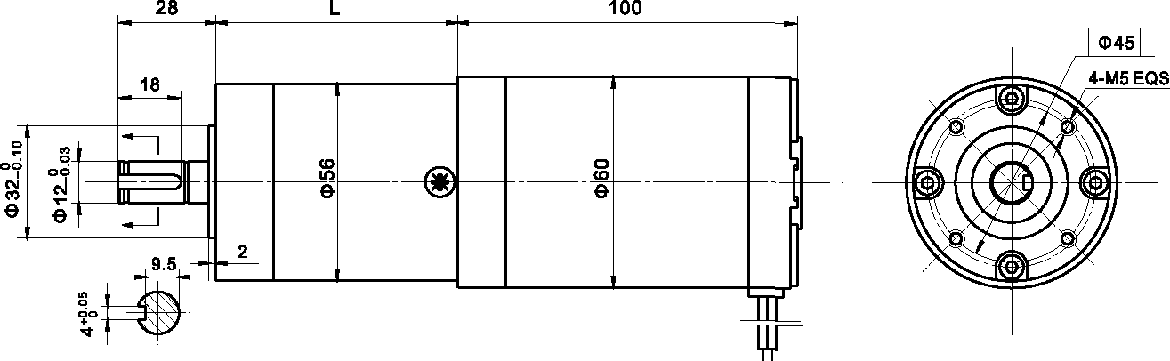
- 外形和安装尺寸Dimensions

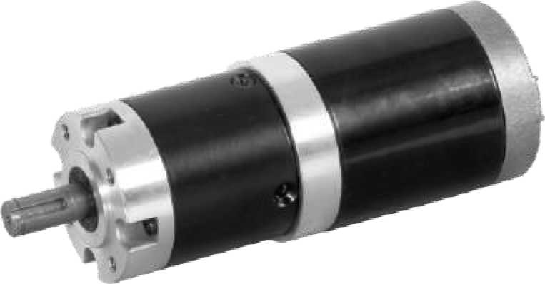

- 电动机主要技术参数Motor Technical Data
电机型号  TYPE | 额定电压  Rated  Voltage  VDC | 空载转速  No-load  speed  r/min | 空载电流  No-load  current  A | 额定转速  Rated  speed  r/min | 额定转矩  Rated  torque  mN.m | 输出功率 Output  Power  W | 额定电流  Rated  current  A | 堵转力矩  Stall  Torque  mN.m | 堵转电流  Stall  Current  A
60ZY95-2420 | 24 | 2000 | 0.4 | 1600 | 150 | 25 | 1.8 | 560 | 6.0
60ZY95-2430 | 24 | 3000 | 0.5 | 2400 | 180 | 40 | 3.0 | 690 | 11.0

- 齿轮减速电机主要技术参数Gear Motor Technical Data
配置60ZY95-2420直流电机(60ZY95-2420 DC Motor)
减速比 Reduction ratio | 3.6 | 4.25 | 7.5 | 13 | 15 | 18 | 27 | 32 | 47 | 55 | 65 | 76 | 115 | 168 | 198 | 234
减速级数 Number of gear trains | 1 | 1 | 1 | 2 | 2 | 2 | 2 | 2 | 3 | 3 | 3 | 3 | 3 | 4 | 4 | 4
减速器长度(L) Length(L) mm | 41 | 41 | 41 | 53 | 53 | 53 | 61 | 61 | 64 | 64 | 64 | 64 | 64 | 76 | 76 | 76
空载转速 No-load speed r/min | 556 | 470 | 266 | 154 | 133 | 111 | 74 | 63 | 43 | 36 | 31 | 26 | 17 | 12 | 10 | 9
额定转速 Rated speed r/min | 444 | 376 | 213 | 123 | 106 | 88 | 59 | 50 | 34 | 29 | 24 | 21 | 14 | 9.5 | 8 | 6.8
额定转矩 Rated torque N.m | 0.48 | 0.57 | 1.0 | 1.5 | 1.8 | 2.1 | 3.2 | 3.8 | 5.1 | 6.0 | 7.1 | 8.3 | 12.5 | 16.5 | 19.6 | 20
最大瞬间允许负载 N.m  Max. permissible load in a short time | 6 | 6 | 6 | 25 | 25 | 25 | 25 | 25 | 50 | 50 | 50 | 50 | 50 | 60 | 60 | 60
配置60ZY95-2430直流电机(60ZY95-2430 DC Motor)
减速比 Reduction ratio | 3.6 | 4.25 | 7.5 | 13 | 15 | 18 | 27 | 32 | 47 | 55 | 65 | 76 | 115 | 168 | 198
减速级数 Number of gear trains | 1 | 1 | 1 | 2 | 2 | 2 | 2 | 2 | 3 | 3 | 3 | 3 | 3 | 4 | 4
减速器长度(L) Length(L) mm | 41 | 41 | 41 | 53 | 53 | 53 | 53 | 53 | 64 | 64 | 64 | 64 | 64 | 76 | 76
空载转速 No-load speed r/min | 833 | 706 | 400 | 230 | 200 | 167 | 111 | 94 | 64 | 54 | 46 | 39 | 26 | 18 | 15
额定转速 Rated speed r/min | 667 | 565 | 320 | 185 | 160 | 133 | 89 | 75 | 51 | 44 | 37 | 32 | 20 | 14 | 12
额定转矩 Rated torque N.m | 0.58 | 0.68 | 0.82 | 1.9 | 2.1 | 2.6 | 3.9 | 4.6 | 6.1 | 72 | 8.5 | 10 | 15 | 19 | 20
最大瞬间允许负载 N.m  Max. permissible load in a short time | 6 | 6 | 6 | 25 | 25 | 25 | 25 | 25 | 50 | 50 | 50 | 50 | 50 | 60 | 60

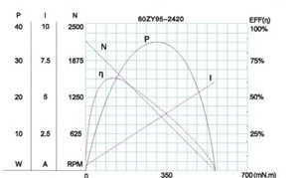
- 电动机特性图 Motor Characteristic Figure
技术参数如有变动，恕不另行通知
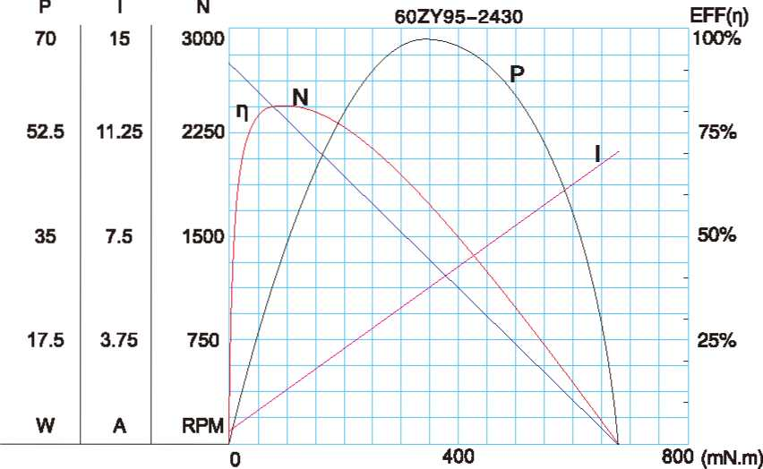

A-29

