永磁直流行星齿轮电机（内齿圈材质:金属）
PM DC Planetary Gear Motor (Ring Gear Material: Metal)
Φ56 标准型减速器，允许转矩范围：2N.m~20N.m
56mm OD Standard Gearbox,
Permissible Load Range:2N.m~20N.m
56JX200K/60ZY75

- 外形和安装尺寸Dimensions

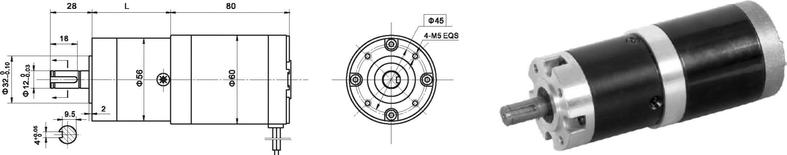

- 电动机主要技术参数Motor Technical Data
电机型号  TYPE | 额定电压  Rated  voltage  VDC | 空载转速  No-load  speed  r/min | 空载电流  No-load  current  A | 额定转速  Rated  Speed  r/min | 额定转矩  Rated  Torque  mN.m | 输出功率 Output  Power  W | 额定电流  Rated  current  A | 堵转力矩  Stall  Torque  mN.m | 堵转电流  Stall  current  A
60ZY75-2420 | 24 | 2000 | 0.3 | 1600 | 50 | 8 | 0.8 | 215 | 2.1
60ZY75-2430 | 24 | 3000 | 0.4 | 2400 | 70 | 17 | 1.2 | 296 | 5.0
60ZY75-2440 | 24 | 4000 | 0.5 | 3200 | 90 | 30 | 2.2 | 404 | 8.5

- 齿轮减速电机主要技术参数Gear Motor Technical Data
配置60ZY75-2430直流电机(60ZY75-2430 DC Motor)
减速比 Reduction ratio | 3.6 | 4.25 | 7.5 | 13 | 15 | 18 | 27 | 32 | 47 | 55 | 65 | 76 | 115 | 168 | 198 | 234 | 276 | 326
减速级数 Number of gear trains | 1 | 1 | 1 | 2 | 2 | 2 | 2 | 2 | 3 | 3 | 3 | 3 | 3 | 4 | 4 | 4 | 4 | 4
减速器长度(L) Length(L) mm | 41 | 41 | 41 | 53 | 53 | 53 | 53 | 53 | 64 | 64 | 64 | 64 | 64 | 76 | 76 | 76 | 76 | 76
空载转速 No-load speed r/min | 833 | 706 | 400 | 230 | 200 | 167 | 111 | 94 | 64 | 54 | 46 | 39 | 26 | 18 | 15 | 13 | 11 | 9
额定转速 Rated speed r/min | 667 | 565 | 320 | 185 | 160 | 133 | 89 | 75 | 51 | 44 | 37 | 32 | 20 | 14 | 12 | 10 | 9 | 7.5
额定转矩 Rated torque N.m | 0.22 | 0.26 | 0.47 | 0.73 | 0.85 | 1.0 | 1.5 | 1.8 | 2.4 | 2.8 | 3.3 | 3.8 | 5.8 | 7.7 | 9.1 | 10.8 | 12.7 | 15
最大瞬间允许负载 N.m  Max. permissible load in a short time | 6 | 6 | 6 | 25 | 25 | 25 | 25 | 25 | 50 | 50 | 50 | 50 | 50 | 60 | 60 | 60 | 60 | 60
配置60ZY75-2440直流电机(60ZY75-2440 DC Motor)
减速比 Reduction ratio | 3.6 | 4.25 | 7.5 | 13 | 15 | 18 | 27 | 32 | 47 | 55 | 65 | 76 | 115 | 168 | 198 | 234 | 276 | 326
减速级数 Number of gear trains | 1 | 1 | 1 | 2 | 2 | 2 | 2 | 2 | 3 | 3 | 3 | 3 | 3 | 4 | 4 | 4 | 4 | 4
减速器长度(L) Length(L) mm | 41 | 41 | 41 | 53 | 53 | 53 | 53 | 53 | 64 | 64 | 64 | 64 | 64 | 76 | 76 | 76 | 76 | 76
空载转速 No-load speed r/min | 1111 | 941 | 533 | 308 | 267 | 222 | 148 | 125 | 85 | 73 | 62 | 53 | 26 | 24 | 20 | 17 | 15 | 12
额定转速 Rated speed r/min | 889 | 753 | 426 | 246 | 213 | 177 | 118 | 100 | 68 | 58 | 49 | 42 | 27 | 19 | 16 | 13 | 11 | 9.5
额定转矩 Rated torque N.m | 0.29 | 0.34 | 0.6 | 0.94 | 1.1 | 1.3 | 1.9 | 2.3 | 3.0 | 3.6 | 4.2 | 4.9 | 7.5 | 10 | 11.7 | 13.8 | 16.3 | 19.3
最大瞬间允许负载 N.m  Max. permissible load in a short time | 6 | 6 | 6 | 25 | 25 | 25 | 25 | 25 | 50 | 50 | 50 | 50 | 50 | 60 | 60 | 60 | 60 | 60

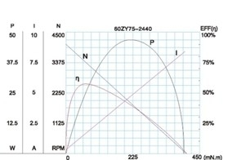
- 电动机特性图 Motor Characteristic Figure
技术参数如有变动，恕不另行通知
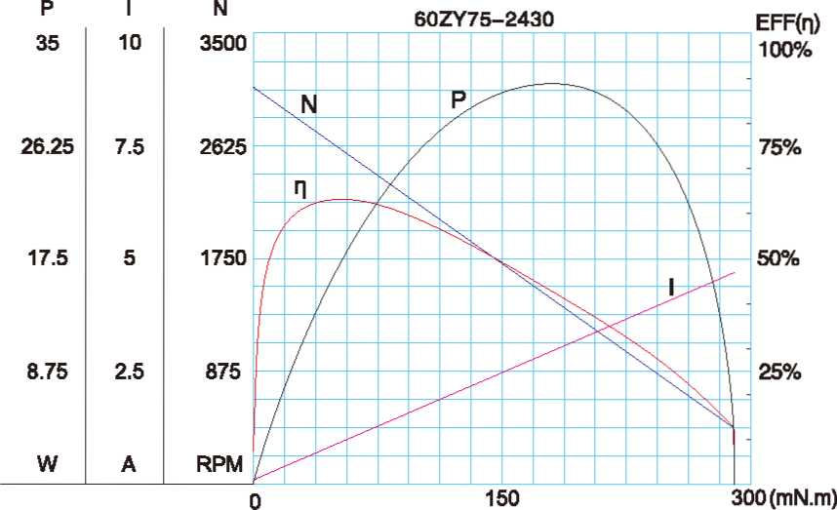

A-28

