永磁直流行星齿轮电机（内齿圈材质:金属）
PM DC Planetary Gear Motor (Ring Gear Material: Metal)
52JXM200K/52ZY125

Φ52 行星减速器，允许转矩范围：2N.m~20N.m
52mm OD Planetary Gearbox,
Permissible Load Range:2N.m~20N.m

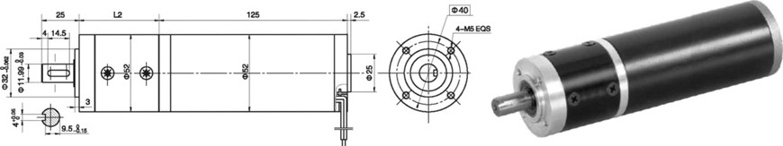
- 外形和安装尺寸Dimensions

- 电动机主要技术参数Motor Technical Data
电机型号  TYPE | 额定电压  Rated  Voltage  VDC | 空载转速  No-load  speed  r/min | 空载电流  No-load  current  A | 额定转速  Rated  speed  r/min | 额定转矩  Rated  torque  mN.m | 输出功率 Output  power  W | 额定电流  Rated  current  A | 堵转力矩  Stall  torque  mN.m | 堵转电流  Stall  Current  A
52ZY125-2420 | 24 | 2000 | 0.4 | 1600 | 160 | 28 | 2.0 | 620 | 6.5
52ZY125-2430 | 24 | 3000 | 0.6 | 2400 | 190 | 50 | 4.0 | 700 | 11.5
52ZY125-2440 | 24 | 4000 | 0.8 | 3200 | 220 | 80 | 5.0 | 838 | 16.4

- 齿轮减速电机主要技术参数Gear Motor Technical Data
配置52ZY125-2430直流电机(52ZY125-2430 DC Motor)
减速比 Reduction ratio | 4.5 | 6.25 | 8 | 20 | 28 | 36 | 50 | 64 | 91 | 127 | 162
减速级数 Number of gear trains | 1 | 1 | 1 | 2 | 2 | 2 | 2 | 2 | 3 | 3 | 3
减速器长度(L) Length(L) mm | 50 | 50 | 50 | 65 | 65 | 65 | 65 | 65 | 80 | 80 | 80
空载转速 No-load speed r/min | 666 | 480 | 375 | 150 | 106 | 83 | 60 | 46 | 33 | 24 | 18
额定转速 Rated speed r/min | 533 | 384 | 300 | 120 | 85 | 66 | 48 | 37 | 25 | 18 | 13
额定转矩 Rated torque N.m | 0.76 | 1.0 | 1.3 | 3.0 | 4.3 | 5.2 | 7.6 | 9.8 | 12.6 | 17.6 | 22
最大瞬间允许负载 N.m  Max. permissible load in a short time | 6 | 6 | 6 | 25 | 25 | 25 | 25 | 25 | 50 | 50 | 50
配置52ZY125-2440直流电机(52ZY125-2440 DC Motor)
减速比 Reduction ratio | 4.5 | 6.25 | 8 | 20 | 28 | 36 | 50 | 64 | 91 | 127
减速级数 Number of gear trains | 1 | 1 | 1 | 2 | 2 | 2 | 2 | 2 | 3 | 3
减速器长度(L) Length(L) mm | 50 | 50 | 50 | 65 | 65 | 65 | 65 | 65 | 80 | 80
空载转速 No-load speed r/min | 888 | 640 | 500 | 200 | 142 | 111 | 80 | 62 | 44 | 31
额定转速 Rated speed r/min | 711 | 512 | 400 | 160 | 114 | 88 | 64 | 50 | 35 | 25
额定转矩 Rated torque N.m | 0.9 | 1.2 | 1.5 | 3.5 | 4.9 | 6.0 | 8.9 | 11.4 | 14.6 | 20
最大瞬间允许负载 N.m  Max. permissible load in a short time | 6 | 6 | 6 | 25 | 25 | 25 | 25 | 25 | 50 | 50

- 电动机特性图 Motor Characteristic Figure
技术参数如有变动，恕不另行通知
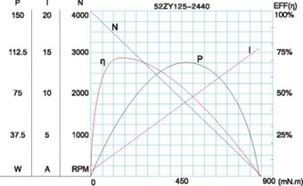
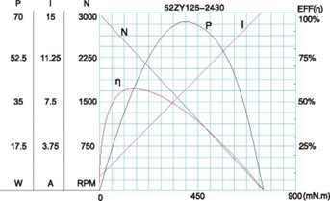

A-27

