永磁直流行星齿轮电机（内齿圈材质:金属）
PM DC Planetary Gear Motor (Ring Gear Material: Metal)
52JXM200K/52ZY95

Φ52 行星减速器，允许转矩范围：2N.m~20N.m
52mm OD Planetary Gearbox,
Permissible Load Range:2N.m~20N.m

- 外形和安装尺寸Dimensions

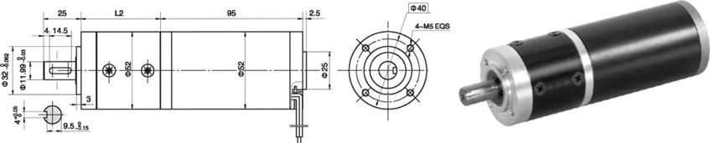
- 电动机主要技术参数Motor Technical Data
电机型号  TYPE | 额定电压  Rated  Voltage  VDC | 空载转速  No-load  speed  r/min | 空载电流  No-load  current  A | 额定转速  Rated  Speed  r/min | 额定转矩  Rated  torque  mN.m | 输出功率 Output  Power  W | 额定电流  Rated  current  A | 堵转力矩  Stall  Torque  mN.m | 堵转电流  Stall  current  A
52ZY95-2420 | 24 | 2000 | 0.2 | 1600 | 80 | 15 | 1.2 | 400 | 4.2
52ZY95-2430 | 24 | 3000 | 0.3 | 2400 | 100 | 25 | 1.8 | 410 | 6.0
52ZY95-2440 | 24 | 4000 | 0.4 | 3200 | 150 | 50 | 3.5 | 585 | 11

- 齿轮减速电机主要技术参数Gear Motor Technical Data
配置52ZY95-2420直流电机(52ZY95-2420 DC Motor)
减速比 Reduction ratio | 4.5 | 6.25 | 8 | 20 | 28 | 36 | 50 | 64 | 91 | 127 | 162 | 225 | 312
减速级数 Number of gear trains | 1 | 1 | 1 | 2 | 2 | 2 | 2 | 2 | 3 | 3 | 3 | 3 | 3
减速器长度(L) Length(L) mm | 49 | 49 | 49 | 65 | 65 | 65 | 65 | 65 | 80 | 80 | 80 | 80 | 80
空载转速 No-load speed r/min | 444 | 320 | 250 | 100 | 71 | 56 | 40 | 31 | 22 | 16 | 12 | 9 | 6
额定转速 Rated speed r/min | 356 | 256 | 200 | 80 | 57 | 44 | 32 | 25 | 17 | 12 | 9 | 7 | 5
额定转矩 Rated torque N.m | 0.32 | 0.45 | 0.58 | 1.3 | 1.8 | 2.2 | 3.2 | 4.1 | 5.3 | 7.4 | 9.5 | 13.1 | 18.2
最大瞬间允许负载 N.m  Max. permissible load in a short time | 6 | 6 | 6 | 25 | 25 | 25 | 25 | 25 | 50 | 50 | 50 | 50 | 50
配置52ZY95-2430直流电机(52ZY95-2430 DC Motor)
减速比 Reduction ratio | 4.5 | 6.25 | 8 | 20 | 28 | 36 | 50 | 64 | 91 | 127 | 162 | 225 | 312
减速级数 Number of gear trains | 1 | 1 | 1 | 2 | 2 | 2 | 2 | 2 | 3 | 3 | 3 | 3 | 3
减速器长度(L) Length(L) mm | 49 | 49 | 49 | 65 | 65 | 65 | 65 | 65 | 80 | 80 | 80 | 80 | 80
空载转速 No-load speed r/min | 666 | 480 | 375 | 150 | 106 | 83 | 60 | 46 | 33 | 24 | 18 | 13 | 9
额定转速 Rated speed r/min | 533 | 384 | 300 | 120 | 85 | 66 | 48 | 37 | 25 | 18 | 13 | 10 | 7.5
额定转矩 Rated torque N.m | 0.4 | 0.56 | 0.72 | 1.6 | 2.2 | 2.7 | 4 | 5.1 | 6.6 | 9.2 | 11.8 | 16.3 | 22
最大瞬间允许负载 N.m  Max. permissible load in a short time | 6 | 6 | 6 | 25 | 25 | 25 | 25 | 25 | 50 | 50 | 50 | 50 | 50

- 电动机特性图 Motor Characteristic Figure
技术参数如有变动，恕不另行通知
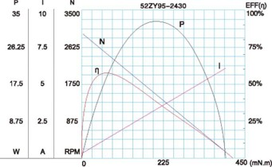
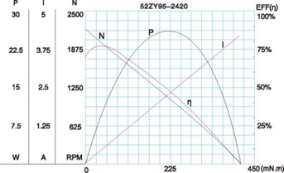

A-26

