永磁直流行星齿轮电机（内齿圈材质:金属）
PM DC Planetary Gear Motor (Ring Gear Material: Metal)
Φ52 行星减速器，允许转矩范围：2N.m~20N.m
52mm OD Planetary Gearbox,
Permissible Load Range:2N.m~20N.m
52JXM200K/52ZY85

- 外形和安装尺寸Dimensions

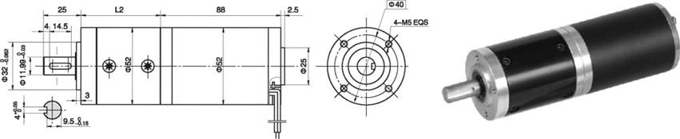
- 电动机主要技术参数Motor Technical Data
电机型号  TYPE | 额定电压  Rated  voltage  VDC | 空载转速  No-load  Speed  r/min | 空载电流  No-load  current  A | 额定转速  Rated  speed  r/min | 额定转矩  Rated  torque  mN.m | 输出功率  Output  Power  W | 额定电流  Rated  current  A | 堵转力矩  Stall  torque  mN.m | 堵转电流  Stall  current  A
52ZY85-2420 | 24 | 2000 | 0.25 | 1600 | 60 | 10 | 0.9 | 260 | 5.0
52ZY85-2430 | 24 | 3000 | 0.35 | 2400 | 75 | 18 | 1.5 | 320 | 6.0
52ZY85-2440 | 24 | 4000 | 0.42 | 3200 | 80 | 27 | 2.0 | 446 | 7.5

- 齿轮减速电机主要技术参数Gear Motor Technical Data
配置52ZY85-2420直流电机(52ZY85-2420 DC Motor)
减速比 Reduction ratio | 4.5 | 6.25 | 8 | 20 | 28 | 36 | 50 | 64 | 91 | 127 | 162 | 225 | 312
减速级数 Number of gear trains | 1 | 1 | 1 | 2 | 2 | 2 | 2 | 2 | 3 | 3 | 3 | 3 | 3
减速器长度(L) Length(L) mm | 50 | 50 | 50 | 65 | 65 | 65 | 65 | 65 | 80 | 80 | 80 | 80 | 80
空载转速 No-load speed r/min | 444 | 320 | 250 | 100 | 71 | 55 | 40 | 31 | 22 | 16 | 12 | 9 | 6.4
额定转速 Rated speed r/min | 356 | 256 | 200 | 80 | 57 | 44 | 32 | 25 | 17.5 | 12 | 9.8 | 7 | 5
额定转矩 Rated torque N.m | 0.24 | 0.34 | 0.43 | 0.97 | 1.3 | 1.7 | 2.4 | 3.1 | 4.0 | 5.5 | 7.0 | 9.8 | 13.6
最大瞬间允许负载 N.m  Max. permissible load in a short time | 6 | 6 | 6 | 25 | 25 | 25 | 25 | 25 | 50 | 50 | 50 | 50 | 50
配置52ZY85-2430直流电机(52ZY85-2430 DC Motor)
减速比 Reduction ratio | 4.5 | 6.25 | 8 | 20 | 28 | 36 | 50 | 64 | 91 | 127 | 162 | 225 | 312
减速级数 Number of gear trains | 1 | 1 | 1 | 2 | 2 | 2 | 2 | 2 | 3 | 3 | 3 | 3 | 3
减速器长度(L) Length(L) mm | 50 | 50 | 50 | 65 | 65 | 65 | 65 | 65 | 80 | 80 | 80 | 80 | 80
空载转速 No-load speed r/min | 666 | 480 | 375 | 150 | 106 | 88 | 60 | 46 | 33 | 24 | 18 | 13 | 9
额定转速 Rated speed r/min | 533 | 384 | 300 | 120 | 85 | 70 | 48 | 37 | 25 | 18 | 13 | 10 | 7.5
额定转矩 Rated torque N.m | 0.3 | 0.42 | 0.54 | 1.2 | 1.7 | 2.2 | 3.0 | 3.9 | 5.0 | 6.9 | 8.9 | 12.3 | 17
最大瞬间允许负载 N.m  Max. permissible load in a short time | 6 | 6 | 6 | 25 | 25 | 25 | 25 | 25 | 50 | 50 | 50 | 50 | 50

- 电动机特性图 Motor Characteristic Figure
技术参数如有变动，恕不另行通知
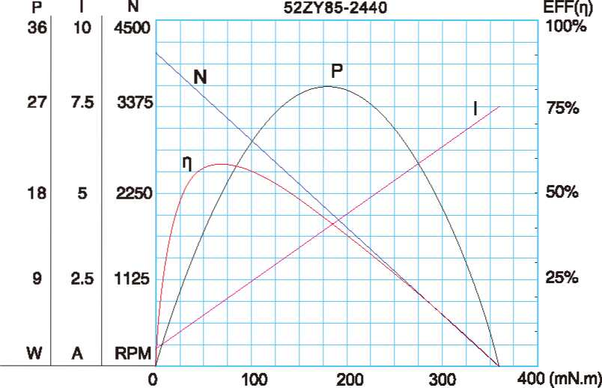
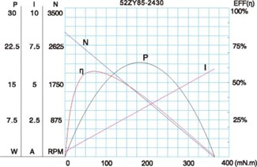

A-25

