永磁直流行星齿轮电机（内齿圈材质:金属）
PM DC Planetary Gear Motor (Ring Gear Material: Metal)
45JX100K/45ZYN68

Φ42 加强型减速器，允许转矩范围：1N.m~10N.m
42mm OD Reinforced Gearbox,
Permissible Load Range:13N.m~10N.m

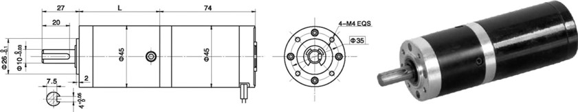
- 外形和安装尺寸Dimensions

- 电动机主要技术参数Motor Technical Data
电机型号  TYPE | 额定电压  Rated  voltage  VDC | 空载转速  No-load  Speed  r/min | 空载电流  No-load  current  A | 额定转速  Rated  speed  r/min | 额定转矩  Rated  Torque  mN.m | 输出功率  Output  power  W | 额定电流  Rated  current  A | 堵转力矩  Stall t  orque  mN.m | 堵转电流  Stall  Current  A
45ZYN68-2420 | 24 | 2000 | 0.18 | 1600 | 42 | 7 | 0.5 | 220 | 2.0
45ZYN68-2430 | 24 | 3000 | 0.25 | 2400 | 65 | 16 | 1.2 | 300 | 4.4
45ZYN68-2440 | 24 | 4000 | 0.30 | 3200 | 90 | 30 | 2.0 | 375 | 6.8

- 齿轮减速电机主要技术参数Gear Motor Technical Data
配置45ZYN68-2420稀土直流电机(45ZYN68-2420 Rare Earth DC Motor)
减速比 Reduction ratio | 3.71 | 5.18 | 14 | 19 | 27 | 51 | 71 | 100 | 139 | 189 | 264 | 369
减速级数 Number of gear trains | 1 | 1 | 2 | 2 | 2 | 3 | 3 | 3 | 3 | 4 | 4 | 4
减速器长度(L) Length(L) mm | 35.3 | 35.3 | 45.6 | 45.6 | 45.6 | 58.4 | 58.4 | 58.4 | 58.4 | 68.7 | 68.7 | 68.7
空载转速 No-load speed r/min | 539 | 386 | 143 | 105 | 74 | 39 | 28 | 20 | 14 | 11 | 7.6 | 5.4
额定转速 Rated speed r/min | 431 | 309 | 114 | 84 | 59 | 31 | 22 | 16 | 9.5 | 8.5 | 6 | 4.3
额定转矩 Rated torque N.m | 0.14 | 0.20 | 0.34 | 0.65 | 0.92 | 1.6 | 2.2 | 3.1 | 4.2 | 5.2 | 7.3 | 10
最大瞬间允许负载 N.m  Max. permissible load in a short time | 3 | 3 | 12 | 12 | 12 | 25 | 25 | 25 | 25 | 30 | 30 | 30
配置45ZYN68-2430稀土直流电机(45ZYN68-2430 Rare Earth DC Motor)
减速比 Reduction ratio | 3.71 | 5.18 | 14 | 19 | 27 | 51 | 71 | 100 | 139 | 189 | 264
减速级数 Number of gear trains | 1 | 1 | 2 | 2 | 2 | 3 | 3 | 3 | 3 | 4 | 4
减速器长度(L) Length(L) mm | 35.3 | 35.3 | 45.6 | 45.6 | 45.6 | 58.4 | 58.4 | 58.4 | 58.4 | 68.7 | 68.7
空载转速 No-load speed r/min | 809 | 579 | 214 | 158 | 111 | 59 | 42 | 30 | 22 | 16 | 11
额定转速 Rated speed r/min | 647 | 463 | 171 | 126 | 89 | 47 | 34 | 24 | 17 | 13 | 9.5
额定转矩 Rated torque N.m | 0.22 | 0.30 | 0.74 | 1.0 | 1.4 | 2.4 | 3.4 | 4.7 | 6.6 | 8.1 | 10
最大瞬间允许负载 N.m  Max. permissible load in a short time | 3 | 3 | 12 | 12 | 12 | 25 | 25 | 25 | 25 | 30 | 30

- 电动机特性图 Motor Characteristic Figure
技术参数如有变动，恕不另行通知
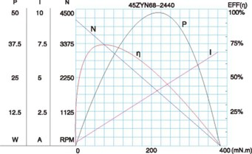
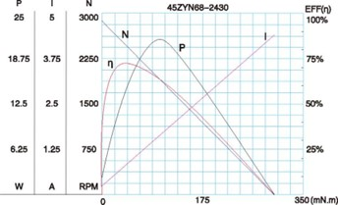

A-24

