永磁直流行星齿轮电机（内齿圈材质:金属）
PM DC Planetary Gear Motor (Ring Gear Material: Metal)
Φ45 加强型减速器，允许转矩范围：1N.m~10N.m
45mm OD Reinforced Gearbox,
Permissible Load Range:1N.m~10N.m
45JX100K/45ZY78

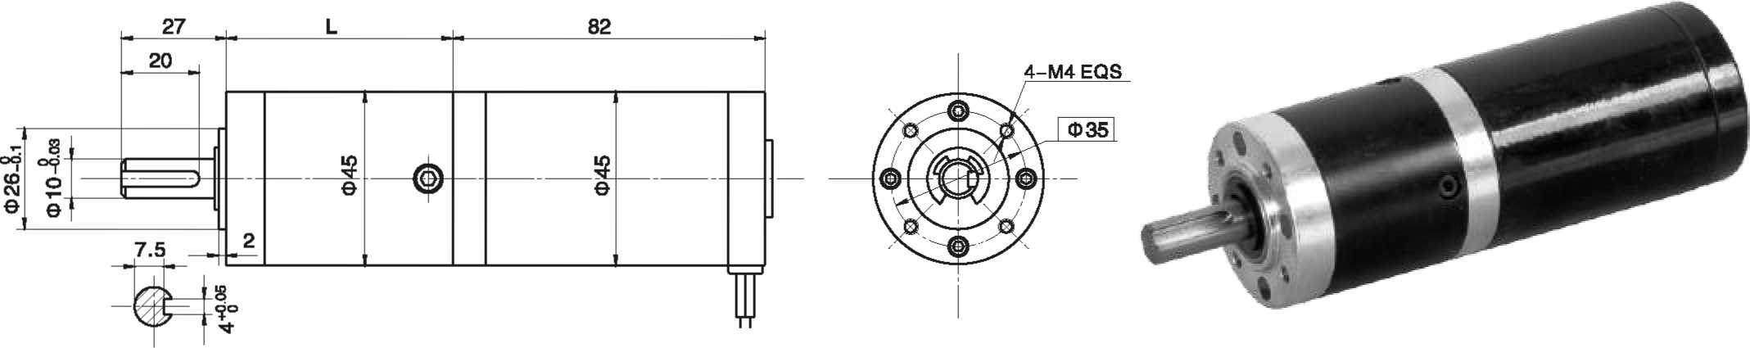
- 外形和安装尺寸Dimensions

- 电动机主要技术参数Motor Technical Data
电机型号  TYPE | 额定电压  Rated  voltage  VDC | 空载转速  No-load  Speed  r/min | 空载电流  No-load  current  A | 额定转速  Rated  speed  r/min | 额定转矩  Rated  torque  mN.m | 输出功率  Output  Power  W | 额定电流  Rated  current  A | 堵转力矩  Stall  torque  mN.m | 堵转电流  Stall  current  A
45ZY78-2430 | 24 | 3000 | 0.22 | 2400 | 55 | 15 | 1.0 | 240 | 3.0
45ZY78-2440 | 24 | 4000 | 0.30 | 3200 | 70 | 23 | 1.5 | 310 | 4.8

- 齿轮减速电机主要技术参数Gear Motor Technical Data
配置45ZY78-2430直流电机(45ZY78-2430 DC Motor)
减速比 Reduction ratio | 3.71 | 5.18 | 14 | 19 | 27 | 51 | 71 | 100 | 139 | 189 | 264 | 369
减速级数 Number of gear trains | 1 | 1 | 2 | 2 | 2 | 3 | 3 | 3 | 3 | 4 | 4 | 4
减速器长度(L) Length(L) mm | 35.3 | 35.3 | 45.6 | 45.6 | 45.6 | 58.4 | 58.4 | 58.4 | 58.4 | 68.7 | 68.7 | 68.7
空载转速 No-load speed r/min | 809 | 579 | 214 | 158 | 111 | 59 | 42 | 30 | 22 | 16 | 11 | 8.1
额定转速 Rated speed r/min | 647 | 463 | 171 | 126 | 89 | 47 | 34 | 24 | 17 | 13 | 9.3 | 6.5
额定转矩 Rated torque N.m | 0.18 | 0.26 | 0.62 | 0.84 | 1.2 | 2.0 | 2.8 | 4.0 | 5.6 | 6.8 | 9.5 | 10
最大瞬间允许负载 N.m  Max. permissible load in a short time | 3 | 3 | 12 | 12 | 12 | 25 | 25 | 25 | 25 | 30 | 30 | 30
配置45ZY78-2440直流电机(45ZY78-2440 DC Motor)
减速比 Reduction ratio | 3.71 | 5.18 | 14 | 19 | 27 | 51 | 71 | 100 | 139 | 189 | 264
减速级数 Number of gear trains | 1 | 1 | 2 | 2 | 2 | 3 | 3 | 3 | 3 | 4 | 4
减速器长度(L) Length(L) mm | 35.3 | 35.3 | 45.6 | 45.6 | 45.6 | 58.4 | 58.4 | 58.4 | 58.4 | 68.7 | 68.7
空载转速 No-load speed r/min | 1078 | 772 | 286 | 211 | 148 | 78 | 56 | 40 | 29 | 21 | 15
额定转速 Rated speed r/min | 863 | 618 | 229 | 168 | 119 | 63 | 45 | 32 | 23 | 17 | 12
额定转矩 Rated torque N.m | 0.23 | 0.32 | 0.79 | 1.0 | 1.5 | 2.6 | 3.6 | 5.1 | 7.1 | 8.7 | 10
最大瞬间允许负载 N.m  Max. permissible load in a short time | 3 | 3 | 12 | 12 | 12 | 25 | 25 | 25 | 25 | 30 | 30

- 电动机特性图 Motor Characteristic Figure
技术参数如有变动，恕不另行通知
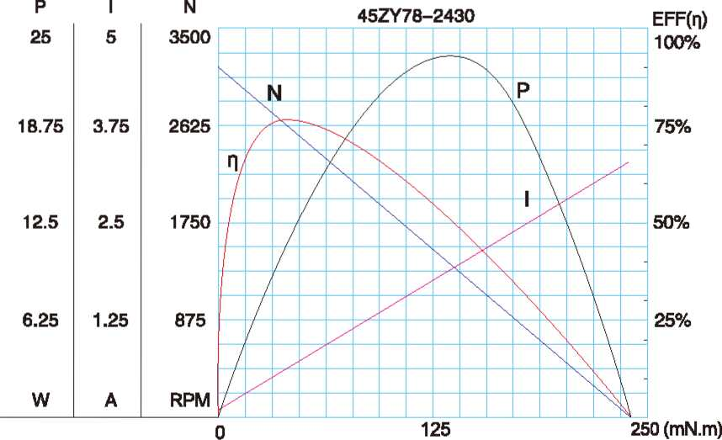
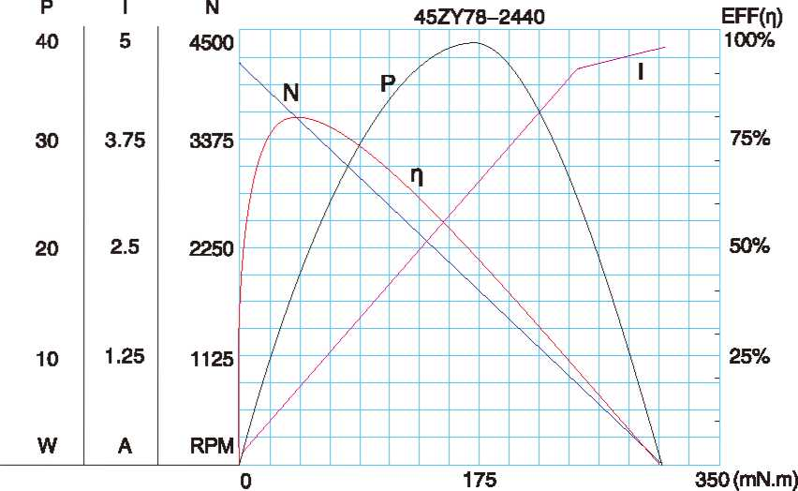

A-23

